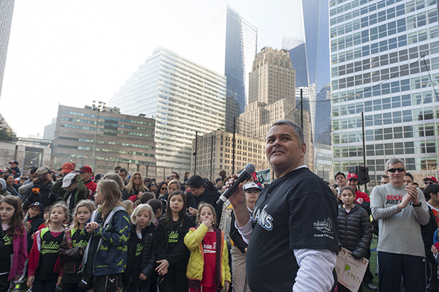Be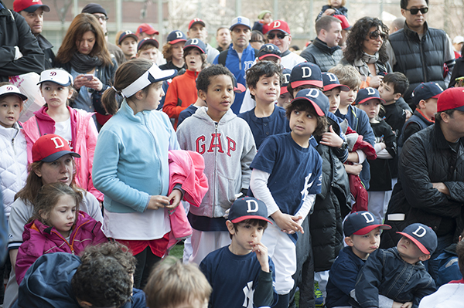

Andrew Zelter, president of the Downtown Little League, greeting the players and coaches, their families and friends on April 5, the opening day of the 22nd Downtown Little League season

(Photos: Terese Loeb Kreuzer)