**WOMEN’S SELF-DEFENSE WORKSHOP**

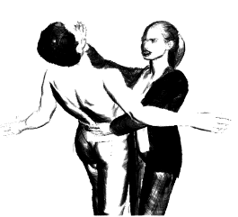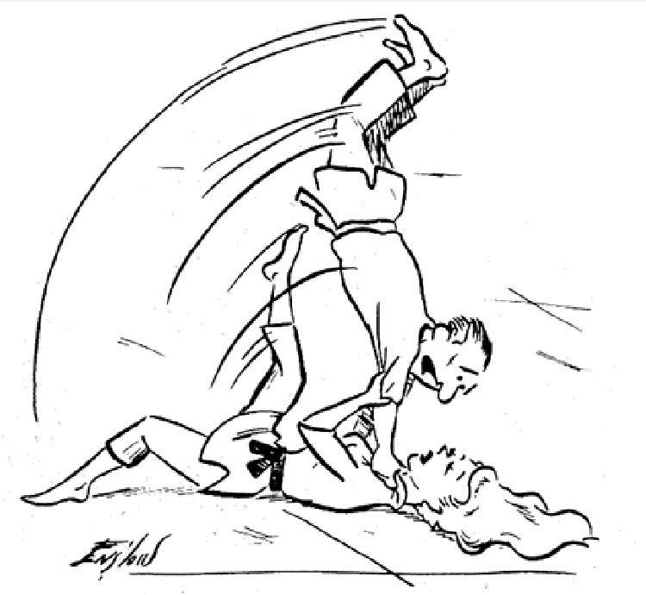

Where: MJDS Gymnasium

When: Thursdays (Nov. 13th, 20th, 27th & Dec. 4th)

Time: 8pm – 9pm

Cost: $100/4-Session Workshop OR $30/Session

This specially designed program is open to all women in our MJDS Community; mothers, grandmothers, aunts or even friends you would like to bring in. Participants will actively engage in a wide variety of controlled scenarios, simulating situations where personal safety would be compromised. This program is structured over 4 consecutive Thursdays (see dates above), each session an hour in duration.

***IMPORTANT***: If you cannot attend all sessions, you will not fall behind or miss out on content covered. Repetition is critical to skill development, so all scenarios covered in previous sessions will always be reviewed prior to the new scenarios covered. The cost (see above) is structured either by session or for the entire four session workshop.

Upon completion of this workshop, participants will be better equipped with proactive measures to minimize, if not avoid, unnecessary situations of vulnerability. Furthermore, if a physically threatening situation presents itself, despite all measures taken, participants will leave feeling greater confidence in their ability to defend themselves.

Focus will be on the most commonly occurring scenarios. The following are a few examples of realistic scenarios to be covered:

* Alone in parking lot (day or night)
* Hands, wrists and/or arms grabbed
* Pinned to the ground
* Pinned to a wall
* Lifted from behind
* Lifted from front
* And more……..***including scenarios brought forward by participants during open discussion***

Participants will be provided a take-home “**cheat-sheet**” that can be posted for daily or regular review, reinforcing content covered during workshop. This **“cheat-sheet’** will include:

* Techniques practiced during the workshop
* Vulnerable Points of Contact on the human body to be targeted
* Proactive measures to minimize/avoid vulnerable situations

*NOTE: Please dress in non-restrictive apparel for the first 3 sessions. For the 4th and final session, participants will be asked to dress in normal daily attire for added realism.*

If you are interested in participating, please contact Jason Rybak at [rybak.jd@gmail.com](mailto:rybak.jd@gmail.com) or 416.951.2444

Jason Rybak

2nd Degree Black Belt – Karate, 1st Degree Black Belt – Jujitsu

Health & Physical Education Program Advisor - MJDS

Athletics Director & Community Liaison – Avalon Children’s Montessori School

Program Director, Sports & Adventure – Appleby College Summer Camps

Member of Balmy Beach Rugby and Balmy Beach Club