Roundtable on the Crown of the Continent
Connecting People to Sustain and Enhance Culture, Community, and Conservation

For Immediate Release

“The Roundtable on the Crown of the Continent”: a new film capturing the landscape and people of the Crown of the Continent

The Roundtable on the Crown of the Continent has released a 10-minute film on the Roundtable, a regional forum focused on connecting people to sustain and enhance culture, community and conservation in the Crown of the Continent:

The Roundtable on the Crown of the Continent:
http://youtu.be/_kcLhbfYasY

Embed Code:
<iframe width="560" height="315"
src="//www.youtube.com/embed/_kcLhbfYasY" frameborder="0" allowfullscreen></iframe>

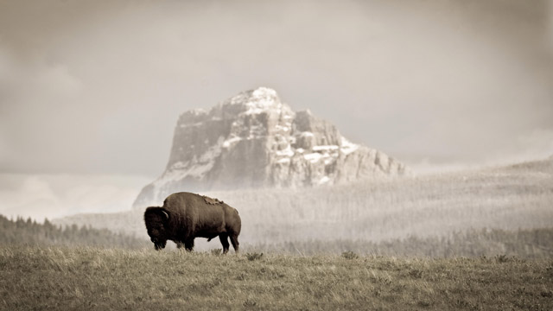
Contacts:

Shawn Johnson, shawn@cnrep.org
Center for Natural Resources and Environmental Policy
(406) 381-2904

Melly Reuling, melly@climateconservation.org
The Center for Large Landscape Conservation
(406) 586-8082

Roundtable on the Crown of the Continent
www.crownroundtable.org

Date: March 3, 2014

Film Synopsis
The film captures the stunning landscape of the Crown of the Continent and the viewpoints and vision of the diverse stakeholders who live and work there—ranchers, scientists, business leaders, and representatives of the region’s First Nations, tribes, municipalities, universities and colleges, conservation organizations, national parks (Glacier and Waterton), and state and federal agencies. The film highlights the role of the Roundtable in connecting these diverse viewpoints to shape the future in a way that reflects local values across cultural, community and conservation dimensions.

What and Where is the Crown of the Continent?
The Crown of the Continent is an exquisite 18-million-acre northern Rocky Mountain landscape that bridges the United States and Canada, including Glacier and Waterton National Parks.

The region straddles the headwaters of three critically important continental watersheds—the Columbia, Missouri and Saskatchewan. These rivers sustain millions of people thousands of miles from the source. The Crown is home to 190,000 residents and visited by over two million people each year. Additionally, seven tribes and First Nations claim the Crown as their cultural homeland. Economic activities from timber production to cattle ranching and recreation utilize natural resources of the Crown. The Crown of the Continent is one of the last places in North America and the world that still hosts all of its native large carnivores.

What is the Roundtable on the Crown of the Continent?
The Roundtable on the Crown of the Continent is a regional forum of leaders and citizens interested in sustaining and enhancing cultural, community and conservation values in the Crown.

Challenges for the Crown of the Continent
The integrity of the Crown of the Continent faces challenges from a changing climate, a fragmented political and jurisdictional landscape, a shifting economy, and new land-use practices, among others (see Issues). In response, this film shares the story and vision of people from throughout the region who have been coming together over the past several years to share information, build relationships, and explore opportunities to work together to both address these challenges and enhance the health and vitality of the region’s communities and landscapes.

Film Production Team
Filmed and produced by award-winning Wimberg Productions Cinematographer: Randy Wimberg
Producer/Editor: Kristin Wimberg
Still Photography: Tony Bynum Photography
Music composition and performance: Stuart Weber

Join the Conversation
Become a Friend of the Crown of the Continent:
http://www.crownroundtable.org/friends-of-the-crown.html

###

