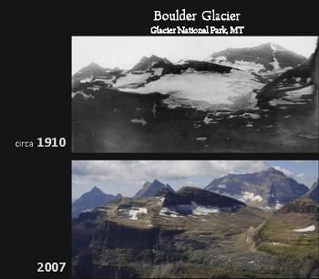

Support Renee Callahan of the Center for Large Landscape Conservation on her 2014 Climate Hike through Glacier to increase awareness about the effects of climate change and to raise money for the Crown Roundtable’s Climate Adaptation Program!
Renee Callahan of the Center for Large Landscape Conservation, http://largelandscapes.org/, is putting boots to trail the last week of August 2014 to raise awareness about one of most pressing issues facing our planet: the effects of climate change. Renee will hike 49 miles in 4 days, including an epic 15-mile hike from the west side of the Continental Divide to the Many Glacier Valley, in her quest to raise money to benefit the Crown Roundtable’s Climate Adaptation program. As many of you already know, the Crown of the Continent is one of the last places in North America that still hosts all of its native large carnivores—one sign of a landscape that remains remarkably healthy and intact. Please help Renee raise awareness about how climate change is robbing us of this national treasure - in hopes of saving this diverse and unique landscape.
All you need to do is email Renee at: renee@largelandscapes.org or go directly to her Climate Hike page to make a secure online donation at: http://tinyurl.com/phwvvoz. If every person who receives this newsletter were to donate only $2.50 each, Renee would instantly meet her fundraising goal of $2,800. As an added incentive, if you provide Renee your email address, she will send you a blog cataloging her Climate Hike experience. Don’t delay – donate today to support Renee’s quest to raise money for the Crown!!!

