4Sponsorship Information:
Please return this form to: Neighborhood Center, Inc.
278 Kaighns Avenue
Camden, NJ 08103

____ Sponsorship Amount: $ ________
Please check the sponsorship opportunity you
have selected on the back of this form.
____ I am enclosing a check
____ I have included my credit card information and would like to be billed:
____ one time
____ in 3 equal monthly installments

First Name: ________________________
Last Name: _________________________
Home Address:
__________________________________
__________________________________
Phone #:___________________________
Email Address:
__________________________________
Credit Card: Visa Mastercard Discover
Card Number:
__________________________________
We thank all of our donors and volunteers for their support of The Neighborhood Center - we are your mission in the city of Camden! The Neighborhood Center is a registered 501(c)3 non-profit organization. Begun in 1913, The Neighborhood Center, Inc., located in Camden, NJ, is a National Mission Institution and an urban outreach mission of the United Methodist Women’s Division and part of the General Board of Global Ministries of the United Methodist Church – giving number N332591 .

The Neighborhood Center is also currently accepting donations of the following new or gently used items to support the summer camp program:
- legos/K’Nex/similar building sets
- sand toys
- riding toys or scooters
- bicycle helmets
- any type of sports equipment
- any type of sports balls
- musical instruments, including keyboards and guitars
- cases of bottled water
- microwave oven
- small refrigerator
- a van in good working order

the neighborhood center
2014 Summer camp
Donation Program
ADVENTURE CAMP 2014
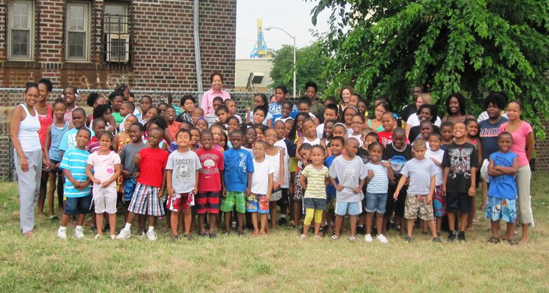

Neighborhood Center, Inc.
278 Kaighns Avenue
Camden, NJ 08103
Phone (856) 365-5295
NCICamden.org
Follow us on Facebook!
We’ve all read the articles labeling Camden N.J. as one of the most dangerous cities in the United States. Here at the Neighborhood Center we provide a safe Christian day camp in the heart of Camden where children can learn, grow and have FUN all summer long – but we can’t do it without YOU!
It’s so easy to become a sponsor of this year’s summer camp program – just check the box next to any of the options below and include a check or we can bill your credit card for either the full amount or in 3 monthly installments – whatever is best for you. Thank you so much for your support – we can really make a difference when we all work together!

___$900 sponsors 1 child for the entire summer ___$100 sponsors 1 child for 1 week
___$400 provides enough fishing gear for the whole camp to share
___$350 provides an outdoor volleyball net ___$75 provides 5 volleyballs
___$300 sponsors a performing arts presentation for the whole camp
___$250 provides an outdoor basketball hoop ___$100 provides 5 basketballs
___$150 sponsors a nature program for the entire camp at a local park
___$125 provides a theme craft project for the whole camp
___$100 sponsors a visit to the Pinelands Center at Mt. Misery
___$100 provides ingredients for two healthy cooking projects
___$80 sponsors a science experiment kit 2013 trip to Pinelands Center at Mt. Misery
___$75 provides 5 theme books ___$75 provides chapter books for a whole class
___$60 provides breakfast for an entire week for a whole class
___$50 provides transportation for 1 day of swimming lessons for the whole camp
___$50 sponsors 2 copies of computer software for academic enrichment projects
___$40 provides writing journals for an entire class
___$25 provides paper and crayons for an entire class

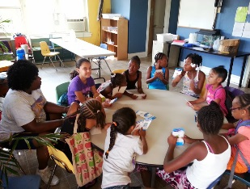
Playing educational games – having fun while we learn together!

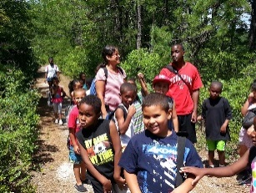
Exploring the beauty of nature on a hike in the woods

Won’t you please sponsor a camper, an activity or some supplies this summer? We are all called to love our neighbors, and to care for the poor and in need. You can make a difference in the life of these precious children with your tax deductible sponsorship of the Neighborhood Center Summer Camp. Please help us make this a wonderful summer - they are counting on all of us!

