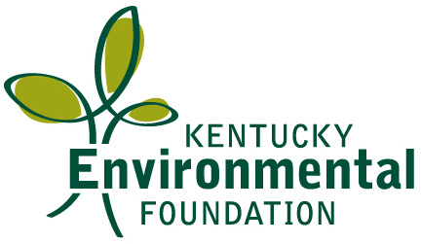

Job Announcement
Advocacy and Outreach Coordinator
Kentucky Environmental Foundation

The Kentucky Environmental Foundation is hiring for a part-time Advocacy and Outreach Coordinator, for fossil fuels and clean energy organizing in Kentucky.

Tasks will include:
- Coordination of statewide information-sharing and collaborative planning among groups working in Kentucky to reduce the harmful effects of coal pollution;
- Outreach to, and engagement with community members most directly affected by pollution;
- Tracking state and federal air, water and waste standards that apply to coal and other fossil fuels;
- Coordinating advocacy on policies and practices to improve health, safety and environmental protection;
- Participating in, and contributing leadership to local and state clean energy projects and campaigns;
- Assisting with media outreach and activities; and
- Sharing other basic administrative tasks as necessary.

The ideal candidate for this position will posses excellent interpersonal, oral, written, and electronic communication skills; background in community and/or coalition organizing; basic understanding of fossil fuels and clean energy landscape and the policies and regulations that shape it; fluency in basic computer programs (e.g. Word, Excel, Power Point), file sharing (e.g. Googledoc), and social media (e.g. Facebook); self-motivation and the ability to work independently and as part of a team. We seek someone who is committed to protecting the environment and public health, using precaution in decision making, and who values collaboration and partnership with a wide range of organizations, institutions, individual perspectives and areas of expertise. Also necessary are a sense of humor and the ability to not take oneself too seriously. Minimum educational requirement: 4-year college degree. Educational background in policy, health, science, economics or communications is preferable but not required.

KEF’s office is located in Berea, Kentucky. Candidates need not live in the Berea area; telecommuting is an option with a mutually agreeable period of time spent in the KEF office per week.

KEF is committed to justice, equality and equity. KEF is an equal opportunity employer. We do not discriminate on the basis of race or ethnicity, political affiliation or beliefs, religion, gender, sexual orientation, physical ability or nationality.

To apply for the job: send a resume, letter of interest, full contact information and at least two references by email to Jamie Austad at Jamie@kyenvironmentalfoundation.org with “Job Application” in the subject line. Or you can mail the same information to Jamie Austad, Kentucky Environmental Foundation, P.O. Box 467 Berea, KY 40403. Deadline for applications: September 20, 2013.

Our office is located on a second floor with stairs. Accommodations will be made for those with physical disabilities.

