**SOROPTIMIST INTERNATIONAL OF SOUTH KOLKATA**

**Q:\140066.enu\MEDIA\OFFICE14\Lines\BD21313_.gif**

Q:\140066.enu\MEDIA\OFFICE14\Bullets\BD15022_.gifQ:\140066.enu\MEDIA\OFFICE14\Bullets\BD15022_.gif Q:\140066.enu\MEDIA\OFFICE14\Bullets\BD14578_.gifQ:\140066.enu\MEDIA\OFFICE14\Bullets\BD14578_.gif …….SISK BYTES…JUNE 2O13……..Q:\140066.enu\MEDIA\OFFICE14\Bullets\BD14578_.gifQ:\140066.enu\MEDIA\OFFICE14\Bullets\BD14578_.gifQ:\140066.enu\MEDIA\OFFICE14\Bullets\BD15022_.gifQ:\140066.enu\MEDIA\OFFICE14\Bullets\BD15022_.gif

**Dear Siskians,**

**“ I am deeply honoured and feel privileged to carry forward the mantle of SI of South Kolkata from my worthy predecessor Savita Jagtiani. As I begin my journey as the President of this vibrant club, I look forward to renewed vigour & zeal from all our members and guidance from my seniors. I hope I will not be found wanting in sincerity in carrying out my duties. We shall focus special attention to education, health, hygiene and issues related to women & girls and look forward to new opportunities. Together WE CAN inspire action and transform lives.”**

**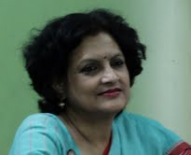 Hobbies – music, sports & games, wildlife & nature, gardening, making new friends.**

**SISK NEWS**

Q:\140066.enu\MEDIA\OFFICE14\Bullets\BD14513_.gifAGM was held as scheduled on 18 May 2013 and EC Members were appointed---

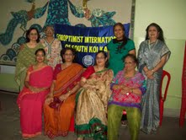

President---Bhaswati Biswas Vice President---Laxmi Parasuram

Secretary---Jyoti Prasad Treasurer—Punam Agarwal

Link Correspondent---Gomathy Venkateswar , PAC ---Savita Jagtiani

Development officer---Ranjana Pillai , Membership---Chitra Gautam Jhangiani

Press and Publicity—Rashmi Magotra

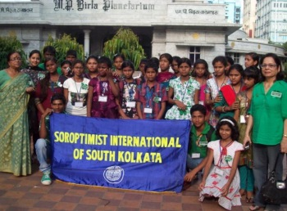 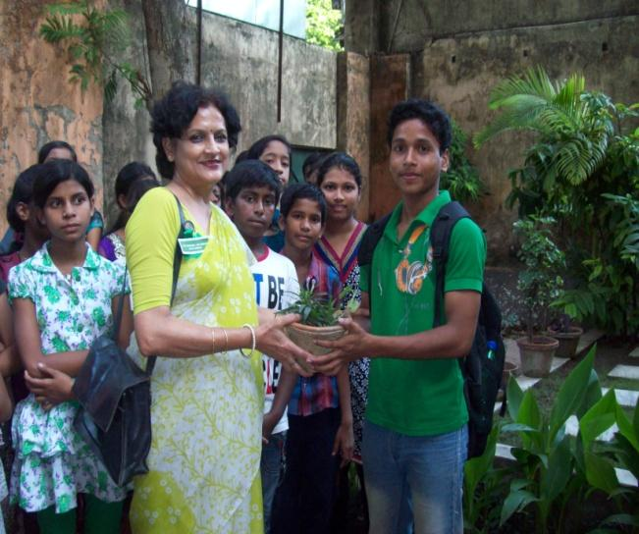

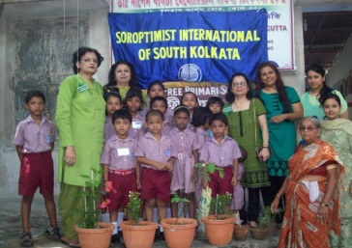 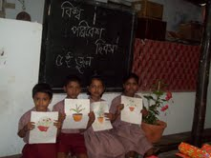

**Q:\140066.enu\MEDIA\OFFICE14\Bullets\BD14513_.gif World Environment Day**

\*On 5th June –CSPD/IPER children were taken to a Birla Planetarium Show sponsored byTreasurer Punam.Awareness programme and Green badges highlighted the occasion.

Quiz and presentation of prizes(plants) followed the show .

\*Celebrated on 6th June at Free Primary School—Flowering plants - Hibiscus,Mogra, Kanchan,Tagor were planted by the children who then enjoyed the Sit & Draw competetion! Prizes and gifts were provided by Jyoti,Bhaswati ,Punam and the “greening effort” was sponsored by Rashmi.

Nutritious beverage and biscuits were served and the morning rounded off by an interesting discussion on the environment.

Q:\140066.enu\MEDIA\OFFICE14\Lines\BD14710_.gif

**SISK – Mother and Child Nutrition Project** Pre natal care of the would be mother and post natal care of mother and infant for a year.Puja Das ---delivered a healthy (though premature) baby boy on 6th June 2013.

**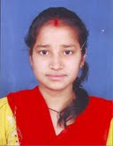 Best Wishes to the mother and baby !**

**SI / SIGBI NEWS**

Message that came across loud and clear at Commission on Status of women 57----

-----**we must include men and boys in work we do around relationships/ violence against women and girls.**

Upcoming events

\*SIE 20th Congress –Berlin-12-14July 2013

\*SIGBI DAY OF ACTION—20 JULY 2013

\*SIGBI 79th Federation Conference –Newcastle Gateshead-31Oct-02Nov 2013

\*SI 20TH Convention-Istanbul-09-12July 2015



SI MISSION STATEMENT

Through international partnerships and a global network of members,

SI inspires action and creates opportunities to transform the lives of

women and girls by: Advocating for equity and equality; Creating safe

and healthy environments; increasing access to education; Developing

leadership and practical skills for a sustainable future.

**\*Founded in 1921, the organisation now comprises of approximately 95,000 members in 125 countries worldwide !**

A SISK Shikshakiran Project at South Kolkata 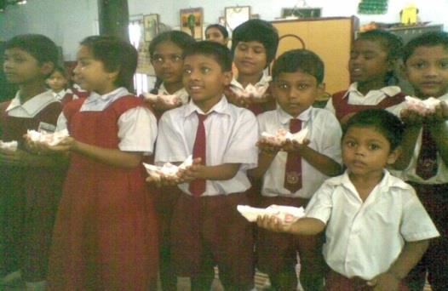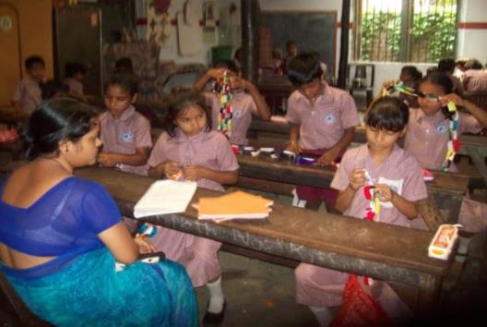

Children at the Free Primary school, Motupara , Charu market

**RABINDRANATH TAGORE……….on EDUCATION………………….**

“The highest education is that which does not merely give us information but makes

our life in harmony with all existence”.

Q:\140066.enu\MEDIA\OFFICE14\Bullets\BD14980_.gifQ:\140066.enu\MEDIA\OFFICE14\Bullets\BD14980_.gifQ:\140066.enu\MEDIA\OFFICE14\Bullets\BD14980_.gifQ:\140066.enu\MEDIA\OFFICE14\Bullets\BD14980_.gifQ:\140066.enu\MEDIA\OFFICE14\Bullets\BD14980_.gifQ:\140066.enu\MEDIA\OFFICE14\Bullets\BD14980_.gifQ:\140066.enu\MEDIA\OFFICE14\Bullets\BD14980_.gifQ:\140066.enu\MEDIA\OFFICE14\Bullets\BD14980_.gifQ:\140066.enu\MEDIA\OFFICE14\Bullets\BD14980_.gifQ:\140066.enu\MEDIA\OFFICE14\Bullets\BD14980_.gifQ:\140066.enu\MEDIA\OFFICE14\Bullets\BD14980_.gifQ:\140066.enu\MEDIA\OFFICE14\Bullets\BD14980_.gifQ:\140066.enu\MEDIA\OFFICE14\Bullets\BD14980_.gifQ:\140066.enu\MEDIA\OFFICE14\Bullets\BD14980_.gifQ:\140066.enu\MEDIA\OFFICE14\Bullets\BD14980_.gifQ:\140066.enu\MEDIA\OFFICE14\Bullets\BD14980_.gif

C:\Users\R.MAGOTRA\AppData\Local\Microsoft\Windows\Temporary Internet Files\Content.IE5\IFH630VC\MC900370268[1].wmf **EXTRA BYTES**

Stress Busters !

Coconut, Chocolate, Oats , Banana , Yogurt-----

---are some foods which are known to add the extra“feel good” elements---so include these in meals for that great “wow” feeling!

Shobhana adds--- the best summer cooler is our very own “daab” paani---so ---hunt for the best tender green coconuts!

RECIPE CONTEST FOR NEXT ISSUE—Include any or all of the above mentioned items –and send in your favourite recipe.

**GENERAL BYTES**

UPSC Exam topper----a woman--third time in a row! Congrats….Haritha Kumar!

\*Sanju-----writes—Rajni - a bride rode a horse and led the Baraat to the grooms’ residence in Satwara, Madhya Pradesh!

\*Swapna---suggestion---lets collect old tablecloths, clothes etc for sewing into patchwork quilts and old cushion covers for making handbags. The quilts could be used in the Mother and baby project and the handbags could be sold in an annual fete.

\*Laxmi---- Let’s do some counselling work for the teenage girls

\*Ranjana--Select and visit a village where we could perhaps develop a new project.

GREETINGS TO BIJLI & her team –for IPER’s Foundation day on 15th July.

BIRTHDAY GREETINGS TO RINA CHATTERJEE ..for her Birthday on 2nd July! **\*\*\*\*\*\*\*\*\*\*\*\*\*\*\*\*\*\*\*\*\*\*\*\*\*\*\*\*\*\*\*\*\*\*\***

**IMMEDIATE PAST PRESIDENT ---SAVITA JAGTIANI says----**

**“Let us renew our pledge towards the change that we want to see, whether it is by providing opportunities in education, healthcare , self sufficiency or creating awareness about violence against women and children. Let us work together for betterment of the lot of women and girls in our society”**

**Q:\140066.enu\MEDIA\OFFICE14\Lines\BD14516_.gif**

**LET’S ,POWER THE 3 E’S—EDUCATE\* ENLIGHTEN \*EMPOWERQ:\140066.enu\MEDIA\OFFICE14\Lines\BD14516_.gif**

**Look forward to hearing from all Siskians!**

**Regards, Rashmi Magotra, Press & Publicity officer-SISK**

**rashmimagotra@gmail.com**