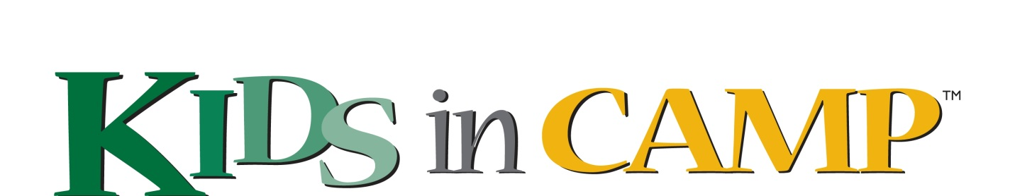

Pass The Music On #2 is going to be outstanding! This is the second year for PTMO and easily the most exciting.

This past summer our 7 partner camps ran PTMO Talent Shows in their settings. All campers were invited to compete - from the very youngest to C.I.T.s. The talented kids who won their camp wide talent shows were invited to move onto to the finals taking place on November 30th, 2014.

The seven selected acts will be competing for top honours, as selected by our celebrity judges. One of the seven camps will take home the PTMO cup.

The 7 partner camps are:
Camp Wenonah
Madawaska Volleyball Camp
Camp Walden
Camp Robin Hood
Camp Tamarack
Camp New Moon
Crestwood Valley Day Camp
Camp Manitou - one of our primary sponsors

PTMO will be benefiting the "Kids In Camp" charitable organization. KIC has placed over 1000 needy kids in OCA accredited camp settings over the last several years.

The competition on November 30th is scheduled for 2:00 PM and is taking place at the beautiful Glenn Gould Studio. The studio has seating for over 300 people and is located inside the CBC Headquarters on Front Street in Toronto.

In addition we will be including additional entertainment with acts that are composed of camp alumni and staff. Also a special guest performer will be added in September: To Be Announced!

For further information, to buy tickets, or make a donation to KIC, please visit our web site: www.passthemusicon.com

We hope you can join us on November 30th and that you will consider making a donation to Kids In Camp!

