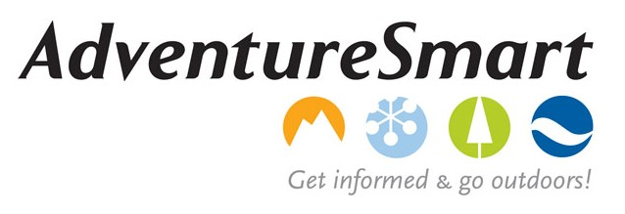
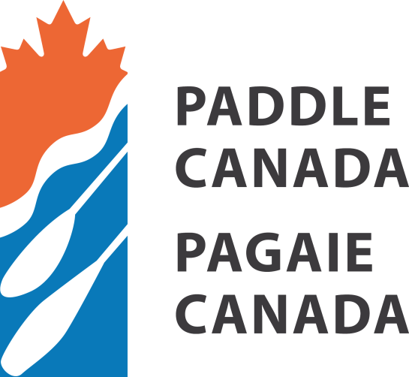

Paddle Canada will be co-hosting an AdventureSmart Trainer Workshop: Niagara Falls On - October 31,2014
This FREE Trainers Workshop provides you with the information needed to train presenters to deliver one, several or all of the AdventureSmart presentations (see AdventureSmart.ca for more details).You may choose to pass on one or two of these topics that day, however we do urge you to take advantage of as many of these sessions as you can attend. A free lunch will be provided.
- Current AdventureSmart programs include:
Hug a Tree and Survive,
Survive Outside,
Survive Outside Snowmobiling,
Snow Safety,
and PaddleSmart.
More information and how to register posted here:
http://www.paddlecanada.com/news/1287-two-more-paddlesmart-adventuresmart-training-opportunities-in-ontario.html

