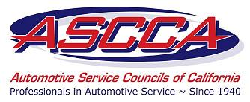

Automotive Service Councils
Of California

One Capitol Mall, Suite 320
Sacramento, California 95814
(916) 924-9054
(800) 810 4272
FAX (916) 444-7462
E-mail: Info@ASCCA.com

September 2, 2014

The Honorable Jerry Brown
Office of the Governor
c/o State Capitol, Suite 1173
Sacramento, CA 95814

RE: AB 1522 (Gonzalez) – Oppose

Dear Governor Brown:

As a member of the Automotive Service Councils of California (ASCCA), I am opposed to AB 1522, which has been sent to you for signature. The ASCCA is a statewide organization that represents over 1,000 independent automotive repair facilities in California.

This bill requires employers to provide payment of sick leave to all employees. Today many small businesses provide paid sick leave payment even though current law does not require doing so. Requiring such a costly mandate on all employers could result in lower wages, reduction of job hours or job losses. The current economic conditions are already making it difficult for small business to survive and mandating additional costs will only worsen the situation.

For the reasons stated above, ASCCA opposes AB 1522 and asks that you decline to sign this bill into law.

Sincerely,

[your name here]

cc: Gloria Peterson, Executive Director, ASCCA

