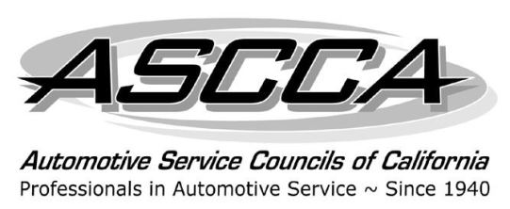
Automotive Service Councils
of California
For additional information contact: Gloria Peterson
One Capitol Mall, Suite 320
Sacramento, CA 95814-3229
(916) 924-9054
We support ASE
(800) 810-4272
FAX (916) 444-7462
E-mail: gpeterson@amgroup.us
For Immediate Release
Mary Kemnitz Elected ASCCA President; New ASCCA Board Elected and Awards Given

Sacramento, CA, December 12, 2013 – Mary Kemnitz, co-owner of D&H Enterprises in Concord, CA, was installed as president of the Automotive Service Councils of California (ASCCA) on December 7 at the Embassy Suites in Sacramento. The installation took place during the ASCCA Team Weekend. The ASCCA is the pre-eminent state trade association for the independent automotive repair industry in California, representing over 800 auto repair professionals and supporting organizations.

Also at this weekend’s event, Steve Vanlandingham received the President’s Award, for his exceptional contributions and devotion to the association. Rory Balmer, owner of Twin Peaks Auto Service in Lake Arrowhead, CA and president of ASCCA Chapter 14, received the ASCCA’s Excellence Award.

The ASCCA also elected their 2014 board of directors, who will take office effective January 1, 2014. The 2014 ASCCA Board of Directors are:

Officers
President: Mary Kemnitz, D& H Enterprises, Concord, CA
President-Elect: Craig Johnson, Craig Johnson Automotive, Rowland Heights, CA
Treasurer: Steve Vanlandingham, Van’s Automotive, El Cajon, CA
Chapter Representatives Committee Chair: Dave Kusa, Autotrend Diagnostics, Campbell, CA
Secretary: Margie van Lierop, Viking Auto Care Corp., Irvine, CA
Immediate Past President: Jack Crawley, Fisk Automotive, Fullerton, CA

Board of Directors
John Eppstein, John’s Automotive Care, San Diego, CA
Declan Kavanagh, Kavanagh Motors, Sherman Oaks, CA
Rocky Khamenian, Bimmer & Benz Specialists, Costa Mesa, CA
Dennis Montalbano, German Auto Repair, Inc., Fresno, CA
Jack Scrafield, North Hollywood Auto Repair, North Hollywood, CA
Jeffrey Stich, Clayton Valley Auto Service, Concord, CA
Stuart Terry, Stuart Terry Auto Repair, San Diego, CA
John Villa, Villa Automotive, San Luis Obispo, CA
Ted Walters, The Auto Specialists in Rancho Cordova, Rancho Cordova, CA

Founded in 1940, the Automotive Service Councils of California is the largest independent automotive repair organization in California. Its members represent all areas of the automotive repair industry, including mechanical, auto body, suppliers and educators.
"To elevate and Unite Automotive Professionals, and give them voice. “

