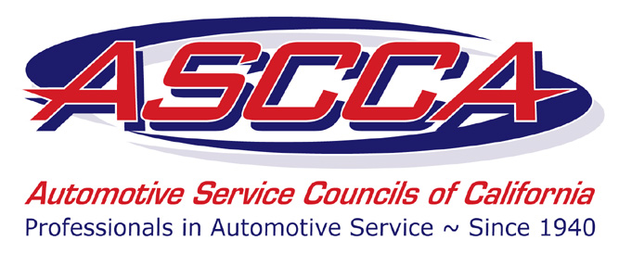

**ASCCA Partners with Educational Seminars Institute**

**Exclusive ASCCA Member Offer**

**Receive Over $50 Off!!**

This is a new member benefit! Courses are normally $149.95. ASCCA members will pay only $95 per attendee!

The number of ASCCA discounted courses is limited, so register today!

To take advantage of this member discount, email Sarah Spencer at [sspencer@amgroup.us](mailto:sspencer@amgroup.us) or call 800.810.4272 x133. (You cannot register for these courses through the ESi website.) The courses are

***Convert the Price Driven Customer***

Sep. 6: La Palma

Sep. 8: Santa Clara

Sep. 9: Fairfield

***Leadership***   
Oct. 19: Lake Tahoe

***Sales and the Customer Experience***

Nov. 22: La Palma,

Dec. 1: Santa Clara

Dec. 2: Fairfield.