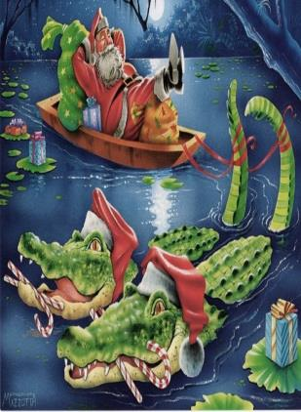
Pierce County Chamber of Commerce
Christmas Parade 2014
“Christmas on the Satilla”
Float Judging Criteria

Float #: _________Judge #:_________ Score:__________

JUDGING CRITERIA: The judges will base their decision on the following criteria: (The highest possible score is 100.)

______A. LIGHTS, ANIMATION AND SPECIAL EFFECTS: Does the float incorporate the use of lights, color, motion and sound to appeal to the audience? 0-40 pts.

______B. CRAFTSMANSHIP: Is the float neat and soundly constructed demonstrating the proper working of mechanical parts and achievement of detail. Does it hold up well during the parade? 0-20 pts.

______C. THEME: Does the float adequately convey the parade theme of Christmas on the Satilla while staying true to the significance and traditions of Christmas? Did the team incorporate a unique idea with creative implementation? 0-20 pts.

______D. PROPORTIONS & PRESENTATION: Can all elements be seen, read and understood by the public? Does the public love it? (Attention should be given to size/proportion/lighting to ensure all elements can be seen by the audience.) 0-20 pts.

Remember, the parade will be at night. Make sure you use spotlights to showcase important elements and scenes.

Notes:___________________________________________________________________________________________________________________________________________________________________________________________________________________________________________________________________________________________________________________________________________________________________________________________________________________________________________________________________________________________________________________________________________________________________________________

