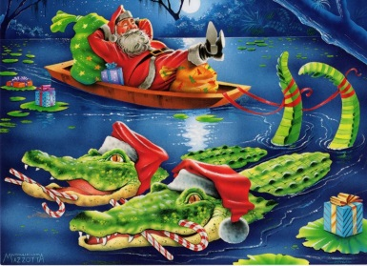
Pierce County Chamber of Commerce Christmas Parade 2014

The Christmas Parade will be held Monday, December 8th beginning at 6:00 at College Avenue and will follow the normal route through downtown and end at the Lee Street Resource Center.

This year’s parade will feature a Float Competition with CASH PRIZES!! We are looking for quality floats highlighting the theme “Christmas on the Satilla”. The competing floats must be at least 15 feet in length, demonstrate the theme, and incorporate lots of color and lights. All parade competition entries will be spotlighted at the grandstand and judged by qualified, out-of-town judges.
Prizes Include:
“Flash Foods Christmas on the Satilla” Grand Champion - $250 ** “Georgia Power Best Use of Lights” Award - $150 ** “Eagle Station Spirit of Christmas” Award - $150 ** “McDonalds Children’s Choice” Award - $150 ** “Main Street Program’s Craftsmanship” Award - $150

All businesses, community organizations, churches, and schools are encouraged to enter a float for competition. Entries registered by noon on Friday, November 21st will not be charge an entry fee. All entries after that date will pay a $25.00 late fee. The absolute entry deadline is Monday, Dec. 1 at 12:00 noon.
ALL PARADE ENTRIES (NOT JUST FLOATS) MUST BE DECORATED WITH A CHRISTMAS THEME. ALL POSTERS, PEOPLE, ETC. MUST BE WELL LIT AND VISIBLE TO THE AUDIENCE.
Entries are NOT allowed to have a live Santa. Santa will appear at the end of the parade as the grand finale!
Participants riding in vehicles or trailer must provide their own vehicles and drivers. Insurance and liability are the sole responsibility of participants.

ENTRIES NOT ABIDING BY THE RULES WILL NOT BE ALLOWED TO PARTICIPATE.
All participants must complete the following entry form and return it to the Pierce County Chamber of Commerce, 200 SW Central Ave., Blackshear NO LATER THAN MONDAY, DECEMBER 1st AT 12:00 NOON. You will be contacted via e-mail the week of the parade verifying your entry information and notifying you of your place in the parade line-up and your report time. Failing to report at your designated time and location may result in your elimination from the parade. Due to City policy, candy may not be thrown from the floats, cars, etc.; however, a person(s) may walk on either side of the entry and pass out candy to the crowds lining the sidewalks.
Questions? Call Angela Manders at 449-7044/or e-mail piercechamberofcommerce@gmail.com

(Detach and return to the Chamber, 200 SW Central Ave., Blackshear before Monday, Dec. 1st at noon.)

------------------------------------------------------------------------------------------------------------------------------------------------------
Pierce County Chamber Christmas Parade 2014 Entry Form

Name of Group/Organization: ____________________________________________Phone #:________________________

Contact Person:_________________________________________ Email:________________________________________

Type of Entry: (ATV/Car/Truck/Van/Float/ Trailer/Choir/Band/Walking Group/Horse/Horse & Buggy)________________

Late Entry Fee Paid: __________ Cash ___________Check # ___________

For office use only: Date Received _____________

