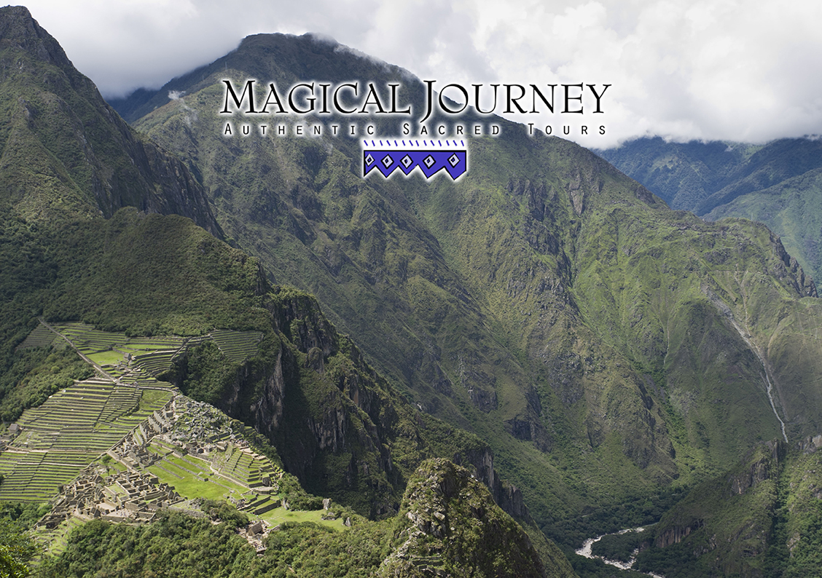
SACRED HEALING ADVENTURE
Pachamama Retreat at Willka T’ika
with Ellen Bradley & Meredith Hogan
February 14 – 21, 2015 Eight days / Seven nights
Experience the Authentic Spiritual and Cultural Wonders of Peru
Cusco ~ Sacred Valley ~ Machu Picchu
Magical Journey
warmly welcomes you
to discover a luxury retreat in the Sacred Valley.

Magical Journey offers the Pachamama Retreat, an ideal program for travelers and spiritual seekers to experience the major highlights of Cusco, Machu Picchu, and the Sacred Valley sites, while allowing ample time for your own personal explorations at Willka T’ika. On select days this program includes professionally guided tours and ceremonies. The quality and variety of offerings in this eight-day program ensure that participants experience a fully Magical Journey to Peru.

Willka T’ika is the perfect base for guests, with special environments to tune into the pure Sacred Valley energies and meditate or relax in the renowned Chakra Gardens. The group has options to practice yoga in beautiful, spacious, sun-filled studios, or hold special gatherings in other beautiful garden structures. Additional healing treatments include solar-heated floral medicinal baths under the stars, Andean spa and massage, and crystal light healing from John of God in Brazil. Each day there is ample time to tap into authentic Andean spirituality. Your carefully chosen guide will help you experience the traditional and cultural wonders of Peru and its people. Willka T’ika is a retreat conceived, built and maintained on sustainable principles, where you will savor gourmet organic vegetarian meals and fully relax in your garden accommodation.

Allow Magical Journey to inspire you...
Pachamama Retreat Highlights

Itinerary: Sacred Healing Adventure – guided yoga and meditation offered daily (TBA)
(B.L.D) indicates breakfast, lunch, or dinner included.
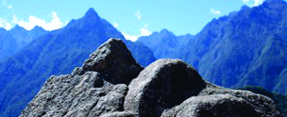

Day 01, Feb 14: Arrival in Cusco Saturday
Your Magical Journey program begins with your private group transfer from Cusco airport to your comfortable hotel conveniently situated off the historic Plaza de Armas. Note: Please arrive into Cusco no later than 11 a.m. to acclimate to the 11,000 ft. altitude.
1:00 p.m. Meet your guide in the hotel lobby. Magical Journey invites you to lunch followed by a brief group orientation meeting in the hotel. Late afternoon walk through the cobblestone streets of San Blas, where your guide will point out fascinating Incan stonework en route to the Korikancha Temple, the holiest site during Incan times. You are free in the evening to dine in one of the highly- acclaimed restaurants near the main square. (L)
Day 02, Feb 15 Sunday
a.m. After breakfast a bus takes you to the Incan ritual fountains at Tampumachay. “Where there is water, there is life.” Participate in a ceremony to honor Yaku, the spirit of water, to open the body’s energy centers and activate and enhance your individual creative and healing forces. A traditional coca-leaf ceremony invites you to tap into the energies of Pachamama, Mother Earth. Continue on a guided tour to the awesome giant stones of Saksaywaman overlooking the city of Cusco where your party may choose to participate in a brief meditation, or hike around the vast Incan site. Afterwards you will visit the shamanic site of Kenko.
p.m. Have lunch at a café of your choice, and shop in the main square of Cusco.
3:00 p.m. Drive to Willka T’ika in the Sacred Valley through the spectacular Andean mountain scenery. Quechua staff will welcome you to the retreat center, and help you schedule time for Andean spa services and the use of the beautiful yoga, meditation and ceremonial spaces. (B.D)
Every day in Willka T’ika
Optional early morning group activity.
Gourmet vegetarian meals served promptly at:
8:00-8:30 a.m. (Buffet breakfast), 1:00 p.m. (Lunch), and 6:30 p.m. (Dinner).
Fresh herbal teas are available from 6:30-9:30a.m. and 3:30-5:00p.m. in the lounge.
Day 03, Feb 16 Monday
a.m. This day is dedicated to Pachamama, Mother Earth, and guests are encouraged to relax or meditate in the splendors of Nature to complement their specific group program. Introduction to the Seven Chakra Gardens. Attune to their energies. Optional guided walk through the Rumichaka farming neighborhood where the Quechua campesinos, farmers live.
1:00 p.m. Wholesome gourmet vegetarian lunch. In the afternoon, the leader may schedule a group meeting or choose to indulge in an Andean spa treatment. Optional coca-leaf reading with the authentic pakko, Qero healer visiting from the high Andes. After dinner, enjoy a full group Andean offering and transformative fire ceremony with our high level pakko. The ceremony serves as a wonderful preparation of mind, body and spirit for your pilgrimage to Machu Picchu. (B.L.D)
Day 04, Feb 17 Tuesday
a.m. Early breakfast. Tourist train to Aguas Calientes. Tea/coffee and snack served on train. A bus takes you to the sunlit terraces of Machu Picchu. Enjoy a fabulous guided tour of the ancient “City of Light.” Experience a journey through the masculine energy temples of political and spiritual power, followed by a deep reconnection of feminine earth energies within the Divine Self.
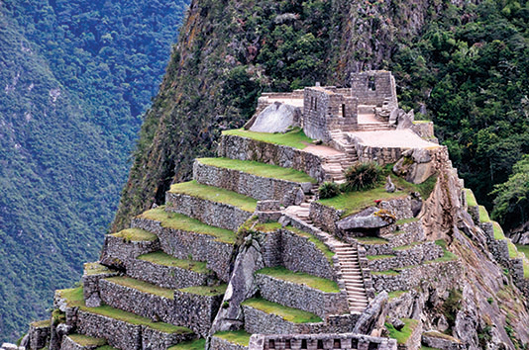
p.m. In the afternoon, hike to the Inti Punku, the original Inkan Gateway to the Sun or take an even more challenging hike to the Machu Picchu Peak. Late afternoon train back to Ollantaytampu where you will transfer to Willka T’ika in time for a late dinner. (B.D)
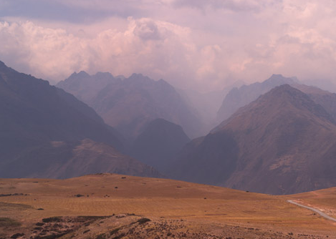

Day 05, Feb 18 Wednesday
A day of yoga, movement, mindfulness and integration at Willka T’ika. Meditate in the Chakra Gardens of your choice, and allow yourself time to receive the ancestral crown chakra energies beneath the 1000-year-old lucuma tree. For the more active, follow a map to hike uphill along zigzag paths to the fascinating ancient Maras salt farms or a variety of other hikes and activities through the valley and up the mountains. After lunch, enjoy an Andean SPA treatment. Crystal light therapy sessions from John of God and spirit doctors in Brazil, are available to pamper the body. Solar baths are reserved for the night. (B.L.D)
Day 06, Feb 19 Thursday
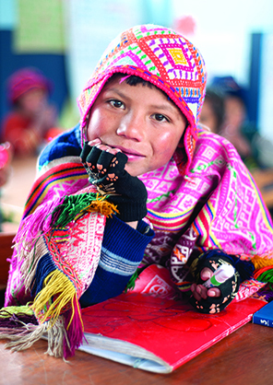
a.m. An ayni day. Welcome the sparkling energies of the day with a drive through the Sacred Valley to a Quechua mountain school, one of four supported by the nonprofit Willka T’ika Children’s Fund. For 19 years, Willka T’ika has maintained contact with dedicated schoolteachers in isolated high mountain communities where few tourists are privileged to visit. In a reciprocal ayni exchange, the group offers an activity the children can enjoy. The warmth and joy of the children, and their open- ness in bringing guests into their daily lives are special moments not easily forgotten. Visitors always are humbled and deeply moved by this heart-opening morning.
p.m. Continue with your guide to the spectacular ruins of P’isaq. Overlooking impressive Incan terraces, the group is invited to hike to the Temple of the Sun, a doorway to the upper Andean world of the Condor, messenger of the Gods. Meditate as a group or walk in a silent personal vision quest to open the third eye. Bag lunch is provided.
Return to P’isaq by bus and visit the famous, colorful market filled with woven goods, jewelry, wall hangings and hand-painted beadwork. Choose a restaurant for lunch in the market square where you can observe colorfully dressed campesinos wearing traditional clothing coming to barter and sell their produce. P’isaq is a photographer’s dream. Return to Willka T’ika with time for a late afternoon garden meditation and restorative yoga practice before dinner. (B.LD)
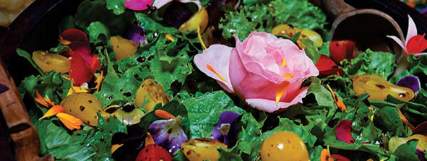

Day 07, Feb 20 Friday
As a sojourner, you were called to the Sacred Valley. Today is dedicated to you, and offered to you as a gift. In silence, enjoy the pure, sacred energies of Pachamama in the Chakra Gardens. Feel Her embrace and allow the Divine Goddess to whisper guidance and wisdom to your soul. Receive Her divine messages, and allow them to penetrate deeply into your heart as you lovingly take them home with you.
Guests may schedule an Andean Spa treatment, or crystal light therapy session to heal and soothe the body. More active guests may practice yoga or choose to hike into the nearby valley and town.
Lunch is served. Later, complete this wonderful day at a Willka T’ika with sacred circle and farewell dinner. (B.L.D)
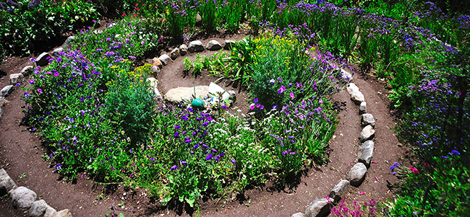
Day 08, Feb 21: Departure for Lima Saturday
10:00 a.m. Check-Out Time. Enjoy a closing practice before or after breakfast. One group bus transfer to the Cusco airport to connect to Lima and your flight home. Allow three hours and 25 minutes before your Cusco flight. Ideal flights to Lima depart between 1:45-3.00p.m.
Filled with the pure spiritual energy of your Andean transformational journey-of-a-lifetime, arrive in your home city the same or next day. (B)
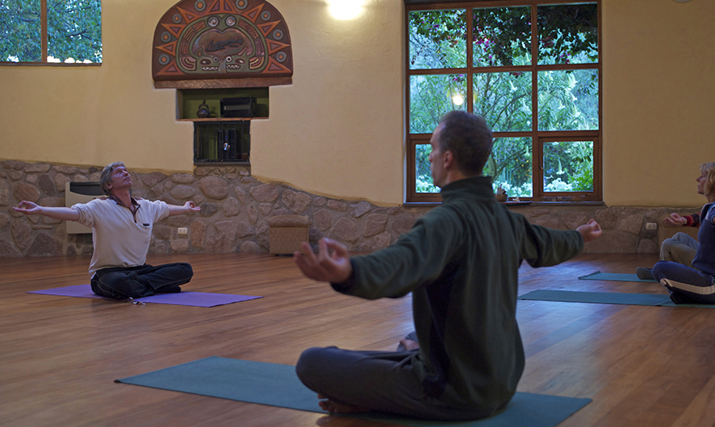
Contact our US office
info@magicaljourney.org
Toll free: (888) 737-8070
Office: (805) 884-1121
Skype: magicwtikainfo
www.willkatika.com
www.magicaljourney.org
Willka T’ika was originally conceived and is lovingly maintained as a private garden retreat center.
It is open only to its registered guests.
Arrival/Departure: Program services begin with a group transfer from the Cusco airport on Day One and end with the group transfer from Willka T’ika to the Cusco airport on Day Eight. Participants arriving at a different time may arrange a private transfer with Magical Journey or take a taxi. If participants wish to arrive a day earlier at the start of the program, they may request Magical Journey to arrange an extra night in the same comfortable Cusco hotel. Please advise at time of registration.
Please take note of Magical Journey’s 29+ years of experience in offering authentic and quality spiritual programs, complemented with unmatched service at Willka T’ika in beautiful garden rooms, organic meals and a staff that has been at the retreat center since its inception – a unique offer at a very affordable, fully-inclusive price. Guests receive great value for their money.
Cost does not include:
* International round trip flight to Cusco via Lima.
* Individual airport transfers and hotel bookings.
* Sundries, alcoholic and bottled beverages, laundry and spa services, and private readings or healing.
Investment:
$3100

Pachamama Retreat is accommodated in shared Garden rooms with space for up to 20 participants housed in:
- 2 twin rooms
- 2 rooms with a queen bed
- 3 large triple rooms
- 3 single rooms
Leader to specify rooming assignments. If group exceeds 20 participants, shared luxury rooms are available for an additional $180/person.
Guests may upgrade to a shared luxury room for $180/person, upon availability. Please request when registering.
$750 Single Garden room supplement is subject to availability.

