A Joyous Day of Dedications • Pastor Ted Krey & Vicar Jeremias Meyer
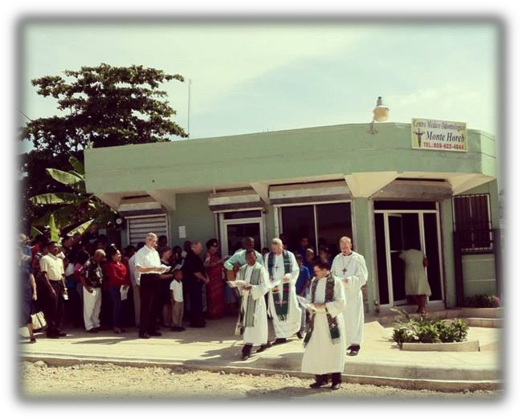
On Sunday October 13th, Amigos de Cristo Lutheran Church in Las Americas celebrated the dedication of its clinic – Mont Horeb Medical Clinic. The clinic sits across the road from the church and seeks to offer both medical and dental care. The nearest access to medical care is more than 20 kilometers away
from the clinic. Several people have died at night due to not having the transportation or monies necessary for getting to the nearest hospital. Pastor Willy Gaspar consistently and faithfully has taken more than his share of people to the clinic at all hours of the night.

About 200 people were present for the divine service, including many visiting guests from our partners in mission – Bethesda Lutheran Communities, LCMS International Mission, South Wisconsin District, St. Michaels Lutheran, Ft. Meyers, Florida. The sermon was based on the wedding invitation in which Jesus invites all to the great wedding feast where He freely gives us His food, His drink and His wedding clothes. Pray with us for Pastor Gaspar that this clinic might both be able to tell others of Jesus and also care for them physically.

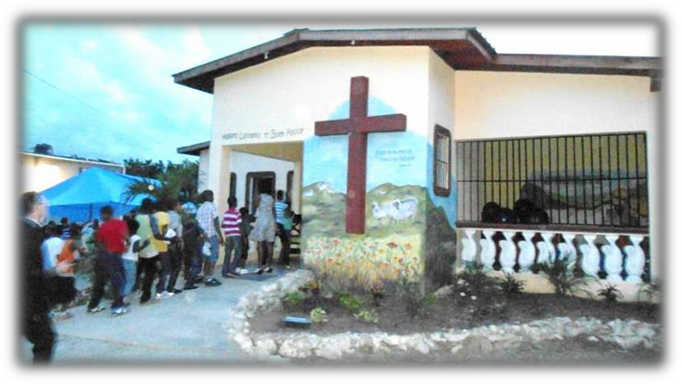
In the afternoon, more than 200 people gathered in Palmar Arriba for the dedication of our group home. Several teams from the US and monies from an LWML grant allowed us to build this home. Construction first began in February and the children – Estefani, Moíses, Randy, Ramona, Francis and Junior - officially moved in on July1st.
It was a service of great celebration, with the group home children dressed in their best (note Francis here in his suit and tie!), and youth choirs from Las Americas and Palmar Arriba joined together to sing for us, during the offerings, the special songs they had prepared. What a blessing that the least of these are the apple of His eye and that in them we see Jesus. We give thanks to our heavenly Father for His tender mercies and for allowing us to call upon His Name in Word and prayer, beseeching Him to be near us as we place these youth in His care.

