Holiday Inn Express
New Construction
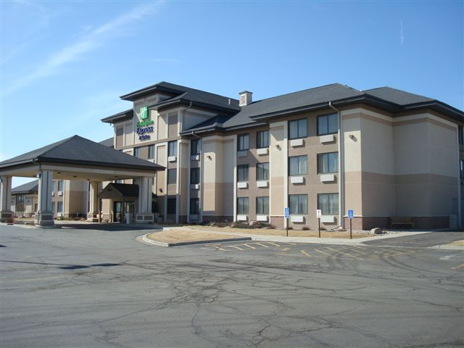
Location
Worthington, MN
Client
Advantage Architectural Group
Contact
Dan Brewer

Architect
Advantage Architectural Group
Type of Construction
New Construction

Project Summary:
This 3-story hotel was built in 1998. Fighting the elements of a Minnesota winter (mid-December),
we started the install of this motel package. FBS provided the interior and exterior walls with exterior finishes applied, the GC did not have to worry about tenting-heating the structure. We also provided
the floor and roof systems, sheathings and soffit material. The owner shipped the windows to our plant
and we factory installed so they did not need to worry about this during the install process.

Meet or Exceeding Owners Goals, Values and/or Expectations:
This motel is located right off the interstate in Worthington and is a very busy place. The motel is still looking as good today as it did when we supplied the package back in 1998. Fullerton is proud to have supplied the “package” for this project.

Funding:
Private

