SHOPPES ON 100
New Construction

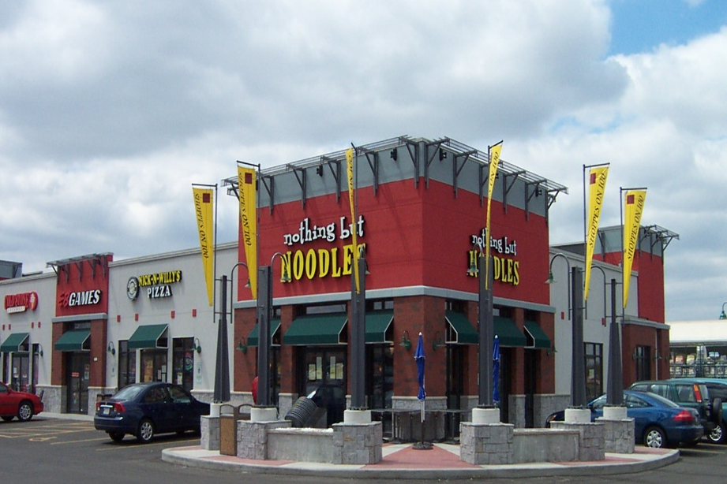
Location
West Allis, WI
Client
Zabest Commercial Group
Contact
Steve Nikolas
Developer

Type of Construction
New Construction

Project Summary:
We provided this package along with another retail building in this development. FBS provided this complete furnish and install for Zabest Commercial Group. The building size was approximately 7,916 sq/ft. Fullerton supplied the interior- exterior walls, steel beams-columns, roof system, sheathing and utilized the Dryvit in selected colors along with Cultured Stone in the European Castlestone. Zabest is a repeat business customer and we have been working together since 2000.

Meet or Exceeding Owners Goals, Values and/or Expectations:
Zabest Commercial Group wanted to add these retail designs to the West Allis, WI area. FBS worked early on in the process with Zabest to develop this new design. Zabest utilizes the Fullerton system for the speed of construction and quality of the building packages they receive on each project. By using Fullerton, they can reduce their construction schedules 45-60 days, which in turn reduces the interest on their construction loans.

Client Profile:
Zabest Commercial Group is a developer of convenience stores, retail and restaurants throughout the State of Wisconsin.

