HyVee Gas & Grocery
New Construction Convenience Store
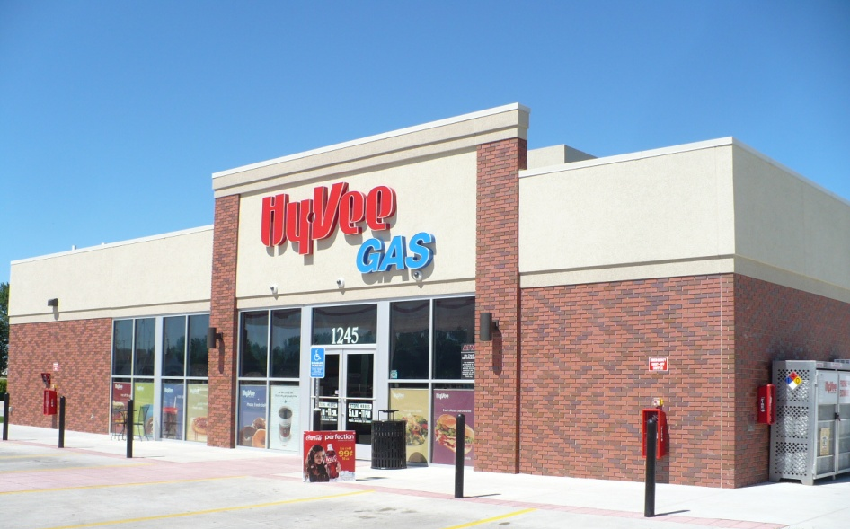
Location
Worthington, MN
Client
HyVee Construction
Des Moines, IA
Contact
Brad Strehlow
brad.strehlow@hy-veeconstruction.com

Type of Construction
New Construction

Project Summary:
FBS provided this complete furnish and install building package for HyVee They are a repeat business client with a long standing relationship with FBS. This project was completed in Worthington, MN, where FBS’s manufacturing facility is located. We watched the building shell be set in 2 ½ days.

Meet or Exceeding Owners Goals, Values and/or Expectations:
FBS works ahead on the permit plans in conjunction with HyVee architects to speed the process along with the city. The finished product went together seamlessly and FBS was completed on-site in 3 days. This allowed for interior finish activities to be started two (2) weeks earlier than what we would typically see. HyVee also sees the value and peace of mind with the FBS warranties.

Client Profile:
FBS provided this complete shell package with the exterior Brickwal and EIFS finishes. HyVee is a fast-growing grocery chain across the Midwest and they have been adding the HyVee Gas Convenience stores to their outlots. Our design department works with HyVee on design changes to the building, changes due to city requirements and developing different prototypes.

