Popeye’s – New Haven, CT
New Construction - QSR
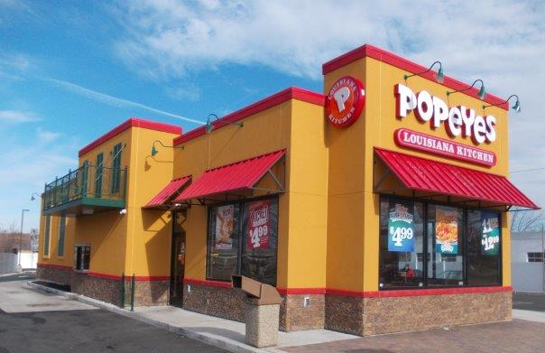
Location:
New Haven, CT

Client
R.Reese Construction
Contact
Bob Reese
tara@rreeseconstruction.com

Type of Construction
New Construction

Project Summary:
This project was completed in New Haven, CT with R.Reese Construction. Fullerton’s scope included the exterior wall panels, interior walls, roof truss system with the EIFS and Cultured Stone exterior finishes factory applied. The building size was approximately 29x84. R.Reese Construction has utilized several Fullerton packages and his crew has been certified to set Fullerton building systems, which they did on this store.

Meet or Exceeding Owners Goals, Values and/or Expectations:
R. Reese Construction, the GC, likes the ease of working with FBS. We quote the FBS package, work with him on the development of plans and deliver the building package on schedule. R.Reese Construction likes the “one stop shop” where he doesn’t have to worry about several different subs on his job site. On this particular project, the city required a 3rd party inspection done on the EIFS System. Fullerton’s package was inspected and we forwarded the necessary paperwork from the inspector to R.Reese Construction.

Client Profile:
Bob Reese Construction has good working knowledge of construction processes on the East Coast and has done multiple packages. We have worked with Bob Reese Construction and his crew to make the FBS construction process safe, easy and fast.

Funding:
Private

