IHOP Restaurant
New Construction - Restaurant

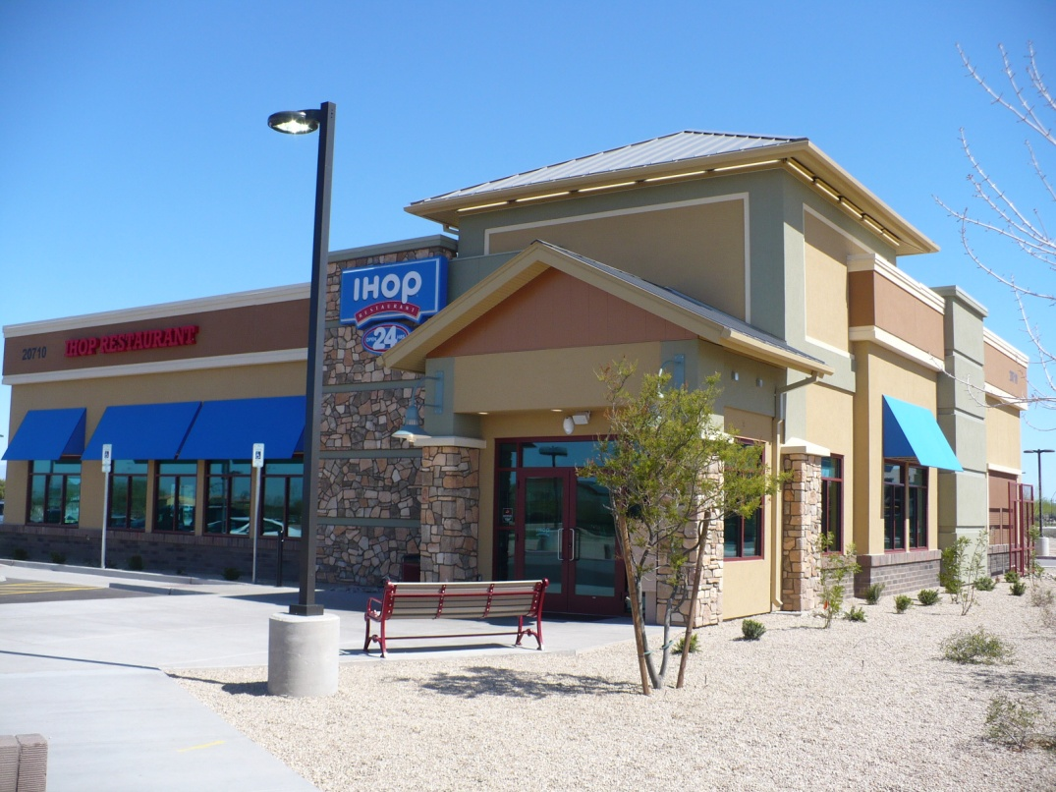
Location:
Queen’s Creek, AZ

Client
Romulus Restaurant Group
Phoenix, AZ
Contact
Mark Steinmetz
MSteinmetzcbell@romulusinc.com

Type of Construction
New Construction

Project Summary:
This project was done in Queen’s Creek, AZ (right outside of Phoenix). Fullerton’s scope included the exterior wall panels with the EIFS exterior finish factory applied (The EIFS was used in several different colors). Also supplied were the interior bearing walls, wood beams, roof truss system. FBS provided the non union assembly labor to set the entire building shell. Utilizing our Midwest assembly crew, Fullerton had this building shell completed in 10 days.

Meet or Exceeding Owners Goals, Values and/or Expectations:
We were pleased to supply this building package to the customer. This is a very eye appealing location. Fullerton Building Systems worked ahead on the plans and developed in conjunction with the architect to ensure the building was constructed per city code requirements.

Client Profile:
Romulus Restaurants is a repeat customer of FBS with a long standing relationship over past projects. They are a respected franchisee in the Blue Roof (IHOP) community. The owner is a director on the Blue Roof Committee (IHOP).

Funding:
Private

