SHOPPING GUIDE
FOR CLEAN FRUITS & VEGETABLES
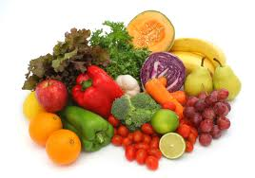

Dirty dozen + Clean 15
BUY THESE ORGANIC Lowest in Pesticides

- Apples 1 Sweet Corn
- Strawberries 2 Onions
- Grapes 3 Pineapples
- Celery 4 Avocados
- Peaches 5 Cabbage
- Sweet Bell Peppers 6 Frozen Sweet Peas
- Imported Nectarines 7 Papayas
- Cucumbers 8 Mangoes
- Potatoes 9 Asparagus
- Cherry tomatoes 10 Eggplant
- Hot Peppers 11 Kiwi
- Kale & Collards 12 Grapefruit
- Spinach 13 Cantaloupe
- Summer Squash 14 Sweet Potatoes 15 Mushrooms

