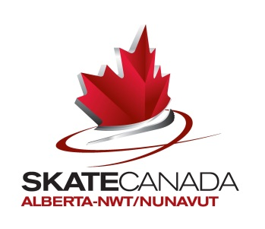
Name: Home Club:
Address: City:
Postal Code: Phone Number:
Email Address:

Triple Flip Ladies Podium Jacket $105.00 Triple Flip Mens Guy’s Jacket $115.00
Size 4 Size 4
Size 5 Size 5
Size 6 Size 6
Size 7 Size 7
Size 8
- Please see attached Teamwear Size Chart for assistance in choosing sizes
- Please see attached photos for images of the jackets
- All jackets will be plain black and will have the Skate Canada: Alberta-NWT/Nunavut logo on the upper-middle back, as well as ‘AdultSkate’ on the right sleeve.
Payment must accompany this order form:
Cash Cheque Visa Mastercard
Name of Cardholder:
Card Number: Expiry Date:

Please mail, email, or fax order forms and payment to:
Skate Canada: Alberta-NWT/Nunavut
11759 Groat Road NW
Edmonton AB T5M 3K6
FAX: 780-427-1734
Email: lisa@skateabnwtnun.ca

Orders with payment must be received by Monday December 2, 2013.

