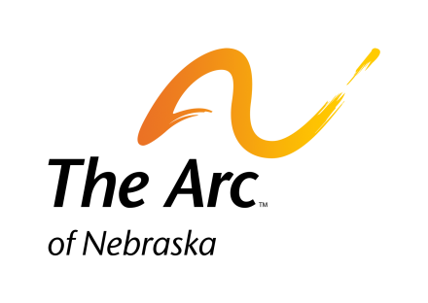
Registration
The Arc of Nebraska’s
42st Annual Senatorial Dinner

Thursday, February 6, 2014

Cornhusker Hotel 333 South 13th Lincoln, NE

1:00-3:30 pm Board of Directors Meeting
4:00-6:00 pm Legislative Briefing
5:00 pm Registration
6:00 pm Social Hour
7:00 pm Dinner

State Senators will be present to meet with and share personal stories along with your hopes for people with developmental disabilities and their families. We wish to express our appreciation to the Senators for their past and continuing support.

Please call your Senator and encourage him/her to attend. You may call The Arc of Nebraska for the name and phone number of your Senator. The Arc of Nebraska’s website also has a Legislative link where you may find your Senator’s contact information.
-------------------------------------------------------------------------------------------------------------------------------------------

Name: __________________________________________________ Phone: _________________________________

Address: _____________________________________________ City: _______________________ Zip: ___________

E-Mail: _____________________________________________ Senator: _____________________________________

_____ Member of The Arc-$40.00 in advance. $45.00 at the door.

_____ Non-Member-$45.00 in advance. $50.00 at the door

_____ I would like to make a contribution for a self advocate’s meal. (Indicate amount)

_____I would like to help pay for my Senator’s meal. (Indicate amount)

_____ I am unable to attend but would like to make a donation. (Indicate amount)

Please mark you meal choice. Meal Includes: coffee, tea, salad and dessert

_____ Maple Glazed Pork Loin (Seasoned sliced pork loin served with maple mustard sauce served with fresh vegetables and potatoes)

_____ Chicken Oscar (Boneless skinless chicken breast grilled and topped w/apricot ginger glaze topped with mushroom cheese sauce and asparagus served with fresh vegetables and potatoes)

_____ Tortellini Rosa (Cheese filled tortellini tossed in a tomato cream sauce with sun-dried tomatoes and sautéed mushrooms with fresh vegetables)

Special Accommodations (Please Specify) ________________________________________________________________

I would like to pay by credit card. Credit Card Number: ______________________________________________________

Security Code _____ Expiration Date: __________________ Total Amount Charged: ______________________________

Reservations MUST be made no later than January 27, 2014
Please Mail or Fax the completed Reservation Form to:

The Arc of Nebraska Phone: 402-475-4407
215 Centennial Mall South, Suite 508 Fax: 888-519-6524
Lincoln, NE 68508 www.arc-nebraska.org

