Simple Solutions for Stressful Lives
Even If You Don’t Think You Have The Time

Tuesday, June 17, 2014
7:00 p.m. – 8:30 p.m.
Alternative Therapy
5801 Braden Run

$20 per person
Space is Limited. Reserve your place early.
Please register at 941-727-1500

Presented by: Ellen S. Brenner, MS, LMT, EMC, CHC, CR, CA
Wellness Educator & Practitioner

Chronic stress can challenge our body beyond its ability to compensate and heal. Left unchecked, it is a leading cause of serious disease and conditions. Chronic stress has been linked to heart disease, obesity, diabetes, depression, anxiety, cancer, chronic fatigue, fibromyalgia and other autoimmune disorders.

This engaging, interactive and informative program will introduce you to the impact of chronic stress on your health, the power you have over your own wellbeing, and how you can take charge with some simple and natural relaxation and restoration remedies you can use on your own even if you are short on time.

This class is for you if:

- You can’t remember the last time you felt vibrant and energized with a overall sense of wellbeing.

- You think you are too busy to care for yourself, you are doing fine by just “sucking it up,” or that eliminating stress requires a major life change.

- You want to support your health and wellbeing to prevent chronic disease, or support your body if you already experience it.

- You are curious about natural healing techniques for relaxation and relief you can do yourself, but don’t know where to start.

Come prepared to experience the power we have over our own wellbeing. Leave with some simple solutions to explore further on your own.

- Understand how the mind, body and spirit work together
- Learn how chronic stress impacts your health
- Discover the power you have over your own wellbeing
- Experience some simple relaxation and restoration techniques
- Be inspired to take charge of your own health through small, doable steps
- Take away additional strategies to explore further

Note: For those with smell sensitivities, portions of this class include the use of pure and natural essential oils.

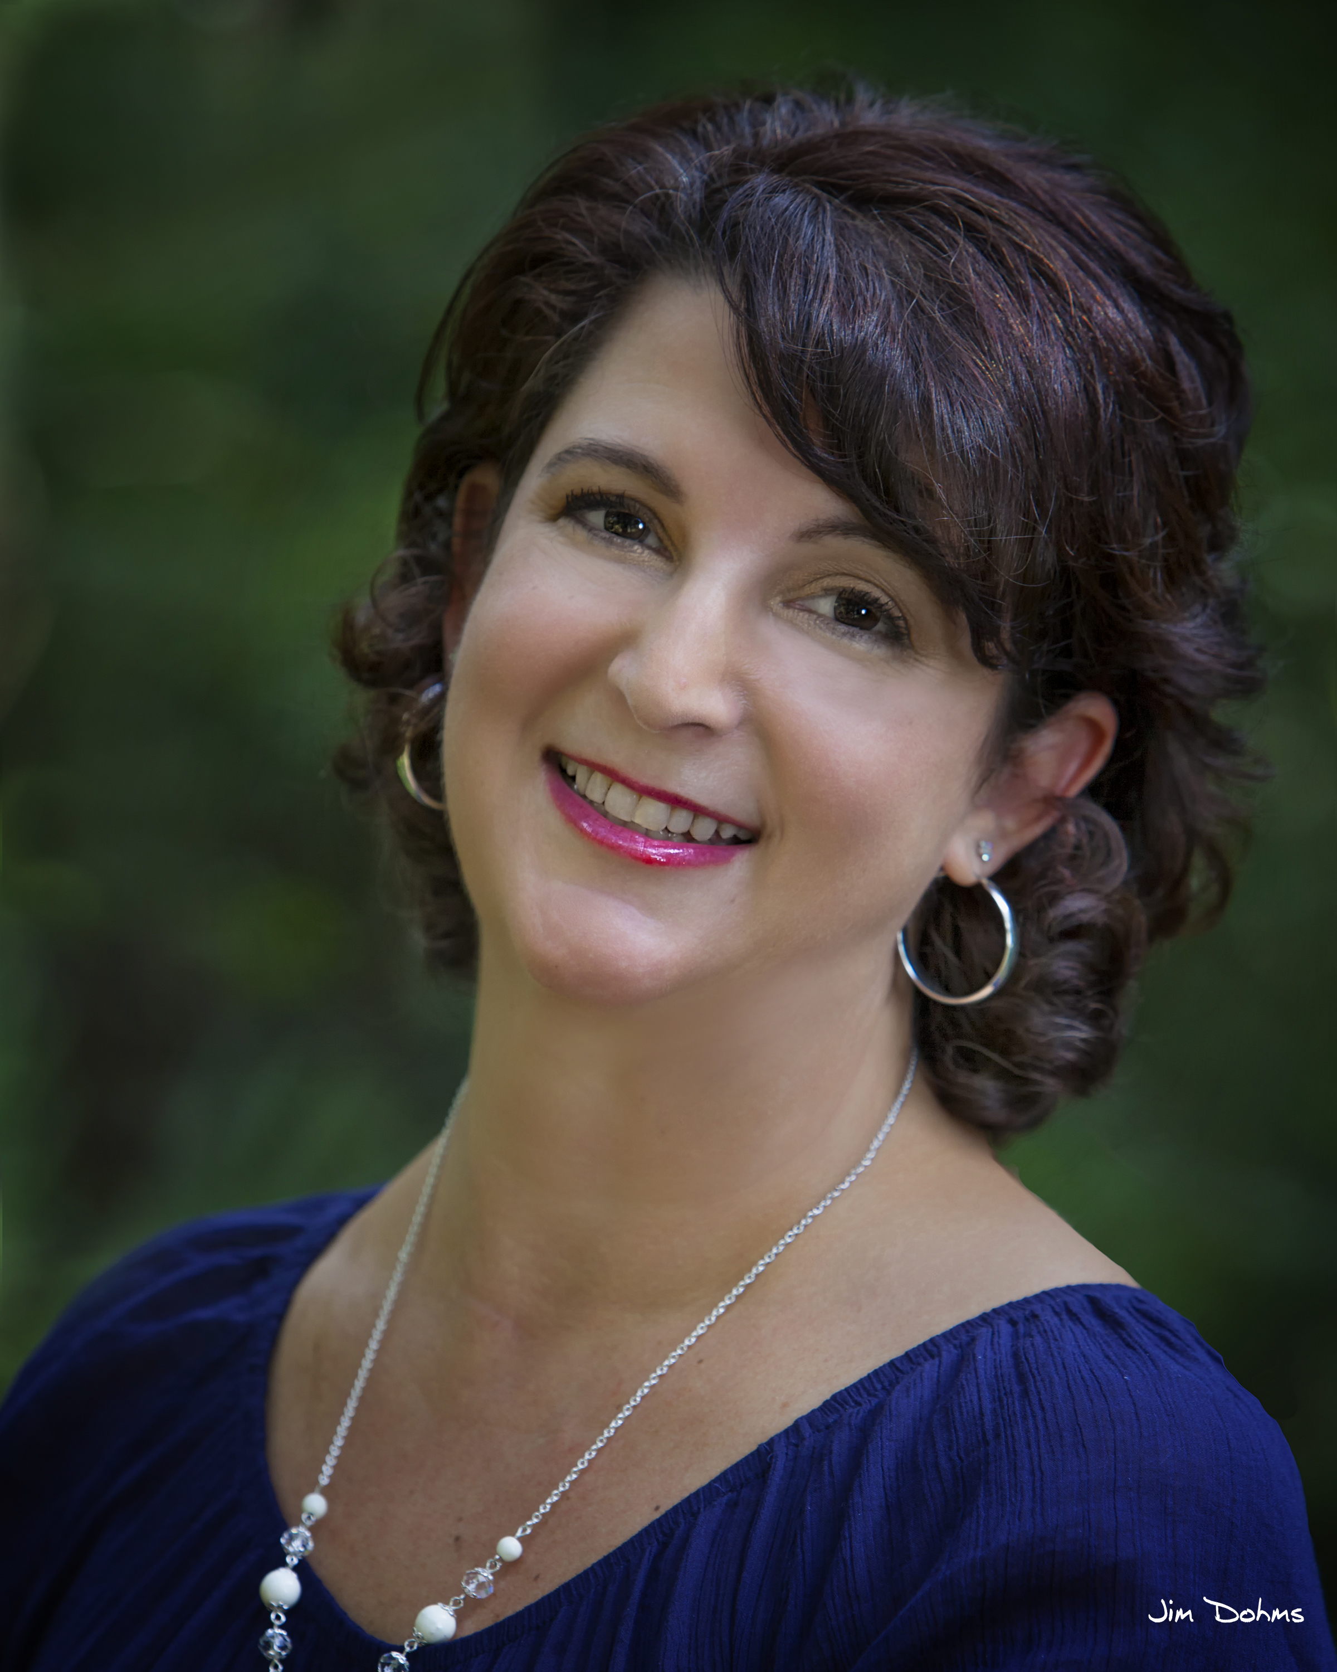
Ellen is a compassionate and comprehensively trained wellness educator and practitioner. She provides inspired wellness education focused on the mind/body/spirit connection, its impact on our health, and the doable steps we can take to sustain our own optimal wellbeing. Ellen believes in whole-person, wellness-based care unique to each individual. She is experienced in supporting those who have faced traumatic illness or injury, chronic conditions, and long-term stress.

Ellen is a nationally board certified and licensed therapeutic bodywork practitioner with intensive training in energy medicine, holistic aromatherapy, and holistic health coaching. She is also certified in reflexology and transformational healing workshops. Ellen received her undergraduate degree from California State University, Long Beach and her graduate degree at DePaul University in Chicago. Previously, she served 22 years as a healthcare executive leading organizations through transformational change and sustainable growth.

