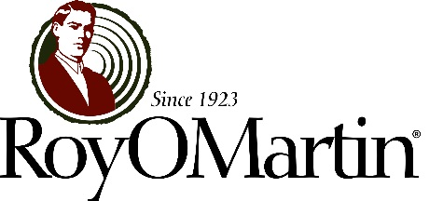

PROMOTIONAL OPPORTUNITY PROGRAM POSTING

Position: Business Development Manager - Marketing
RoyOMartin Corporate Office (Alexandria, Louisiana)

Position Responsibilities: The primary responsibilities of this position are to complement the efforts of RoyOMartin’s existing sales and marketing teams in researching new business opportunities and promoting the use of our products and services, particularly those that are “value added.” Duties include but are not limited to:

- Visiting job sites, retail locations, industry meetings, and other venues to establish and maintain relationships with key influencers, such as architects, designers, builders, dealers, buying groups, and purchasing representatives
- Attending and/or hosting trade shows, seminars, and other events to educate selected audiences about product benefits
- Researching, identifying, and tracking new sales channels and assisting in pulling the products through the sales cycle to each product’s end use
- Maintaining up-to-date knowledge of building codes and other technical information, industry trends, buying patterns, and competitors’ offerings
- Assisting in developing focused annual marketing plan and related campaigns, marketing literature, technical information, and other promotional materials.

This position requires regular travel throughout the RoyOMartin market areas.

Candidate Profile: At least two years of professional work experience in business development, sales, business-to-business marketing, or the building-products industry is required for consideration. A four-year college degree in building science, architecture, construction management, or a related discipline is preferred. Previous homebuilding experience is a plus, as is a knowledge of residential, multi-unit residential, and light commercial markets. This individual should be proficient in Microsoft Office programs; customer relationship management or project management software experience is beneficial.

Behavioral Profile: The ideal candidate will demonstrate strong and effective communication, negotiation, and presentation skills. Resourcefulness and follow-through are essential. Time management, a sense of urgency, and professionalism are important. He/she must work well independently, as well as within a collaborative team environment. The ability to effectively communicate with individuals at all levels is critical. The successful candidate must possess a level of ego-strength necessary to assertively suggest and implement ideas, while remaining open to feedback from others. Lastly, he/she must be willing and able to travel in order to meet established goals and objectives.

If you or anyone you know is interested in this opportunity, contact your site human-resources department for a POP application. Interested applicants must respond by 8:00 a.m., December 10, 2014.

