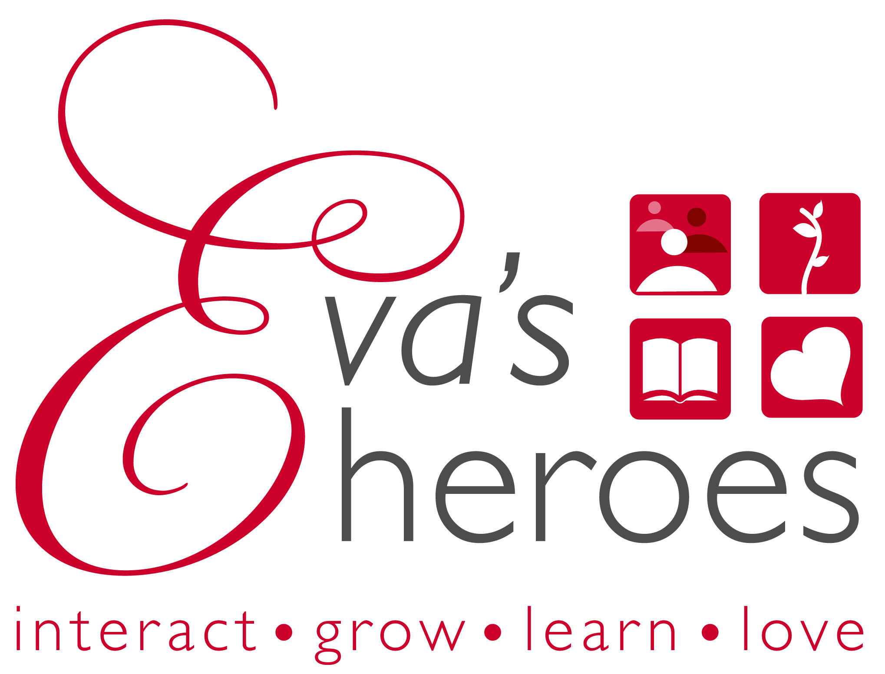
Minor Volunteer Release
Name ____________________________________ ___________________________Date_______________
Address_________________________________________________________________________________
City______________________________________________ State__________ Zip____________________
E-mail___________________________________________________________________________________
Cell Phone______________________ ________________ Home Phone______________________________
Parent/Guardian Name _____________________________________________________________________
Address(if different than minor)______________________________________________________________
City_____________________________________ State______________ Zip__________________________
E-mail___________________________________________________________________________________
Cell Phone______________________________________ Home Phone______________________________

Release and Waiver
I wish to volunteer for Eva’s Heroes. I understand that the nature of volunteer activities that I may perform in my capacity as a volunteer may involve physical activity, contact with unidentified and/or unfamiliar persons, or other potential risk of bodily injury or damage to property. Knowing this and in consideration of being allowed to volunteer, I HEREBY ASSUME FULL AND COMPLETE RESPONSIBILITY FOR ANY PERSONAL INJURY AND/OR PROPERTY DAMAGE THAT I SUSTAIN OR CAUSE DURING MY PARTICIPATION AS A VOLUNTEER. IN ADDITION, I, FOR MYSELF, MY CHILD, MY HEIRS, EXECUTORS, ADMINISTRATORS, AND ANYONE IN PRIVITY WITH ME, HEREBY RELEASE, HOLD HARMLESS AND COVENANT NOT TO FILE SUIT AGAINST THE WASHINGTON STATE APPLE BLOSSOM FESTIVAL, THE EVENT DIRECTOR, THE CITY OF WENATCHEE, ANY OF THEIR EMPLOYEES, VOLUNTEERS, PARTNERS, AGENTS, SPONSORS, BOARD MEMBERS, ASSIGNS AND SUCCESSORS FROM ANY AND ALL LOSS, LIABILITY OR CLAIMS I MAY HAVE ARISING OUT OF MY SERVICE AS A VOLUNTEER.
I will additionally permit the use of my name and pictures in broadcasts, telecasts, newspapers, brochures, etc. As a participating volunteer, I certify all information provided in this form is true and complete.

Minor Signature_________________________________________________________
Print Name_____________________________________________________________

PARENT/GUARDIAN’S RELEASE AND WAIVER FOR CHILD’S PARTICIPATION

I wish __________________(name of minor) to volunteer for Eva’s Heroes. I understand that the nature of volunteer activities that my child may perform in my child’s capacity as a volunteer may involve physical activity, contact with unidentified and/or unfamiliar persons, or other potential risk of bodily injury or damage to property. Knowing this and in consideration of my child being allowed to volunteer, I HEREBY ASSUME FULL AND COMPLETE RESPONSIBILITY FOR ANY PERSONAL INJURY AND/OR PROPERTY DAMAGE THAT MY CHILD SUSTAINS OR CAUSES DURING MY CHILD’S PARTICIPATION AS A VOLUNTEER. IN ADDITION, I, FOR MYSELF, MY CHILD, MY HEIRS, EXECUTORS, ADMINISTRATORS, AND ANYONE IN PRIVITY WITH ME, HEREBY RELEASE, HOLD HARMLESS AND COVENANT NOT TO FILE SUIT AGAINST THE WASHINGTON STATE APPLE BLOSSOM FESTIVAL, THE EVENT DIRECTOR, THE CITY OF WENATCHEE, AND ANY OF THEIR EMPLOYEES, VOLUNTEERS, PARTNERS, AGENTS, SPONSORS, BOARD MEMBERS, ASSIGNS AND SUCCESSORS FROM ANY AND ALL LOSS, LIABILITY OR CLAIMS I MAY HAVE ARISING OUT OF MY CHILD’S SERVICE AS A VOLUNTEER. I will additionally permit the use of my child’s name and pictures in broadcasts, telecasts, newspapers, brochures, etc. As a participating volunteer, I certify all information provided in this form is true and complete.

Parent/Guardian Signature _________________________________________________________________

Print Name____________________________________ Date______________________________________

