FREE Nutrition Lessons FREE
For Parents, grandparents or family members that take care of
YOUR children

Courtesy of:

Prince George’s County University of Maryland Extension
EFNEP
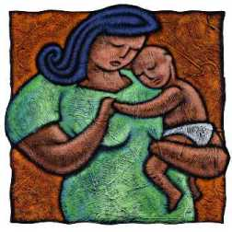

Register TODAY!

All sessions will take place in this building:

Center of Educational Partnership (CEP) in Riverdale
(6200 Sheridan Street, Riverdale, MD 20737)

We will schedule the lessons at your convenience!

For more information or to register please call Ellen at 240-838-2331

