Canstruction Orange County combines the fun of a design/build competition with an ingenious way to help feed hungry people. Local prominent architectural, engineering, construction, planning, and design firms, and students mentored by these professionals, create phenomenal structures built entirely out of canned food.

The structures go on view to the public at South Coast Plaza each year throughout the month of September in conjunction with the Festival of Children.

Judging occurs in categories such as Best Use of Labels, Structural Ingenuity, Best Meal, Jurors Favorite and Honorable Mention, and awards are presented at an annual fundraising gala which will be held at PIRCH on September 11th.

At the close of the exhibition all of the canned food used in these structures is donated to the Orange County Food Bank, for distribution to shelters, soup kitchens and other emergency feeding programs.
With over 500,000 Orange County residents who are food insecure, join us at this year’s Orange County Canstruction event and help put an end to hunger.

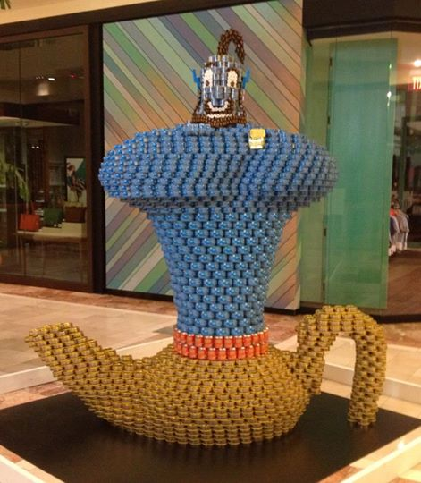
How can you help or get involved?
Donate to the Orange County Food Bank
Click Here to DONATE

Donate a raffle drawing/silent auction item to our Awards and Fundraising Event: Contact Karen Henderson, SDA
Click Here to DONATE A RAFFLE/SILENT AUCTION ITEM

Support a Team
Contact Natalie Newman, SDA
Click Here to SUPPORT A TEAM

Vote for the People’s Choice Award
(online between August 30th and September 10th)
Click Here to Vote on the CanstructionOC Facebook Page
2014 International Award Winner
KTGY Group – ‘Wish Away Hunger’
Become a Sponsor:
Click Here to BECOME A SPONSOR

For more information visit our website: www.canstructionoc.org

