97 Migratory Birds Arriving in March and April

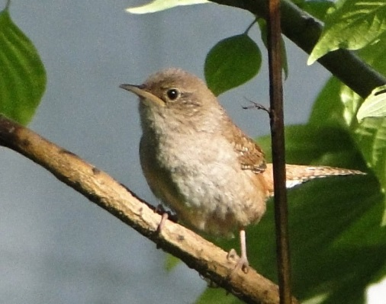
It’s that time of year again, when Vermont’s summer residents arrive and swell the populations – not just of our towns and villages - but also of our forests and fields. Here’s a list of 97 “birds of summer” that you can expect to see again in March and April:

Already Here:

- Red-winged Blackbird
- Brown-headed Cowbird

First Week of March:

- American Kestrel
- Killdeer
- American Robin
- Common Grackle

Second Week of March:

- Northern Pintail
- American Widgeon
- Turkey Vulture
- Northern Harrier
- Northern Flicker
- Eastern Bluebird
- Song Sparrow
- Rusty Blackbird

Third Week of March:

- Pied-Billed Grebe
- Great Blue Heron
- Wood Duck
- Canvasback
- Ring-necked Duck
- Greater Scaup
- Bufflehead
- Hooded Merganser
- Red-shouldered Hawk
- Belted Kingfisher
- Tree Swallow
- Eastern Meadowlark

Fourth Week of March:

- Snow Goose
- Green-winged Teal
- Blue-winged Teal
A Winter Wren Perched Among the Foliage
- Gadwall
- Lesser Scaup
- Red-breasted Merganser
- Broad-winged Hawk
- Golden Eagle
- Peregrine Falcon
- American Woodcock
- Common Snipe
- Eastern Phoebe
- Tree Swallow
- Fox Sparrow

First Week of April:

- Horned Grebe
- Double Crested Cormorant
- Northern Shoveler
- Redhead
- Oldsquaw
- Osprey
- Merlin
- Yellow-bellied Sapsucker
- Winter Wren
- Water Pipit
- Loggerhead Shrike
- Field Sparrow
- Savannah Sparrow

Second Week of April:

- Common Loon
- Red-necked Grebe
- American Bittern
- Black Scoter
- American Coot
- Greater Yellowlegs
- Ruby-crowned Kinglet
- Hermit Thrush
- Yellow-rumped Warbler
- Pine Warbler
- Palm Warbler
- Vesper Sparrow
- Swamp Sparrow
- White-throated Sparrow

Third Week of April:

- Cattle Egret
- Green-backed Heron
- Brant
- Surf Scoter
- Virginia Rail
- Sora
- Pectoral Sandpiper
- Purple Martin
- Northern Rough-winged Swallow
- Bank Swallow
- Barn Swallow
- Solitary Vireo
- Louisiana Waterthrush
- Rufous-sided Towhee

Fourth Week of April:

- Great Egret
- Green-backed Heron
- Glossy Ibis
- White Winged Scoter
- Common Moorhen
- Solitary Sandpiper
- Spotted Sandpiper
- Upland Sandpiper
- Chimney Swift
- Eastern Kingbird
- Cliff Swallow
- House Wren
- Marsh Wren
- Blue-gray Gnatcatcher
- Brown Thrasher
- Black-throated Green Warbler
- Black-and-white Warbler
- Chipping Sparrow

