Vermont State Parks are Open!
- By Jenny Montagne, Vermont State Parks
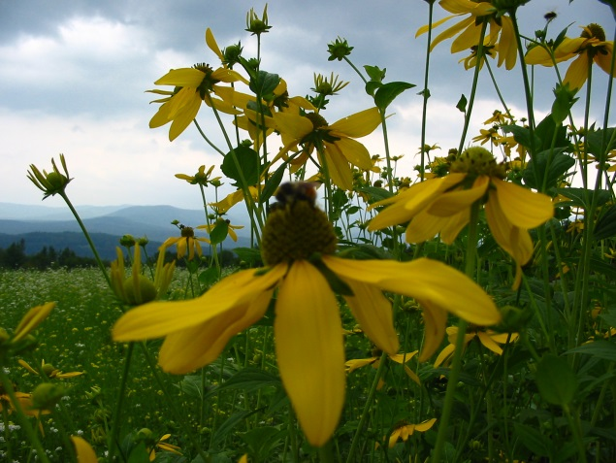
After a long winter, trees and flowers are in bloom, the weather is getting warmer, and summer is here! Throughout the spring, Vermont State Parks have been preparing for the 2014 season. Starting with Wilgus State Park on April 28 and continuing through Memorial Day Weekend, parks have been opening their gates and welcoming visitors and campers.
Vermont State Parks are located in some of the most beautiful areas of the state, and no matter where you are you are never more than 30 minutes away from a park. With views of Lake Champlain, the Adirondack and Green Mountains and Vermont’s gorgeous lakes, rivers, valleys, and state forests, there is truly a park for everyone. Visit for the day or come camp in a tent, lean-to, cabin, or cottage. Vermont State Parks offers many resources to help you get outside, hike, bike, swim, and camp all summer long.
Our Top Five Parks for Family Camping list a great tool to help you plan your next camping adventure. Elmore, Grand Isle, Half Moon Pond, Jamaica, and Stillwater State Parks are all wonderful parks for family camping, offering a variety of amenities from sandy beaches and rail trails to volleyball courts, nature programs, and concerts. Camping Tips & Tricks, found on the Vermont State Parks website, provides visitors with instructional videos, weekend itineraries, camp menus and recipes, packing checklists, and ideas for fun, family-friendly activities.
There are lots of different events and performances scheduled at the parks this summer. We will be hosting music concerts, history hikes, trail runs, art in the park days, fishing clinics, and more. Take a look at our events page to see all of the activities planned. Events are free of charge for individuals who are camping at the parks and are a fun and informative way to experience nature.
To learn about a park, ask a question, or make camping reservations, visit our website or call our reservation line at 888-409-7579.

