

**Two Congregations, One Voice**

**B’nai Israel Synagogue**

**& Temple Kol Ami**

**Family Camp Weekend**

Tamarack Camps’

Butzel Conference Center

March 21-23, 2014

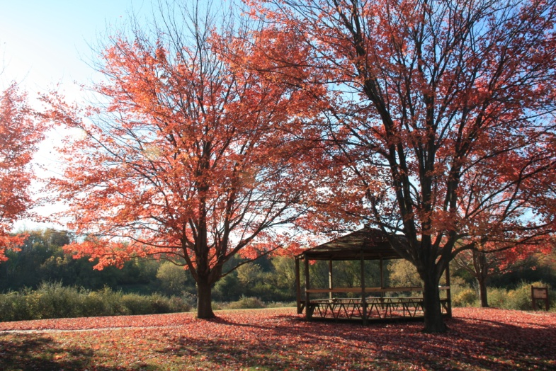

Family-friendly kosher meals, evening activities for adults, age-appropriate activities for kids, private rooms, camp fire & more!

**Priority registration, exclusively for BI and TKA members, by January 24. First come, first served. Receive $100 off your family’s registration fee!**

Contact Ilana Glazier (248-303-2212) or Melanie Gorman (248-217-4395) for more information

**REGISTRATION INFORMATION**

Family Name:

Address:

Email:

Telephone:

Adult(s):

Child(ren) Name(s) and Age(s):

Please list any special dietary needs:  
  
______________________________________________________

Please list any other special requests or needs:   
  
______________________________________________________

**Pricing Information**:*

Family of 2 ($350) Family of 3 ($450)  
Family of 4 ($525) Family of 5 ($600)  
Family of 6 ($675)   
Children 2 and under are free  
* Subtract $100 if registering and paying by January 24

Final registration deadline, based on availability, is February 28, 2014. There are no refunds after that date. Payment and registration form should be mailed to: B’nai Israel Synagogue, 5085 Walnut Lake Road; West Bloomfield, MI 48323