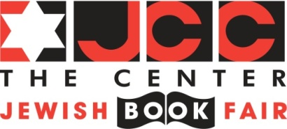
62nd Annual Jewish Book Fair
November 6-17, 2013

Book Club Night
with
Wine and Cheese Reception
“The Execution of Noa P. Singleton”
by Elizabeth L. Silver

Monday, November 11th at 7:30 p.m.
Ticketed Event
(You do not have to be a member of a book club to attend this event.)
Please tear off and return bottom portion to Book Fair Office
-------------------------------------------------------------------------------------------------------------

Name: _____________________________________________________________________________

Book Club Member: Yes No If yes, name of Book Club __________________________

Address: __________________________________________________City:_____________________

Zip: _____________ Phone: ____________________________ E-mail:_________________________

Advance Registration:

Speaker with wine & cheese reception - $20
Book Only - $20.00 (Speaker and reception not included)
Speaker and book, with wine & cheese reception - $35
Books available at the JCC in West Bloomfield
Book Fair Office
Hours: 10 a.m. to 4 p.m.

Cash: $ _________ Check #: _____________ Check Amount $: ________________________
(Please make checks payable to the JCC)

Credit Card Information

Payment type: ____VISA ____MasterCard

Name on Card: ______________________________________________________________________

Credit Card #_____________________________________________ Exp Date: ______/________

CSC (three-digit number on back of card): _________

Signature ___________________________________________________________________________

If you have any questions please let me know.

Jewish Community Center of Metro Detroit, 6600 West Maple Road, West Bloomfield, MI 48322
aroisman@jccdet.org - Phone: 248-432-5442 - Fax: 248.432.5562

