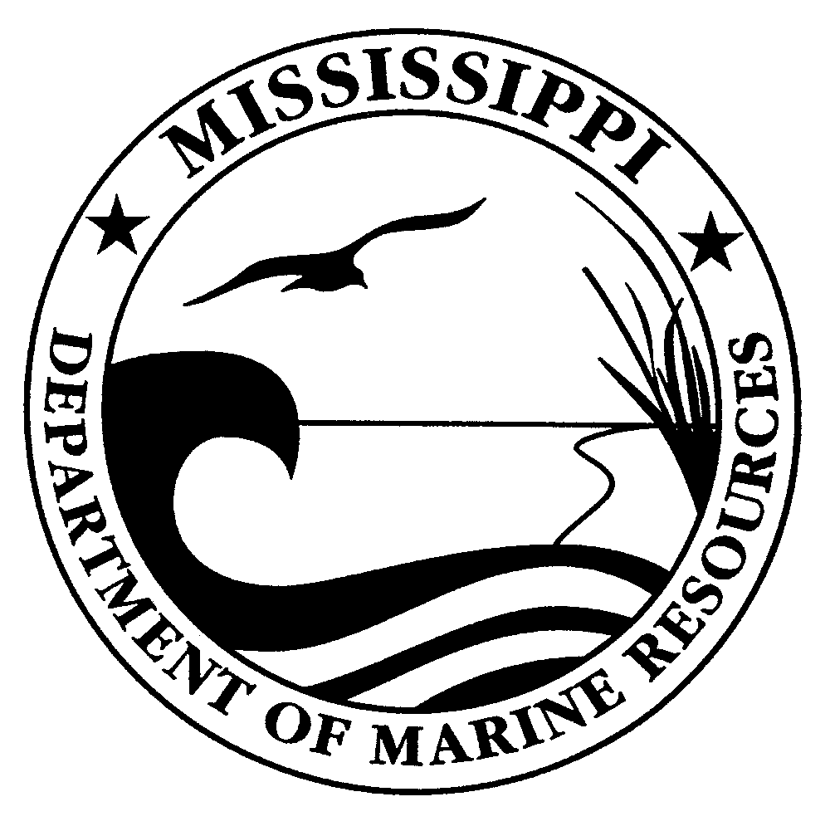
VACANCY ANNOUNCEMENT

STATE OF MISSISSIPPI

MISSISSIPPI DEPARTMENT OF MARINE RESOURCES
1141 Bayview Avenue
Biloxi, MS 39530
(228) 374-5000

March 27, 2014

The Mississippi Department of Marine Resources (MDMR) is recruiting for the position described below. ALL applications for this position must be filled out online at the Mississippi State Personnel Board’s Career Center located at www.mspb.ms.gov under the Job Seekers tab. Please enter the job title as it appears below in the Job Openings section.

Resumes are not a substitution for completing a job application. The Mississippi Department of Marine Resources does not have the authority to fill this position above the below listed annual starting salary.

POSITION: Director, Grand Bay National Estuarine Research Reserve (NERR)

POSITION TITLE / PIN#: DMR-Marine Director I / PIN 5156

ANNUAL SALARY RANGE: $57,593.08 - $100,787.97

OFFICE: Grand Bay National Estuarine Research Reserve (NERR)

LOCATION: Jackson County, Mississippi

RECRUITMENT DATES: March 27, 2014 – April 30, 2014

ESSENTIAL FUNCTIONS:

This is senior level, professional, administrative and management position involved in coordinating the operations of the Grand Bay National Estuarine Research Reserve (GBNERR) in Jackson County. The incumbent develops, administers, and manages the GBNERR’s multi-disciplinary administrative, research, monitoring, education, interpretive, outreach, training, and resource management programs. The incumbent will perform in a manner consistent with goals and objectives of the Department of Marine Resources and the Reserve Management Plan. Supervises staff and oversees the operations and maintenance of the Grand Bay Coastal Resources’ Center. The incumbent is responsible for securing fiscal and programmatic support for GBNERR operations and activities including administering multiple grants. The incumbent develops and maintains partnerships with local, state, regional and federal representatives on relevant coastal issues and promotes GBNERR programs and activities with local communities. Serves as the primary liaison between the GBNERR, MDMR and National Oceanic and Atmospheric Administration’s Coastal Office Administration.

EXPERIENCE/EDUCATIONAL REQUIREMENTS:
Education:
A Master's Degree from an accredited four-year college or university;
AND
Experience:
Seven (7) years in the special experience defined below, five (5) years of which must have included line or functional administrative or advanced technical supervision.
OR
Education:
A Bachelor's Degree from an accredited four-year college or university;
AND
Experience:
Eight (8) years in the special experience defined below, five (5) years of which must have included line or functional administrative or advanced technical supervision.
Special Experience:
Employment must have been in an administrative, professional capacity in an area of work related to the functional responsibility of the agency in which the position exists. In program areas where special certification is required, the incumbent must be certified and experienced in that profession. Work experience must have included supervising and coordinating a variety of functions.
Substitution Statement:
Above the Bachelor's Degree related to education and experience may be substituted on an equal basis, except there shall be no substitution for the special experience defined above and two (2) years of line or functional administrative or advanced supervision.

The Mississippi Department of Marine Resources is an equal opportunity employer and will fill positions without regard to race, religion, color, national origin, sex, age, marital status or handicap.

