Volunteers Make a HUGE Difference

ALearn Work Day
2000 pencils + 175 calculators + 3000 quizzes + many more materials = 45 ALearn classroom bins assembled by Deloitte and Cisco volunteers on Saturday, May 31.
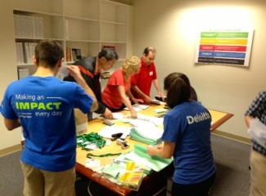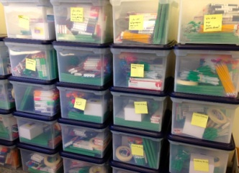

"Deloitte and Cisco volunteers are an invaluable part of this work we do for low-income students. When the teachers open these bins, with all the materials they need to start the summer program, they are going to see time and energy that volunteers have put into helping teachers be prepared," said Kathryn Hanson, CEO and founder of ALearn.

Many thanks to Gino Grilli, Katie Kobayashi, Jeff Lee Chan Kam, Sudhir Mannava, Rekha Prodduturi, Sherry Rantunga, Megumi Takeuchi, Belinda Solomon, and Jeanie Yi, Eddie Correa and Zengyuan Wang, who donated time and energy to ready the supplies for ALearn's programs.

