Volunteers Make a HUGE
Difference

Guest Speakers Visit ALearn Classrooms
ALearn students at high schools in Mt. View, Woodside, Oak Grove, Yerba Buena, Mt. Pleasant, were treated to fantastic presentations by 12 guest speakers with inspiring high school-to college-to career success stories. Microsoft XBox engineers, Nathan Slattengren and Steve Schmidt gave students a chance to get a hands-on look at a prototype:
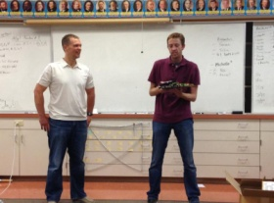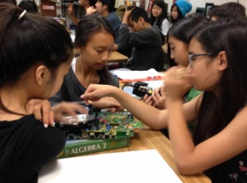
DPR project manager, Aurora Ildefonso, told students what it's like to be one of the few Latino civil engineers in Silicon Valley, building some its most notable high-tech buildings:
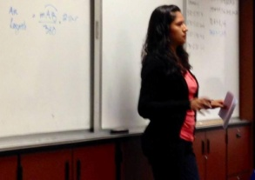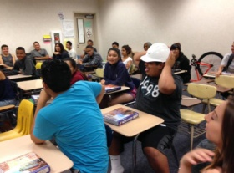
Cisco project manager, Lalitha Venkatesh shared Cisco's vision of the "Internet of Things" with examples of tele-medicine and retail virtual mirrors:
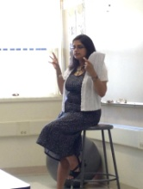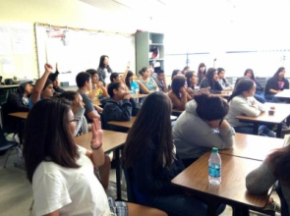
Many thanks to these volunteers for sharing their college and career stories:
Cisco:  Ricardo Benavidez  Frances Brooks  Justin Riray  Jennifer Um  Lalitha Venkatesh  DPR:  Aurora Ildefonso  Sarah Gigliotti | Microsoft:  Sharena Pari-Monasch  Steve Schmidt  Nathan Slattengren  Maxim Integrated:  Jonathan Ho  Xilinx:  Yogesh Chobe

