Math-Strong,
College-Ready

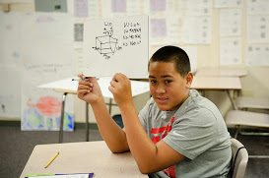
Catalyst student nails yet another Geometry problem
After an intensive 6 weeks, all of ALearn's 43 classes have just wrapped up! ALearn partnered with 10 school districts and 16 schools to bring Common Core Math and College Readiness curriculum to underserved students. In total, 21 classes of 550 6th/7th graders, and 22 classes of 513 9th graders prepared students to be math strong, and college ready!

Not only did students study Common Core Math, Algebra, Geometry, and Algebra 2, they learned about "Growth Mindset" which encourages success through perseverance and hard work. Students also took fun field trips to Stanford University, Santa Clara U, and San Jose State University.

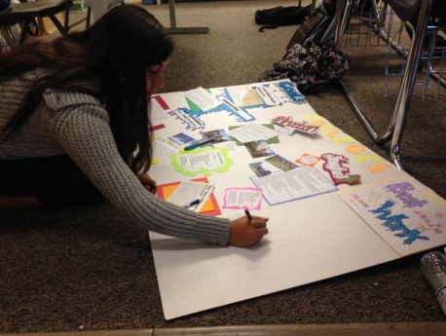
Yerba Buena student charts her path to college

New and seasoned ALearn Teachers and Teaching Assistants received excellent professional development training from the ALearn Program Team. All that hard work paid off, as Rocio Abundis-Rodriguez, Vice President of Programs, attests: "It has been exciting to see our MAP and Catalyst classes in action. Our teaching teams are phenomenal and passionate about the work they do. I have seen a lot of collaborative work in the classrooms and students teaching students. Hearing laughter and seeing smiles confirms to me the value of this work."

These End-of-Program Celebration shots show the joy the students--and their families--feel about becoming Math-Strong, College-Ready:

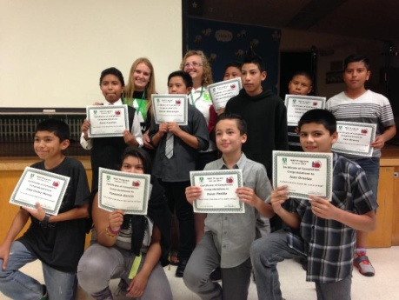
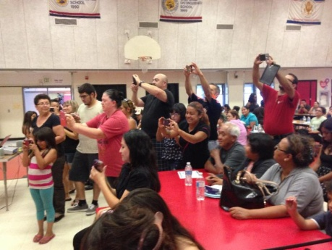
We look forward to reporting their improvement results in our fall newsletter.

