John I Malone, MD
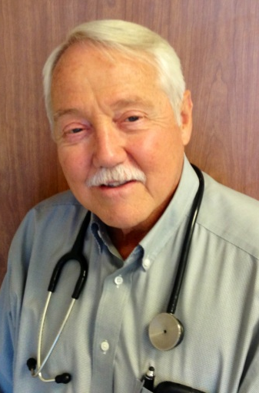
Dr. Malone received his MD degree from the University of Pennsylvania, completed a Pediatric Residency at Children’s Hospital of Philadelphia and the Hospital of the University of Pennsylvania, and a Fellowship in Inborn Errors of Metabolism at Children’s Hospital of Philadelphia. He has been certified by the American Board of Pediatrics and the American Board of Pediatric Endocrinology. He joined the full time clinical faculty of the Department of Pediatrics at the University of South Florida in June of 1972. He was active as a lecturer for the Departments of Biochemistry, Physiology, Microbiology, and Pathology for 1st and 2nd year students.
More recently he has been a regular Moderator for Clinical Problem Solving for the Med 2 class. He has received extramural funding from NIH for the longest running multicenter clinical trial for the study of type 1 diabetes mellitus (DCCT/EDIC). He has also received basic science funding to study the pathogenesis of diabetes complications from the Juvenile Diabetes Research Foundation, the American Heart Association, the American Diabetes Association and the Hoerst Marrion Rochell Foundation. Eli Lilly, Pfizer Pharmaceuticals, and Sigma Tau have also funded investigator initiated studies that have resulted in significant research observations and publications. During this period of research activity Julia Parish endowed the Medical School with an Endowment for research into the problems of childhood diabetes which helped fund some of Dr. Malone’s basic science projects related to the influence of high blood glucose upon brain development in children.
Dr. Malone also started the first Pediatric Diabetes Clinic at TGH in 1973 which with the help of Children’s Medical Services provided a multispecialty clinic that included a Nurse Educator, Dietician, Social Worker in addition to a Physician for individuals with diabetes from birth until 21 years of age. This effort with the collaboration of interested physicians at the University of Florida and the University of Miami led to the legislators of the State of Florida designating these three Universities as Centers of Diabetes Excellence with the responsibility of improving knowledge about ideal diabetes care throughout the State of Florida, with particular emphasis upon the State’s Health Departments.
Since, that time in 1980 the State has provided funding for that activity to those Universities. The activity of the University of South Florida Diabetes Center has provided a clinical environment for the education of medical students, nursing students, dieticians, social workers, psychologist, physical therapists, as well post graduate physicians and other health professionals. Dr. Malone retired from the University in December of 2010, but is now returning to continue his participation in the DCCT/EDIC Clinical observation follow-up.

