
COMMUNITY OUTREACH PROJECT
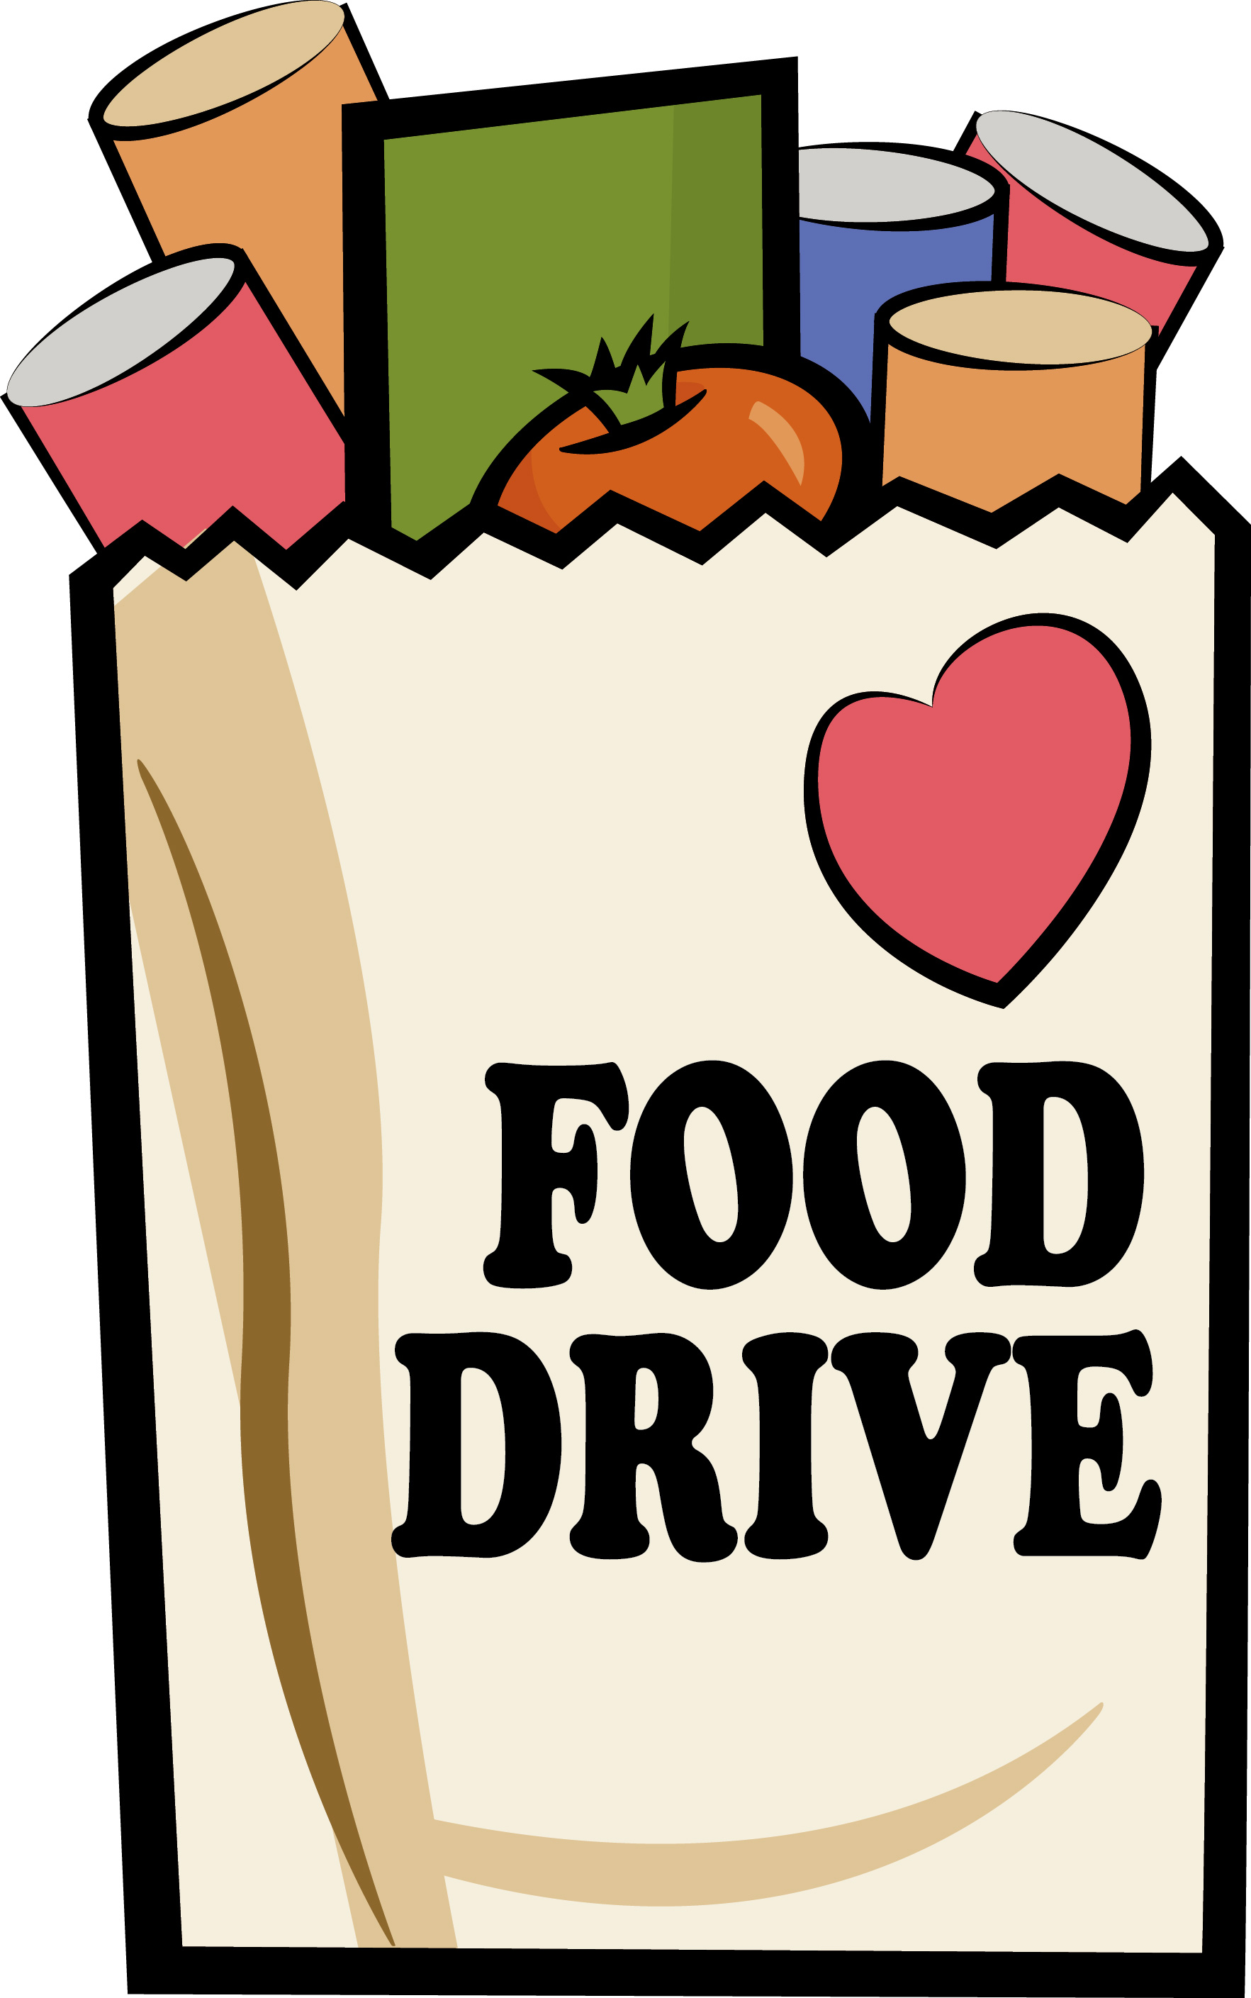
Benefiting: CALL Primrose Center
Please help Burlingame Public Schools collect the following items for our community in need this Thanksgiving. Thank you for your support!

November 17th-21st
CANNED FOODS  • Stews, chili, hearty soups  • Canned vegetables and fruits  • Tuna, canned meat  • Peanut butter and jelly  • Tomato sauce  • Spaghetti sauce  DRY FOODS  • Macaroni & Cheese  • Instant potatoes, gravy packs  • Jello and pudding mix  • Spaghetti, rice, beans  • Hot and cold cereal  • Crackers and cookies | “WALK AROUND FOOD”  • Cracker snack packs with  peanut butter, cheese or tuna  • Energy bars, granola bars  OTHER  • Deodorant, toothpaste, toothbrushes, shampoo  (large and individual sizes)  • Gallon and quart Ziplock bags, paper towels, toilet tissue, napkins

Place any item(s) in the marked bins around your school or in your classroom. Learn more about CALL-Primrose Center at www.callprimrose.org, or donate food online at www. 2ndharvest.net.

