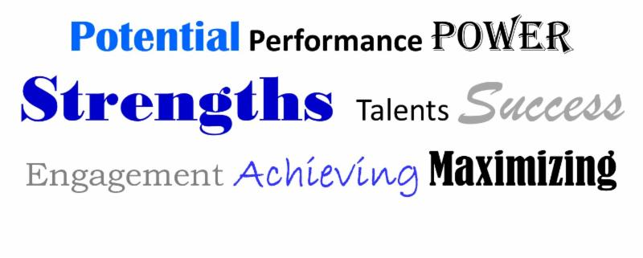
StrengthsFinder Coaching
Mpowerment Works is GALLUP StrengthsFinder trained and is offering individual and group StrengthsFinder coaching sessions for clients to understand their strengths, appreciate their talents and invest in developing themselves to improve personal and group performance. The Clifton StrengthsFinder is an effective instrument for measuring talent that has helped people excel. From top business executives and managers, to sales people, nurses, board members, teachers, students, and others, more than 10 million people have realized the benefits of leading with their strengths.

Strengths based Coaching sessions will assist you to:
- Identify your innate top talents and how to use them towards your own success.
- Understand and appreciate strengths-based development.
- Give teams a way to identify, discuss, develop, and use each person's natural potential and power.
- Help Managers and teams understand, apply, and integrate their strengths into their respective roles and develop effective strategies for improving team performance using strengths-based development.
1 on 1 Coaching Sessions  Do you ever wonder why you make certain choices?  Why you do what you do?  Why you are better at some things than others?  There is a reason. It's your talents! Strengths-based development is unique in that it build's on one's areas of greatest potential. It is based on a simple notion that our greatest talents- the ways in which we naturally think, feel, and behave represent our innate power and potential! By focusing on what is innate in you and strengthening it- lays our secret forsuccess!!  Cost: $250 pp/hour |  | Team/Group Coaching Sessions  Do you want to increase team performance and engagement at work? Do you want your staff and organization to be more productive and work better together?  Gallup studies have shown that people who use their strengths every day are 6 times more likely to be engaged on the job. Teams that focus on their strengths are 12.5% more productive. Team coaching sessions can help teams better understand each others talents and how they can work best together to accomplish their goals and performance objectives.  Cost: Based on group size
For More Information call Marisa Rivera at (703) 999-4122 or email marisa@mpowermentworks.com

