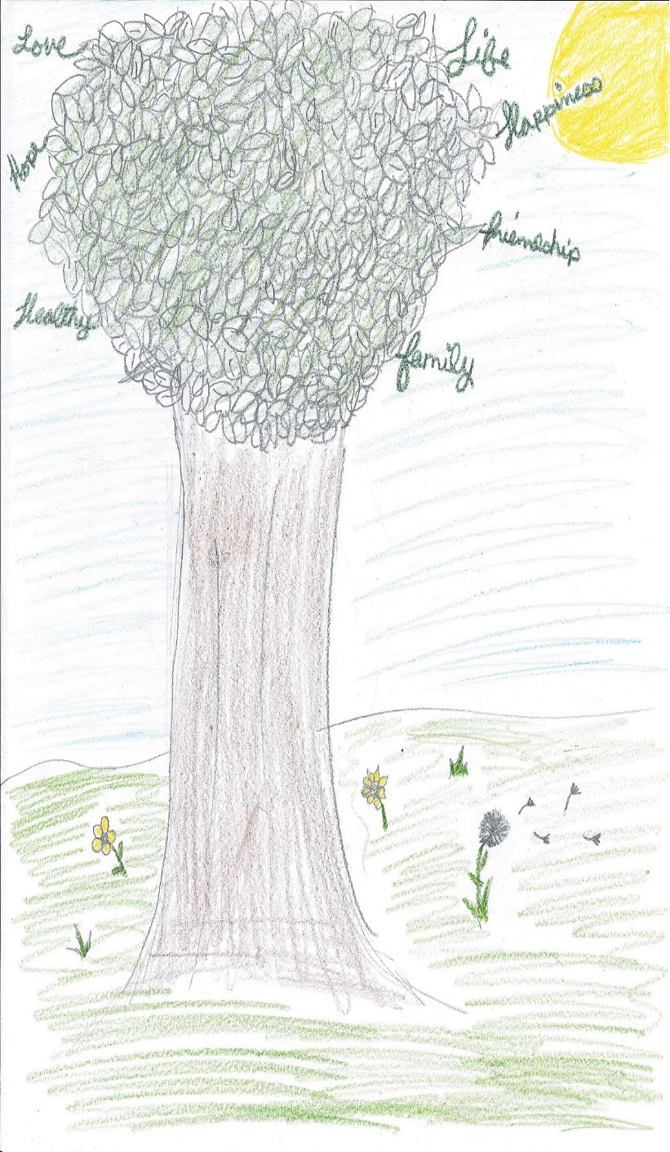

*Artwork courtesy of Tristan Hughes Finger Lakes Parent Network Youth Program*

**SAVE THIS**

**DATE!!!!**

**The Children’s**

**Mental Health**

**Coalition of**

**western new york**

**presents**

**our 18th annual conference**

With Keynote Speaker

Stephanie Orlando

Statewide Director

YOUTH POWER!



Life Transitions: A GPS for Success!

Saturday, September 20, 2014 – 9AM – 4 PM

Western New York Children’s Psychiatric Center

1010 East and West Road, West Seneca New York