Join YOUTH POWER! For our Annual Youth Forum
YOUTH POWER!
2014 Youth forum
Join us
Meet new Friends, Group Discussions, and Advocacy Talk, Story Sharing
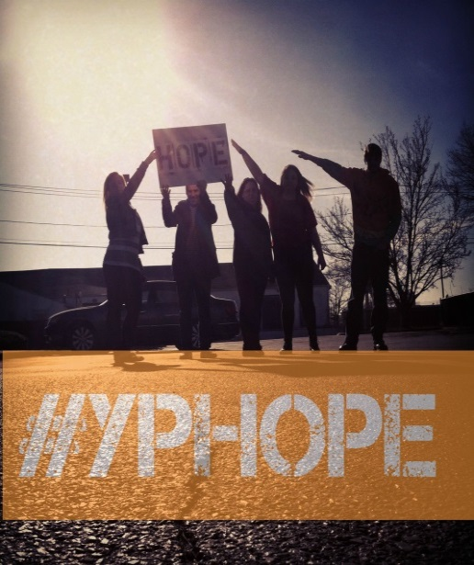
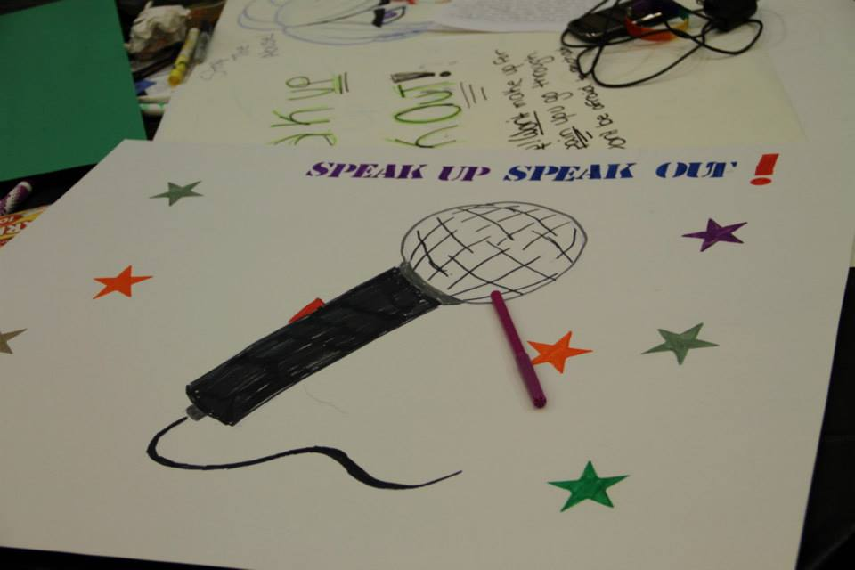
June 27, 2014
Meet us at the Wyandanch Ambulance Corp : 295 Merritt Avenue, Wyandanch, NY 11798
Doors open at 4:00pm Art / Creative Hope Photo Session: Come early and make “Stay Strong Cards” with us. (Empowerment cards for young people in psychiatric hospitals and residential placements). Take creative pictures that symbolize Hope &Recovery
Event begins at 5:00pm
This is a FREE event and is open to Nassau and Suffolk Counties. Space is limited.
Please RSVP no later than June 23rd
YOUTH POWER! is a statewide advocacy network for young people who are passionate about making change in the various child serving systems such as Disabilities, Foster Care , Special Education, etc. “We believe in peer support and youth involvement.
Contact Person: Desiree Moore, YOUTH POWER!’S Long Island Regional Youth Partner (631)245-5289. Dmoore@youthpowerny.org

This is a FREE event but space is limited please RSVP with Desiree Moore, Long Island Regional Youth Partner

Art/Hope photo Session
Show off your talent: Karaoke & Talent Showcase

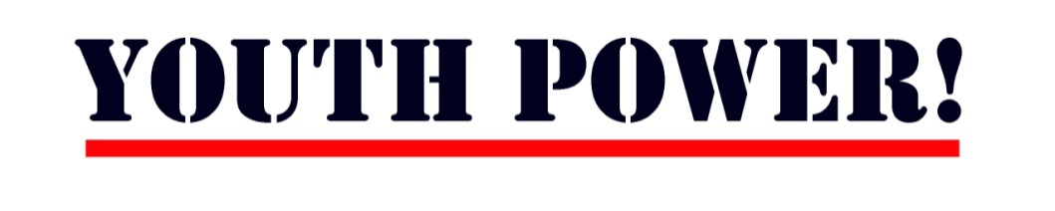

Return By: June 23rd, 2014
Desiree Moore Phone: (631) 245-5289 Fax: 631-264-0762 Email: dmoore@youthpowerny.org

Name: | Title:
Organization:
Address:
Street | apt #
City | State Zip
Phone: | Email:
Emergency contact: | Relationship:
Phone #: | Cell phone #:
Food, medications, allergies, etc that presenters should know about:

Media Release Form (optional)

I, ____________________________,(print your full name) hereby agree to appear in audio, video or print media for public relations, advertising, web development, commercial productions, documentaries, educational broadcast presentations, as well as any other forum to the benefit of YOUTH POWER! and Families Together in NYS.

I understand that YOUTH POWER! and Families Together in NYS will have ownership of all recorded materials and I agree that YOUTH POWER! and Families Together in NYS may use my image and voice in any manner. I understand and agree that YOUTH POWER! and Families Together in NYS has the right to reproduce and distribute these materials and that I will not receive any form of compensation.

Participant’s Signature: ________________________________________ Date: _______________
Guardian’s Signature (If under18 yrs old): ____________________________________________
Guardian’s Printed Name ______________________________________Date: _______________

Code of Conduct

I will help to create a youth peer community based on mutual respect and a sense of personal wellbeing. I will treat others with honor and respect because that is how I wish to be treated.

I have read the following rules, designed to promote the health and safety of all people attending the event. I have indicated my complete acceptance by my signing this form. If I am not a legal independent adult my parent/guardian has signed this form as well.

- I will attend and participate fully in the entire event, unless otherwise agreed upon with the YP! and event leaders.
- I will arrive on time, stay until the end, and remain on the event premises at all times.
- I will not participate in any activities that could be deemed as hazing, sexually harassing, demeaning, or hurtful.
- I agree to refrain from sexual behavior and public displays of affection while attending the YP! event.
- I will not bring or use any weapons, firearms, or anything that may be construed as a weapon.
- I will not possess, consume, or distribute alcoholic beverages, even if I am of legal drinking age.
- I will not possess, use, or distribute any illegal drug or drug paraphernalia.
- I will not commit any illegal act. I understand that vandalism, disturbing the peace, or other inappropriate behavior as determined by the YP! leadership in accordance with the youth leadership will not be tolerated. I understand that I will have to pay for any damage that I cause.
- I understand that no gambling is allowed, except for fundraisers approved by the YP! leadership.
- I understand that no guests are allowed unless the YP! leadership grants permission in advance, and that any unauthorized guests will be asked to leave immediately.
- If I take medications I will take responsibility in bringing needed medications and supplies to the event, and in following my medication regimen.
- I agree to abide by any additional rules, pertinent to a specific event, which may be announced, and to accept the consequences of their violation.
- I am willfully attending this event and acknowledge that YP! does not allow young people to be forced to attend their events.

I understand that these rules apply from the time I leave home for the event, during the event itself, and until I return home after the event.

Young Person’s Signature: ______________________________________________________________

Printed Name: _________________________________________ Date: _________________________

I understand that part of the YP! experience involves empowerment activities that may be new to the young person. These things come with certain risks and uncertainties beyond what the young person may be used to dealing with at home. I am aware of these risks, and I am assuming them on behalf of this young person. I realize that no environment is risk free and so I have instructed the young person on the importance of abiding by the YP! Code of Conduct. The young person and I both agree that he or she is familiar with these rules and will obey them. We understand that the young person must be willing to attend the event and that YP! will not make exceptions or tolerate force. We further understand that violation of the code and our force policy could include immediate expulsion from the event, at the expense of the parent or guardian.

Parent/Guardian’s Signature: _______________________________________________________

Printed Name: _________________________________________ Date: _________________________

