Save the date!

Estes Park
5th Annual Early Childhood Education Conference

Saturday April 19, 2014; 8:30am – 4:00 pm
5 hours of training credit!

- Multiple presenters
- Breakout sessions
- Lunch included
- Door prizes

Escape for a day to the beautiful
YMCA of the Rockies!

For all early childhood professionals:
Preschool and Center Staff, Teachers, Directors, Family Child Care Providers,
Early Intervention Specialists, and Administrators.
$10 for Estes Park participants
$40 for out-of-town attendees

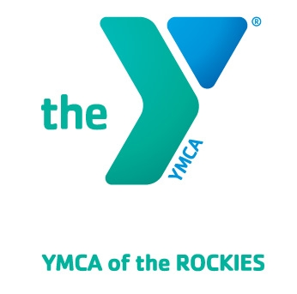
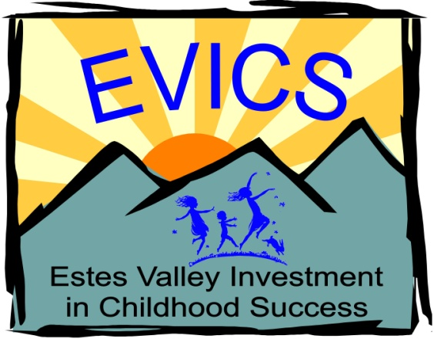
For more info:
office@evics.org Watch for
970.586.3055 registration details…
coming soon!

