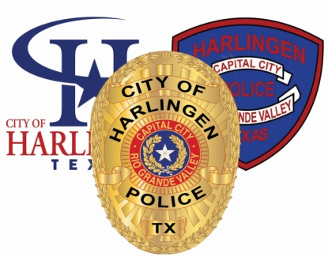
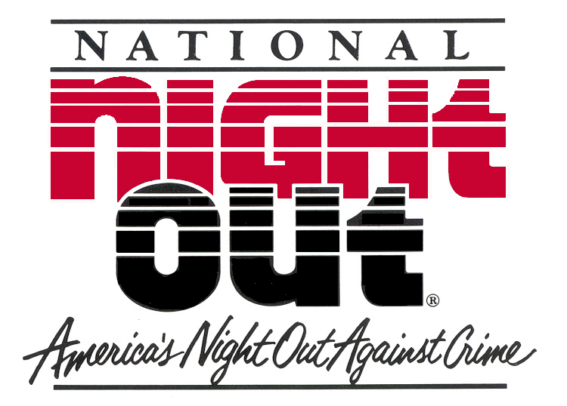

31st Anniversary

HARLINGEN PARTNERSHIPS WORKING TOGETHER

August 5, 2014
PARTNER PACKET

PRESENTED
BY

HARLINGEN POLICE DEPARTMENT
SPECIAL SERVICES UNIT
1018 Fair Park Blvd
HARLINGEN, TEXAS 78550
(956) 216-5527

31st Anniversary

HARLINGEN PARTNERSHIPS WORKING TOGETHER

Welcome to our NATIONAL NIGHT OUT 2014 celebration!

We thank you for your support of our local crime prevention and awareness campaign. We sincerely hope your participation will be most enjoyable and rewarding!

This year’s celebration theme is “Harlingen Police Officers and Citizens……”

- 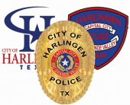

Please support this year’s celebration theme through your active participation in event promotions, theme wearable, and booth decoration contest. We encourage your creativity and design in helping us promote this year’s theme. “X” will be at the forefront of our presentations.

Your Partner Packet contains important information regarding Harlingen Police Department National Night Out 2014.

Please review the material carefully. If you have questions or need further assistance, please let us know.

We look forward to serving you as we build better police-community partnerships!

Sincerely,

Special Services Unit

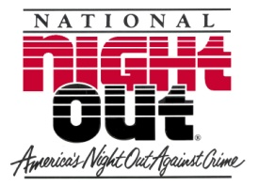
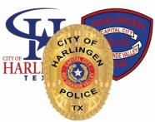 2014
HARLINGEN PARTNERSHIPS WORKING TOGETHER

IF YOU NEED ASSISTANCE, WE ARE HERE TO HELP!

HPD SPECIAL SERVICES UNIT
CDR. Miryam Anderson – Coordinator
(956) 216-5493

EVENT OPERATIONS
OFFICER ORLANDO GONZALES / OFFICER SERGIO RUIZ
(956) 244-2482 / (956)202-5175
On-site overall operations, event registration, guest relations, volunteer staffing, event security detail, first aid services and event design & set-up

EQUIPMENT/ ENTERTAINMENT
OFFICER JC GARCIA / OFFICER SGT. ALFREDO ALVEAR
(956) 367-5848/ (956) 535-8517
Overall equipment, electrical, event lighting, mechanical set-up, park grounds & utilities, live bands, recorded music DJ services, stage security & access, programming

FOOD, GENERAL SERVICES AND SANITATION
OFFICER JOE MARTINEZ (956) 245-7267
Food service and preparation, beverages, picnic area access, food vendor certificates, sanitation, stocking and general services (event staff needs)

CHILDREN GAMES/ PARKING
OFFICER HECTOR VILLEGAS
(956) 367-1545
Children’s games coordination, public parking, special needs parking, shipping and receiving

POLICE EDUCATION ACTIVITIES
Officer SALVADOR CARMONA
(956) 202-2722
HPD tent, Explorer literature, CPA/VIP Literature, Police Services Literature

2014

HARLINGEN PARTNERSHIPS WORKING TOGETHER
EVENT INFORMATION, RULES, & GUIDELINES

The following event information, rules, & guidelines are provided to help ensure a safe and effective police-community event. Harlingen National Night Out 2014 is sponsored by the Harlingen Police Department and is under the direction of the Special Services Unit in association with the Office of the Chief.

REGISTRATION

- All event volunteer groups, community / business partners, and special presenters MUST complete an official event registration form prior to participating in Harlingen Police Department National Night Out 2014. The deadline to register is July 31st 2014. Registration forms are available by calling

(956) 244-2482 , (956)202-5175,OR (956) 216-5433

- There is no registration fee. Simply complete an official event registration form and return it to EVENT OPERATIONS prior to registration deadline of July 31st 2014.

- Group contact persons shall be responsible for their group members’ actions and conduct during event. All registered event participants shall reflect the attitude of police – community partnerships and strive to further this idea through positive, responsible participation in Harlingen National Night Out 2014!

BOOTHS, FOOD DISTRIBUTION, PERMITS

- Spaces are limited on a “first come – first served” basis. Review the included map layout and select your location. Indicate the number of the location you selected in your registration form. Due to an overwhelming request from businesses/organizations to display their own tent to better advertise their business, this year we are requesting businesses/ organizations to bring their own tent, table, and chairs. This will also allow everybody to expand in the area of creativity.

- Partners, you are strongly encouraged to organize an inter-active booth to better connect with our community. Based on past events we have noticed these types of booths attract more participants. Interaction can be in the form of face painting, fishing out-of –the-water games, bouncers, and /or physical and brain games. .

- Partners will set up their area on Monday August 4TH beginning at 12:00 p.m. through Tuesday August 5th ending at 2:00 p.m. The Harlingen Police will provide you with a Crime Prevention tip poster to be displayed by your organization. Overnight security will be provided by the Harlingen Police.

- If providing ANY prepared/packaged food/drink items for public consumption, please indicate on Official Event Registration Form. This includes wrapped candy, baked goods, food samples, fruit drinks, popcorn, cotton candy, hotdogs, cookies, fruit, etc. Special Note: No Temporary Food Permits are necessary for this year’s event however, food handling ordinances will apply! Please check with EVENT FOOD & SANITATION for ordinance details at (956) 245-7267.

- No sale of ANY items, products or services shall be allowed at event. All awards, prizes, gifts, promotions, and give-aways shall be provided to the event public “absolutely free of charge.” Promotions, products, and/or services requiring off-site applications, processing, solicitations, demonstrations, and/or other requirements may be acceptable during event with prior approval by HPD. Questions? Contact EVENT OPERATIONS.

- All booth operators shall provide a sample of all written, printed, copied and/or otherwise published material being distributed at event. All booth promotional items i.e.: logo bracelets, toys, jewelry, wearables, bumper stickers, pens, etc. must be approved by HPD prior to event distribution.

- Published materials must provide anti-crime slogans, drug prevention and awareness information, and/or crime prevention tips supporting the Harlingen Police Department’s crime prevention efforts. Ideas are available at HPD. For more information, contact EVENT OPERATIONS prior to event date.

- All booth decorations MUST be pre-approved by HPD EVENT OPERATIONS. It is the sole responsibility of group contact person(s) to receive HPD approval for booth promotional decorations, slogans, banners, highlights, etc. prior to event date. All booths must display HPD-issued Crime Prevention poster in front.

- No alcoholic beverages shall be allowed on event grounds during event. Promotions of alcoholic beverages including wearable slogans, images or depictions shall NOT be allowed on event grounds by any registered event participant, group member, booth operator and/or event volunteer during event.

- Group contact person(s) shall be responsible for ALL persons entering and/or “working” within group contact person’s assigned booth and/or event structure. Person(s) entering any booth and/or event structure will be considered booth volunteer(s) and/or booth operator(s).

- Food handling ordinances shall apply to all booth volunteers and operators and are subject to inspection(s) by Health Department personnel in accordance to ordinance regulations.

- Food booth operators are responsible for providing food preparation equipment, sanitary utensils, power cords, etc. Electric power extension cords should be a “minimum” of 100 feet in length.

- Power outlets are very limited on park grounds. Self-powered electric generators are recommended.

- HPD rented park attractions, powered-mechanical children games and rides, public safety features, and audio entertainment shall receive priority use of electrical power outlets throughout park grounds!

- Space locations shall be pre-marked by EVENT OPERATIONS. PLEASE: Do not move or otherwise exchange booth or structure locations without prior approval from EVENT OPERATIONS.

PARKING

- General public parking is available in designated areas and will be free of charge.

- Motor vehicles will NOT be allowed within event park grounds except during set up. All vehicles must be removed by 2:00 p.m. on Tuesday. Measures will be taken to remove unauthorized vehicles left on the park grounds after 2:00 p.m.

- Special needs parking will be available in designated areas. Questions? Contact 367-1545.

SANITATION

- Several portable restrooms will be available throughout park grounds. Handicap-accessible restrooms will also be available.

- Trash receptacles will be located throughout park grounds. Please help maintain event park grounds clean before, during, and after event.

- Each booth operator is responsible for trash located around and inside their tent/booth. Upon completion of the event, each partner area should look the way it did prior to set up.….let’s keep Harlingen Beautiful!

- Water faucets will be available throughout park grounds under limited use.

SECURITY

- Harlingen Police Department will be in charge of all event security. This uniformed unit will be strictly law enforcement, police emergency services, and public safety. Applicable local, state, and federal laws will be enforced. Violators may be subject to arrest.

- If you need police emergency services during the event, please contact any uniformed officer on the grounds.

- Emergency Medical Services will also be available during event.

LOST & FOUND

- LOST & FOUND will be located at the EVENT OPERATIONS gazebo. All found property should be deposited at this booth. Any unclaimed property will be stored at:
Harlingen Police Department
SUPPORT SERVICES DIVISION
1018 Fair Park Blvd.
Harlingen, Texas
956 216-5493

- If you should encounter a “lost child” or a “special needs person”, please escort the child or person to the Lost & Found booth. HPD officers will help reunite the lost child/person with their loved ones.

GAMES, RIDES & ATTRACTIONS

- Games, rides and attractions are provided free of charge.

- All games, rides and attractions are operated by event volunteer staff.

LIVE BANDS & ENTERTAINMENT

- Officers assigned to ENTERTAINMENT will be in charge of stage and event programming.

- Stage access shall be limited to scheduled performers and guest speakers.

- Security will be enforced. Public Service Announcements will be allowed into scheduled programming. Other announcements will be reviewed by EVENT ENTERTAINMENT for broadcast consideration.

- All live bands, performers, guest speakers, and entertainers SHALL adhere to event programming.

- No sexually explicit, vulgar, obscene or otherwise offensive language and/or offensive gestures shall be allowed at Harlingen National Night Out 2014.
Violators shall be subject to removal from event grounds and/or subject to arrest
pursuant local, state and federal laws.

- Event participants including volunteers, performers, and guest entertainers shall not be allowed to display, promote or distribute printed materials, posted images and/or wearables depicting sexually explicit, vulgar, obscene or otherwise offensive material at Harlingen National Night Out 2014. Interpretation of content SHALL be exclusively at the discretion of HPD administration and the overall project interest of Harlingen National Night Out 2014. Violators shall be subject to removal from event grounds and/or subject to arrest pursuant local, state and federal laws.

- No audience participation allowed on stage unless authorized by Officers in charge of ENTERTAINMENT.

GENERAL SERVICES

- The Harlingen Police Department will provide drinking water stations for all during event.

- The Harlingen Police will prepare hot dogs for the general public at NO CHARGE.

- Emergency Medical Services will be located at this year’s event to handle minor first aid needs.

- Please take time to visit the many booths and site features available at this year’s Harlingen National Night Out 2014. Refer to your “Partner Packet Site Map” for an overview of event site and features. Site maps also available at EVENT OPERATIONS.

- Event times are 6:00 p.m. to 10:00 p.m. Please make necessary plans and preparations to provide sufficient supplies, food items, literature, prizes, giveaways, games etc. for event visitors.

This year marks the 31ST Anniversary of National Night Out!
Thank you for joining America’s Night Out Against Crime!
The men and women of the Harlingen Police Department appreciate your help and support in making our local event a great success!

HARLINGEN PARTNERSHIPS WORKING TOGETHER

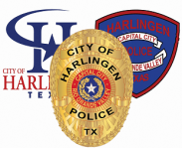 “Harlingen Police Officers and Citizens….”

Join Neighborhood Watch today!
Call HPD Special Services 216-5401

