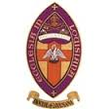The Roots of Anglicanism
For the Episcopal Diocese of Louisiana

An Exploration of our Anglican History, Heritage and
Historic sites in England

With Bishop Morris Thompson & Deacon Mark Hudson

April 10th – April 20th, 2015

Our trip will begin with a
overnight flights from New Orleans to London on Friday
April 10th.

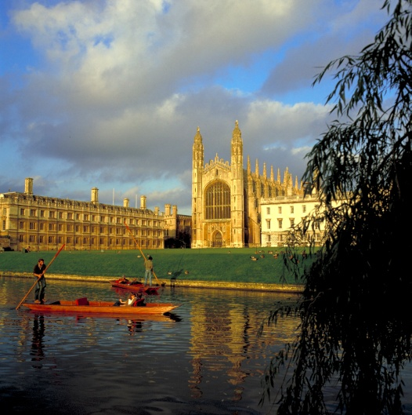

Upon arrival in England, we will begin an historic 10-day/9 night journey to the significant sites of Anglicanism, and the roots of our own Episcopal Church, in England–London, Winchester, Canterbury, Cambridge, Durham, and York, as well as to other historical sites along the way. We will enjoy many private tours of great cathedrals, churches and sites, experiencing different forms of worship (from Evensong, to the Eucharist, to prayer services) in these amazing places, often with special seating. We will hear some of the great choirs of England and hear some of the grandest organs of the world played by the musicians who know them best. Guides and guest speakers, with particular expertise in the places we visit and in church history, will guide us through this extraordinary experience. You are invited to join us for this unique opportunity to explore our common Anglican heritage!

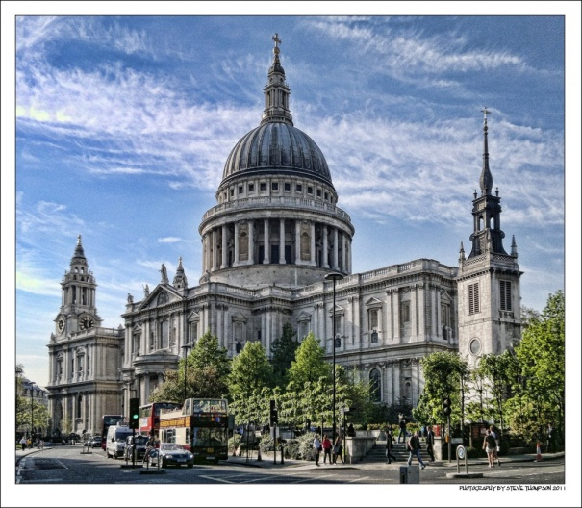

What’s the cost, and what’s included?
$6250 per person, double occupancy
Single Supplement (subject to availability): $800

- Roundtrip Economy air on Delta/Virgin Atlantic*
- 4 Star or equivalent hotels in London (7) and York (2), based on double occupancy. (Single occupancy available at single supplement rate above).
- Full English breakfast daily and most lunches and dinners while in England. Gratuities included.
- Luggage handling for 1 bag per person in England plus separate luggage transportation London-York-London (for overnight rail excursion).
- Private motor coach transportation throughout.
- Tour hosting at transfer and accommodation points to provide assistance.
- Private Blue Badge guide to accompany and guide all planned excursions. Local guides, as per location requirements.
- Excursions to major itinerary sites (Winchester, Canterbury, London, Cambridge, Durham and York/Fountains Abbey).
- First Class rail (London-Durham and York-London) with meals on board).
- Entrance fees, tours, talks/lectures, and attendance at Anglican services in major locations.
- Gala London farewell dinner.
- Private champagne “flight” on the London Eye prior to gala farewell dinner.

- * Final itinerary arrangements subject to airline schedules. Upgrades to Virgin Atlantic’s Premium Economy or Upper Class may be available at additional cost, subject to airline availability.

SPACE IS LIMITED!!

Please complete and return the attached registration form with your deposit to:
Pinnacle Travel Services
Attn: Pintrav
390 N. Sepulveda Blvd, Suite 3100,
El Segundo CA 90245

Deposit: October 15th - $500 ($250 refundable until December 15th)
First payment: December 15th (50% of balance)
Final payment: January 31st (remainder of balance)

Trip Cancellation/ Travel Insurance is strongly recommended – please contact
Pinnacle Travel Services at (888) 896-3636 or edla@pintrav.com for information

Travel Arrangements coordinated by:

