Milestones 2015 Individual Awards Nomination Form
Deadline: January 15, 2015
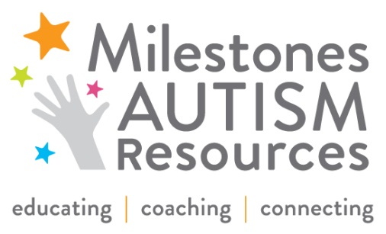

Milestones Autism Resources annually awards parents, professionals, and teens who have gone above and beyond the call of duty in serving others. Awards are presented at our annual June Conference.
Please feel free to nominate an individual you think is deserving of one of the following awards:
____ Community Innovator Award For an individual who has made a profound impact on the community at large
by creating innovative services or products that benefit those with special needs

____ Outstanding Educator Award For an exemplary educator who has designed exceptional programming or
Instruction for students with special needs

____ Parent Tribute Award For a parent who has gone above and beyond their own child, such as
developing resources or services

____ Personal Achievement Award For a person with autism who has achieved individual excellence in
accomplishing a personal goal or milestone (no age requirement)

____ Professional Excellence Award For a professional who has extended her or himself to make a difference
in the lives of children and families

____ Teen Trailblazer Award For a teen who has been a role model and inspiration to others in the community

Person You Are Nominating: ___________________________________________________________________

Nominee’s Title, Affiliation & Credentials: ________________________________________________________

Email: _____________________________________ Phone: ___________________________________

Your Name: ________________________________ Connection to Nominee: _____________________

Your Title, Affiliation & Credentials: _____________________________________________________________

Email: _____________________________________ Phone: ___________________________________

The following questions will guide the selection process. Please answer completely and provide specific examples about the person you are nominating. You can use additional space as needed.

Why do you feel this person deserves to be recognized?

What has this person done within a school, community or organization to support individuals with special needs?

Please submit completed form to Leslie Rotsky at lrotsky@milestones.org or by fax to 216.464.7602. Thank you!

