

**S.CHOOL**

**S.ECURITY**

**C.OMPETITIVE**

**G.RANT**

**P.ROGRAM**

**Application Package for:**

**Non-Public Schools**



**State of Connecticut**

**Department of Emergency Services and Public Protection**

Division of Emergency Management and Homeland Security

**Due: On or before Monday, September 15, 2014**

TABLE OF CONTENTS

1. Introduction and Program Summary3
2. Instructions to Applicants5
3. Applicant Information and Data Sheet7

District Breakdown (list of schools applying for) 8

1. Program Narrative 9
2. Instructions for the Project Budget(s)10
3. Emergency Plan Sign Off ………11
4. Allowable Project Expenses12
5. Prohibited Expenses13
6. Decision Matrix.……………………………………………………………………………………….13
7. NCEF Safe Schools Facilities Checklist (selected questions from Checklist) 13

Completion Checklist

Section C (page 1): Application Information and Data sheet

Section C (page 2): Signed District Breakdown (list the schools you are applying for under this grant)

Section D: Program Narrative

Section E: Budget form (completed for each school) **A Separate File named “**[**Budget Tool**](http://www.ct.gov/demhs/lib/demhs/school_security/2014/budget_tool.xlsx)**”**

Section F. Emergency Plan Sign Off

Section J: Safe School Checklist - *portion of NCEF Safe Schools Facility Checklist* (complete for each school applying for under this grant) – requires signatures **Separate File named “**[**NCEF Checklist Tool**](http://www.ct.gov/demhs/lib/demhs/school_security/2014/ncef_checklist_tool.xlsx)**”**

Please submit all documents listed above electronically to [schoolsecuritygrant@ct.gov](mailto:schoolsecuritygrant@ct.gov) and by hardcopy with original signatures to DESPP/DEMHS on or before September 15, 2014 at 4:00 pm. If hand carried it must be received at 1111 Country Club Road, Middletown, CT by 4:00 pm. Postmarked by that date is also acceptable.

Section A. Introduction and Program Summary

Public Act 14-98 establishes funding for a second round of competitive state grants for State Fiscal Years ending June 30, 2013 to June 30, 2015 inclusive to improve security infrastructure in schools.

**Program Highlights:**

* Ten percent of funds available under this program shall be awarded to eligible Non-Public Schools.
* Ninety percent of funds available under this program shall be awarded to eligible Public School Applicants which include: public schools, Regional Educational Service Centers, State Charter Schools, the State Department of Education (SDE) on behalf of Technical High Schools, and Incorporated or endowed high schools or academies approved by SDE pursuant to section 10-34 of the general statutes.
* This Grant Program is a Reimbursement Grant Program.
* Eligible expenses can be incurred on or after January 1, 2013. The period of performance for subgrants ends on June 30, 2015.
* Eligible Applicants and Match requirements:

Supervisory Agent of a non-public School: 50% match requirement.

* Eligible expenses include but are not limited to: installation of surveillance cameras, penetration resistant vestibules, ballistic glass, solid core doors, double door access, computer controlled electronic locks, entry door buzzer systems, scan card systems, panic alarms, or systems, real time interoperable communications and multimedia sharing infrastructure, and the training of school personnel in the operation and maintenance of the security infrastructure of school buildings. In addition, the purchase of portable entrance security devices, including but not limited to metal detector wands and screening machines and related training (training on equipment purchased/installed under this program.
* Decisions on allowability will be made in accordance with the school safety infrastructure standards contained in the **Report of the School Infrastructure Safety** **Council dated June 27, 2014.** These standards can be found at <http://das.ct.gov/images/5510/Security%20Report%20June27.pdf>.
* If there are insufficient funds to cover grants to all non-public schools, priority shall be given to schools with the greatest need for security infrastructure based on the school building security assessments of the schools. The assessment, utilizing a portion of the National Clearinghouse for Educational Facilities’ (NCEF) Safe Schools (Section J) Facilities Check List shall be conducted under the supervision of the local law enforcement agency.

**Prior to receiving a reimbursement under this grant, the eligible applicant must show that it:**

1. Has conducted a uniform security assessment of its school security, including any security infrastructure, using the National Clearinghouse for Educational Facilities’ Safe Schools Facilities Check List; The full assessment must be filled out and submitted for each school and that receives funding under the grant.
2. Has in place a Security and Safety Plan for the schools under its jurisdiction and periodically practices the Security and Safety Plan. A plan must be in place for each school that receives funding under the grant prior.

The security assessment must be conducted under the supervision of the district’s local law enforcement agency and use the Safe Schools Facilities Check List published by the National Clearinghouse for Educational Facilities. The full checklist is available on the DESPP/DEMHS website at [www.ct.gov/demhs](http://www.ct.gov/demhs) and [www.sde.ct.gov](http://www.sde.ct.gov).

***PROGRAM POINT OF CONTACT:***

Please direct all questions to the Grant Unit at the Department of Emergency Services and Public Protection’s Division of Emergency Management and Homeland Security. You may reach us by email at [schoolsecuritygrant@ct.gov](mailto:schoolsecuritygrant@ct.gov) .

***IMPORTANT DATE:***

**A completed application consists of:**

* Section C: completed Application Information and Data Sheet (page 1 of 2).
* Section C: completed and signed District Breakdown sheet (lists all the schools applied for under the grant), (page 2 of 2).
* Section D: Program Narrative Form (one form containing information on all schools applied for under the grant).
* Section E: Separate budget for each school applied for under the grant - **Separate File named “**[**Budget Tool**](http://www.ct.gov/demhs/lib/demhs/school_security/2014/budget_tool.xlsx)**”**
* Section J: Completed and signed security assessment questions for each school applied for under this grant program *(these are a select group of questions from the Safe Schools Facility Checklist published by the National Clearinghouse for Educational Facilities).* The full checklist must be completed before reimbursement is made. **Separate File named “**[**NCEF Checklist Tool**](http://www.ct.gov/demhs/lib/demhs/school_security/2014/ncef_checklist_tool.xlsx)**”**

**NOTE:** The items listed above must be submitted **electronically** to DESPP/DEMHS ([schoolsecuritygrant@ct.gov](mailto:schoolsecuritygrant@ct.gov) ) by **Monday, September 15, 2014 at 4:00pm.**

When submitting electronic applications and attachments to the school security email address - enter the entity applying for the grant in the subject line.

***Example: “Pleasantville” School Security Application***

**Signed original copies** must also be mailed or delivered to DESPP:

**Department of Emergency Services and Public Protection**

**Division Emergency Management and Homeland Security**

**Attention: Grants Unit/School Security**

**1111 Country Club Road, 3rd floor North**

**Middletown , CT 06457**

Application Due Date: On or before **Monday, September 15, 2014.** Please note if the application is dropped off, it must be received before 4:00 pm on Monday, September 15, 2014. Applications postmarked on or before September 15th will be accepted.

SECTION B. INSTRUCTIONS TO APPLICANTS

Below are instructions for filling out each of the forms contained in this grant application kit. Please fill out these forms completely and accurately. If you need assistance filling out this kit, please contact the DESPP/DEMHS Grant Unit by email at [schoolsecuritygrant@ct.gov](mailto:schoolsecuritygrant@ct.gov). For all forms that require an original signature, the signature location on the form will be indicated by this tab:

**SIGN**

**H E R E**

**Section C. The Applicant Information and Data Sheet:**

The Applicant Information and Data Sheet is the form that provides DESPP/DEMHS with all of your organization’s contact and audit information. Please provide the requested information in Boxes 1 through 11 of this form. **Special Note:** Box 3 is intended for the person authorized to sign documents on behalf of your municipality/organization. All applications must be signed by that authorized person. As the preparer of this document, you should include your name and contact information in the appropriate boxes. DESPP/DEMHS grants staff will contact you if questions arise during the review of the application.

Page 2: Please list the name and address of each school applied for under this grant. Please indicate if an emergency plan is in place for each school.

**Section D. The Program Narrative Form:**

Use the Program Narrative form to provide an overview of your proposed project. Your answers to the five questions on this form should provide DESPP/DEMHS with a summary of what your organization plans to accomplish with this grant funding. If you are applying for more than one school, please include in your narrative the proposal for each school.

**Section E. Project Budget Form:**

The Project Narrative and Budget form allows you to describe the projects that will be funded to accomplish your proposed goals and objectives. For example: Security Camera System consisting of 10 cameras, two monitors. Your application should be in line with the allowable expenses in Section F of this package. The Project Narrative and Budget form is included in this application as a Microsoft Excel spreadsheet. Please be sure to enter your municipal/organization name at the top of the sheet.

**Separate File named “**[**Budget Tool**](http://www.ct.gov/demhs/lib/demhs/school_security/2014/budget_tool.xlsx)**”**

**Section F. Emergency Plan Sign Off**

The process requires before reimbursement can be made the applicant must submit a form indicating the school has an emergency plan in place which was developed in concert with the appropriate local first responders and has exercised (practiced) the plan. In addition, please indicate if you were involved in reviewing the NCEF assessment tool.

**Section G. Allowable Program Expenses:**

Reimbursements are allowed in three areas: 1) for improvements to the security infrastructure at the school including but not limited to: installation of surveillance cameras, penetration resistant vestibules, ballistic glass, solid core doors, double door access, computer controlled electronic locks, entry door buzzer systems, scan card systems, real time interoperable communications and multimedia sharing infrastructure panic alarms, or systems 2) the purchase of portable entrance security devices, including but not limited to metal detector wands and screening machines, and related training 3) the training of school security personnel in the operation and maintenance of the security infrastructure purchased under.

**Section H. Prohibited Expenses:**

See this section for the list of prohibited items.

**Section I: Decision Matrix:**

This section articulates the process used to rank eligible projects.

**Section J: NCEF Security Assessment Check off Sheets:**

The program requires that a security assessment is completed for each school included in your Grant Application. Public Act 14-98 specifies that these assessments must utilize the National Clearinghouse for Education Facilities’ Safe Schools Facilities Checklist. For this application, a select portion of the assessment has been identified. **Please answer YES or NO to each of the questions**. Additional comments will not be considered in the application ranking process. Please note: The full assessment must be completed prior to reimbursement. **Separate File named** **“NCEF Checklist Tool”**

SECtion C. NON-Public School Applicant Information And Data Sheet

|  |  |  |  |  |
| --- | --- | --- | --- | --- |
| STATESEAL | **State of Connecticut**  **Department of Emergency Services and Public Protection**  **Division of Emergency Management and Homeland Security**  Grant Administration Unit | | | DEMHS-logo |
|  | | | | |
| **Mail Completed Application To:**  Department of Emergency Services and Public Protection  Attention: Grants Unit/School Security  1111 Country Club Road, 3rd floor North  Middletown , CT 06457  **E-mail Completed Application To:**  [schoolsecuritygrant@ct.gov](mailto:schoolsecuritygrant@ct.gov)  Subject: **School Security Grant Application** | | | **FOR DESPP/DEMHS USE ONLY**  **Application Tracking #:**  **Date Received: ____________________** | |
|  | | | | |
| **1. Name of Applicant:** | | | | |
| **2. Point of Contact (Project Director) Name & Address**  Name:       Title:  Organization:  Address Line 1:  Address Line 2:  City/State/Zip:  Phone:       Fax:  E-mail: | | **3. Official Authorized to Sign for the Applicant:**  Name:       Title:  Organization:  Address Line 1:  Address Line 2:  City/State/Zip:  Phone:       Fax:  E-mail: | | |
| **4. Application Prepared by: (If Different than Point of Contact)**  Name:       Title:  Organization:  Address Line 1:  Address Line 2:  City/State/Zip:  Phone:       Fax:  E-mail: | | **5. Financial Officer**  Name:       Title:  Organization:  Address Line 1:  Address Line 2:  City/State/Zip:  Phone:       Fax:  E-mail: | | |
| **6. Applicant Federal Employer Identification Number:**        **DUNS:** | | | | |
| **AUDIT INFORMATION** | | | | |
| **Please note that the information required for boxes 7 through 11 refers to the sub-grantee’s audit cycle.** | | | | |
| **7. Applicant Fiscal Year End:** | | **8. Date of Last Audit:** | | |
| **9. Dates Covered by Last Audit:**       to | | **10. Date of Next Audit:** | | |
| **11. Dates to be Covered by Next Audit:**       to | | | | |

SECTION C. District Information Form

|  |  |  |  |  |  |
| --- | --- | --- | --- | --- | --- |
| STATESEAL | **State of Connecticut**  **Department of Emergency Services and Public Protection**  **Division of Emergency Management and Homeland Security**  Grant Administration Unit | | | | DEMHS-logo |
|  | | | | | |
| **DISTRICT BREAKDOWN** | | | | | |
| 1. **List of School(s) to be considered under this grant program:** | | | | | |
| **Name of School:** | | **Address of School:** |  | **Emergency Plan in Place :**  **Yes  No** | |
| **Name of School:** | | **Address of School:** | **Emergency Plan in Place:**  **Yes  No** | |
| **Name of School:** | | **Address of School:** | **Emergency Plan in Place:**  **Yes  No** | |
| **Name of School:** | | **Address of School:** | **Emergency Plan in Place:**  **Yes  No** | |
| **Name of School:** | | **Address of School:** | **Emergency Plan in Place:**  **Yes  No** | |
| **Name of School:** | | **Address of School:** | **Emergency Plan in Place:**  **Yes  No** | |
| **Name of School:** | | **Address of School:** | **Emergency Plan in Place:**  **Yes  No** | |
| **Name of School:** | | **Address of School:** | **Emergency Plan in Place:**  **Yes  No** | |
| **Name of School:** | | **Address of School:** | **Emergency Plan in Place:**  **Yes  No** | |
| **Name of School:** | | **Address of School:** | **Emergency Plan in Place:**  **Yes  No** | |
| **Name of School:** | | **Address of School:** | **Emergency Plan in Place:**  **Yes**   **No** | |
| **I, the undersigned, for and on behalf of the named Applicant, do herewith apply for this sub grant, attest that, to the best of my knowledge, the statements made herein are true, and agree to any general or special grant conditions attached to this grant application form.**  **SIGN**  **H E R E**  **SIGNATURE OF AUTHORIZED OFFICIAL: X __________________________________________ DATE: ____________________** | | | | | |

|  |  |
| --- | --- |
| SECTION D: PROGRAM NARRATIVE | **APPLICATION TRACKING # _________** |
| **Provide a brief overview of your grant application**: *if applying for more than one school please identify proposed projects at each school* | |
|  | |
| **Needs Statement:** *Provide a brief description of the problem or gap that will be addressed using grant funding.* | |
|  | |
| **Target Population:** *Identify the target school(s) that will be served by this grant.* | |
|  | |
| **Goals and Objectives:** *List goals (what is this project trying to accomplish) and objectives (how goals will be achieved, including how these measures will work within your school environment).* | |
|  | |
| **Evaluation:** *Indicate how you will measure success of your project (through drills, testing if applicable)* | |
|  | |
| **Project Schedule:** *Estimated Time Line of Project* | |
|  | |

Section E. Instructions for Budget Work Sheet

**Provided as a sample only**

Enter name and address of school

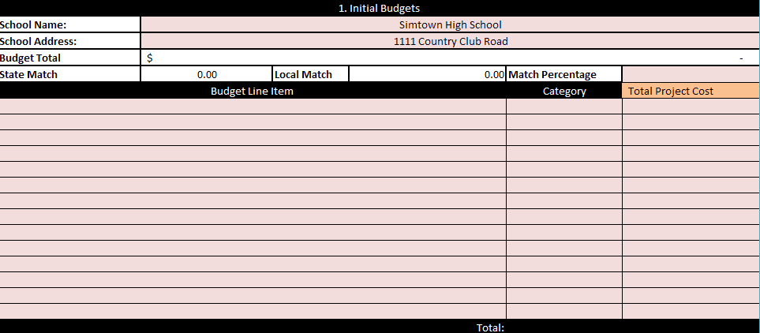

Enter project information and project totals

Please enter budget into **Separate File named “**[**Budget Tool**](http://www.ct.gov/demhs/lib/demhs/school_security/2014/budget_tool.xlsx)**”**

Section F. emergency plan sign off sheet

**Please Note: This can be submitted at the time of application or at the time of reimbursement**

**School Emergency Plans**

**Non-Public School:**

**Date Emergency Plan last exercised:**

**Note:** By signing the document, the signatory is attesting that the Non-Public School listed above has an emergency plan in place which was developed in concert with the appropriate local first responders and exercises the plan. The signatory is also attesting that the school has provided for a uniform assessment of the school including any security infrastructure using the National Clearinghourse for Educational Facilities/Safe Schools Facilities Checklist, which assessment was conducted under the supervision of the local law enforcement agency.

**Signature**

**NCEF**

**Checklist**

**Reviewed**

**____________________________  Yes  No Date ___________**

**Local Law Enforcement Agency**

**____________________________  Yes  No Date ___________**

**Fire Chief**

**____________________________  Yes  No Date ___________**

**Local Fire Marshal**

**____________________________  Yes  No Date ___________**

**Local Emergency Medical Services**

**____________________________  Yes  No Date ___________**

**Local Emergency Management**

**Director**

**____________________________  Yes  No Date ___________**

**Local Public Health Director**

Section G. Allowable Project Expenses

Please note that this is a **reimbursement-only** grant program. If awarded, the applicant must purchase the approved items using its own procurement system and submit a reimbursement form which will be included in the **Grant Award Documents.** Additional copies of the Reimbursement Request Form may be found on our website at ct.gov/demhs.

**Equipment and equipment related training**:

The following equipment items may be purchased under this program.

Improvements to the security infrastructure at the school including but not limited to:

* installation of surveillance cameras
* penetration resistant vestibules
* ballistic glass
* solid core doors
* double door access
* computer controlled electronic locks
* entry door buzzer systems
* scan card systems
* panic alarms or systems
* the purchase of portable entrance security devices, including but not limited to metal detector wands and screening machines
* real time interoperable communications
* multimedia sharing infrastructure
* training of personnel in the operation of security enhancements obtained under this grant.

Questions regarding eligible items may be directed to [schoolsecuritygrant@ct.gov](mailto:schoolsecuritygrant@ct.gov) .

Decisions on allowability will be made in accordance with the school safety infrastructure standards contained in the **Report of the School Infrastructure Safety** **Council dated June 27, 2014.** These standards can be found at <http://das.ct.gov/images/5510/Security%20Report%20June27.pdf>.

A Frequently Asked Questions Document (FAQ) will be maintained on the DESPP/ DEMHS and SDE website. Additional items that are determined to be eligible will be added to FAQ.

Section H. Prohibited Expenses

1. Any costs currently approved for payment under the “State School Construction Grant Program” administered by the State Department of Education.
2. Any costs that are currently funded under other State or Federal funds for the same purpose.
3. Personnel Costs.
4. Training Costs that are not related to the use of equipment installed under the grant.
5. Replacement of landscaping, plantings etc.
6. Any items deemed ineligible after review.

Section I Decision Matrix

Of the applicants on behalf of such schools with **greatest need** for security infrastructure, **first priority** shall be given to applicants on behalf of schools that have **no security** infrastructure at the time of the school building security assessment.

Section J NCEF SAFE Schools Facilties checklist

Part of the application process requires completing an evaluation under the supervision of the local

law enforcement agency for each school funding is being requested using a portion of the NCEF

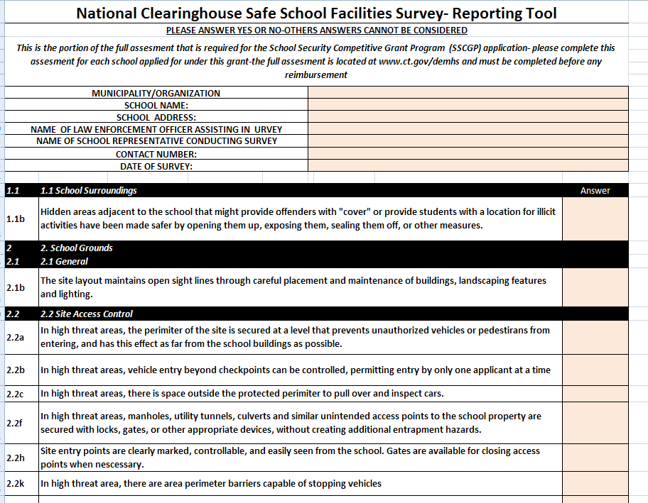checklist in an excel spreadsheet format. The Excel spreadsheet, “[**NCEF Checklist Tool**](http://www.ct.gov/demhs/lib/demhs/school_security/2014/ncef_checklist_tool.xlsx)**”** must be completed and submitted electronically in addition to submitting a printed copy with the application.