A learning management system (LMS) livery of e-learning education courses and training programs.
HBE'S LMS - The HUB
- Begin by Self Registering

  - Link to Access the LMS HUB Self Registration : https://stateofmaryland.csod.com/selfreg/register.aspx?c=srg_1
- Click on the link or copy and paste it into you web browser to access the self registration link.
- Complete the registration form.
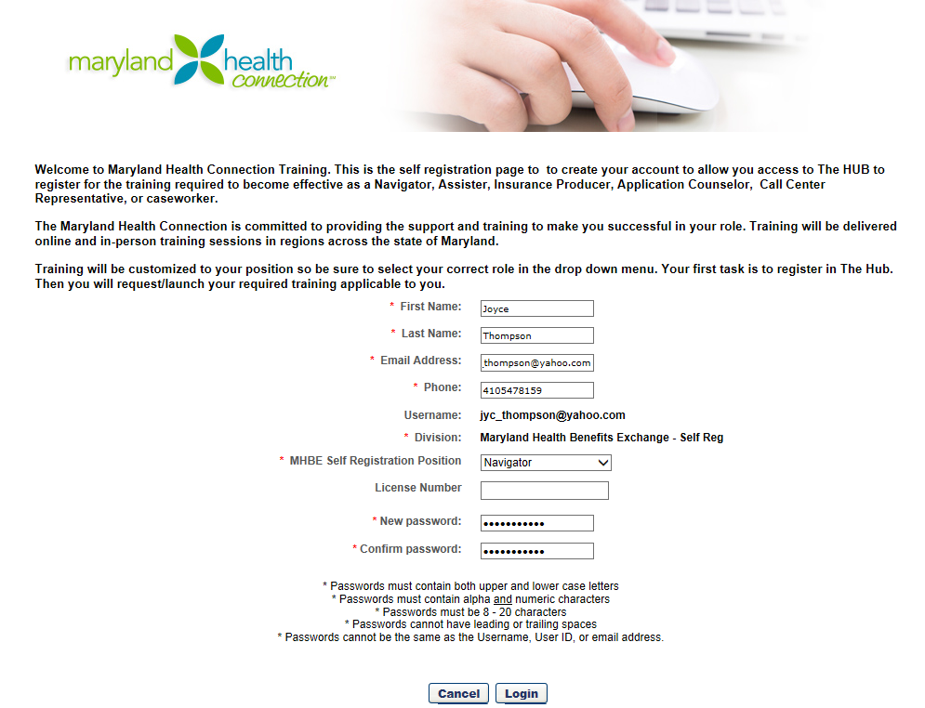

- Please be sure to select the correct MHBE Self Registration position, as the training is tailored to your role, using the drop down box.

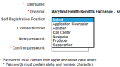
- Once you enter your email address, this will become your user name and it will appear on the screen.
- During the self registration,you must create a password. Password creation instructions are located at the bottom of the screen.
- Click “Login”

  - The next screen will be titled “Welcome to The Hub”. Click “Close” at the bottom of the screen.
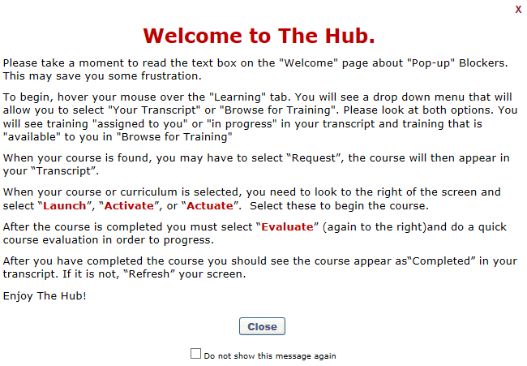

  - Once you click “Close”, you will be provided with detailed instructions about "Pop-up" Blockers and Surfing “The Hub” in the Formatted Message Box widget on the Home page. Please make the appropriate adjustments to your pop up blockers.

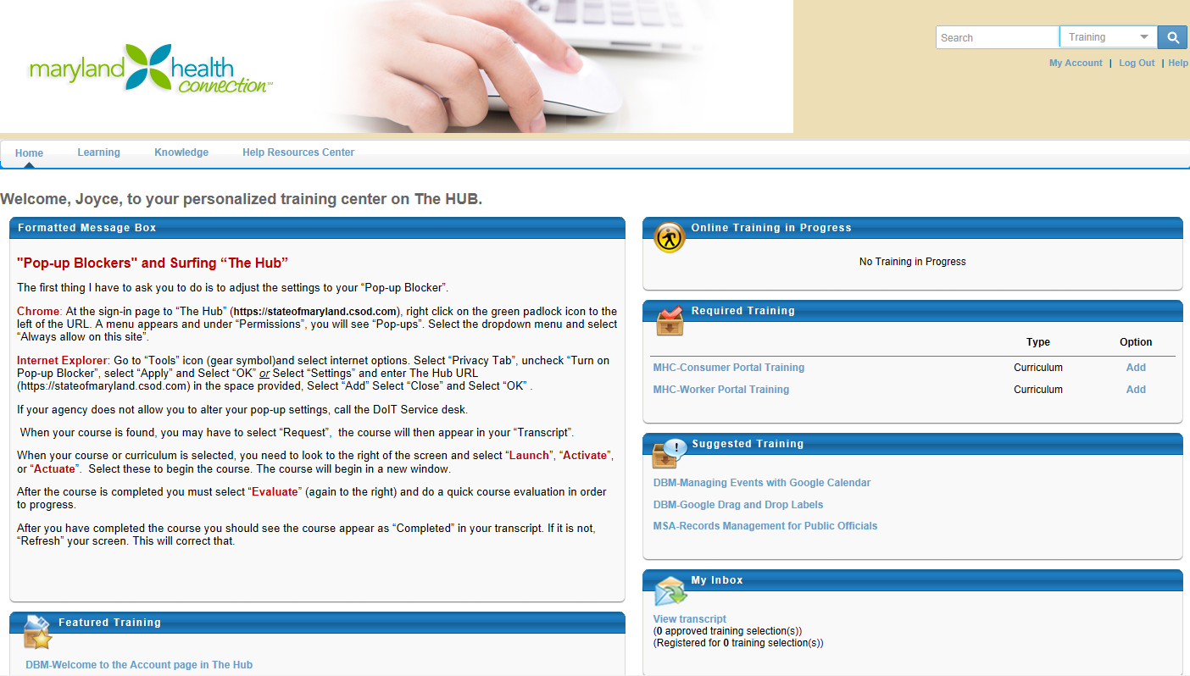

  - After you have completed your registration and created a password, please allow 1-2 days for your account to become active in the system to allow access to your training.

- Accessing the Training

- Link to Access the LMS HUB Training - https://stateofmaryland.csod.com
- You will access the HUB training by entering your User name and Password and by clicking “Log in”.

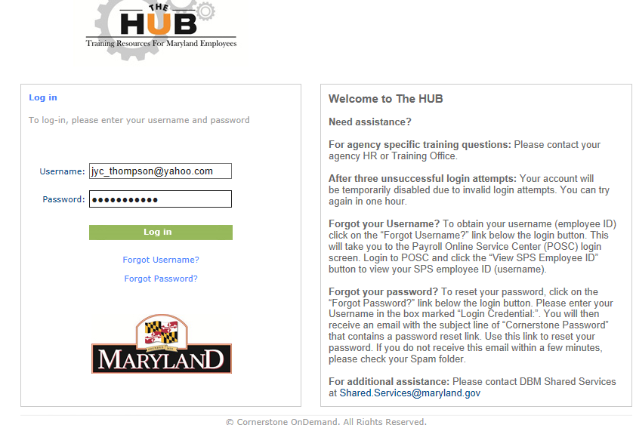
- Once your account is active, any curriculum or online classes that are required for you to complete the training will be listed under your Required Training widget on the welcome page. Your role will determine which currciulum and/or courses are required to complete the training. Although there may be other training listed on your page only the training listed in the Required Training widget are the courses that need to be completed and added to your transcript. The following roles are listed with the corresponding curriculum and/or courses that need to be completed:

Producers: MHC-Consumer Portal Training (Curriculum) and MHC-MD HBX-Producer View of the Consumer Portal (Course)

Naviagtors: MHC Consumer Portal (Curriculum) and MHC Worker Portal (Curriculum)

Assisters: MHC Consumer Portal (Curriculum)

Consolidated Service Center Representative: MHC Consumer Portal (Curriculum) and MHC Worker Portal (Curriculum)

Application Counselor: MHC Consumer Portal (Curriculum)

Caseworkers: MHC Consumer Portal(Curriculum) and MHC Worker Portal (Curriculum)
- Click “Add” next to the online courses or curriculum listed under your Required Training widget to add the needed courses to your transcript.

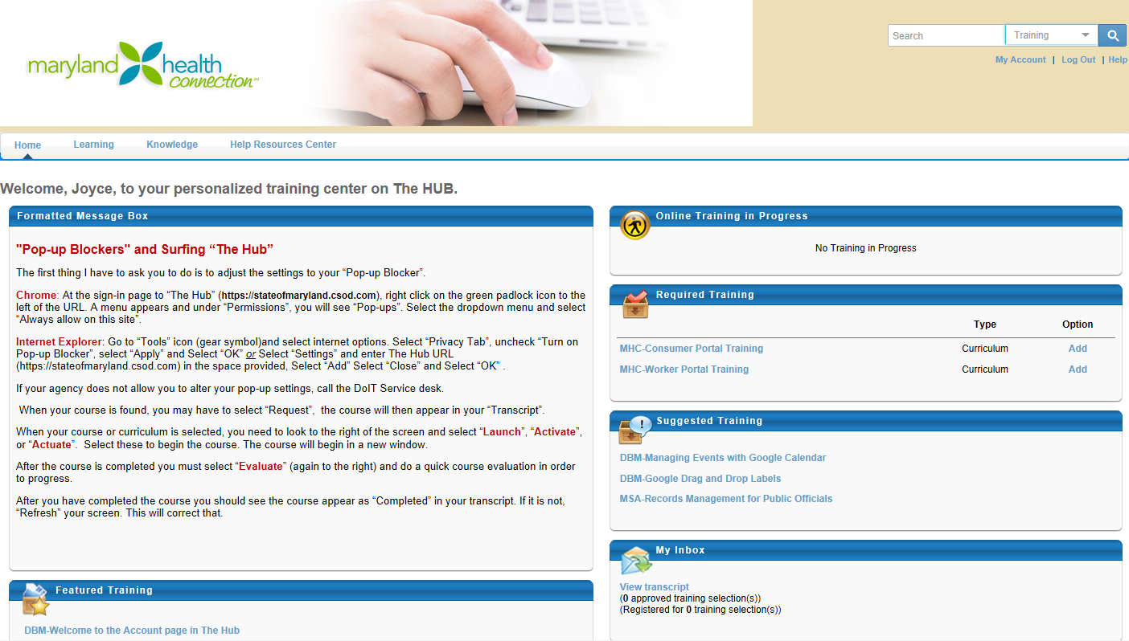
- Once all the required curriculum and/ or online courses are added to your transcript, they will be listed on your Transcript Page. To access your transcript, click “View Transcript” under the My Inbox widget and click the “Active” tab to view the added curriculum and/or online class.

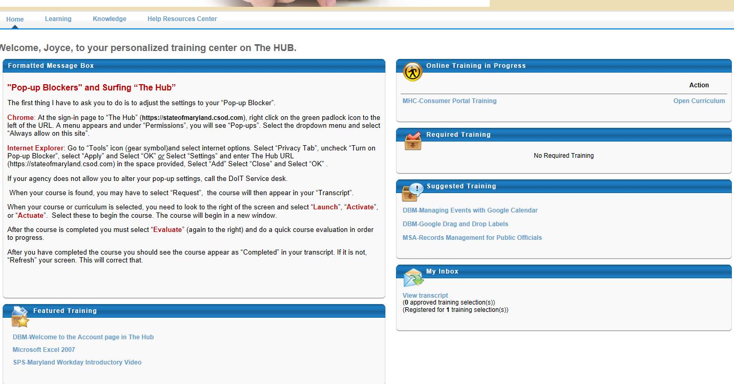
- Once you are ready to access the training, click “Open Curriculum” next to the curriculum that you would like to access.
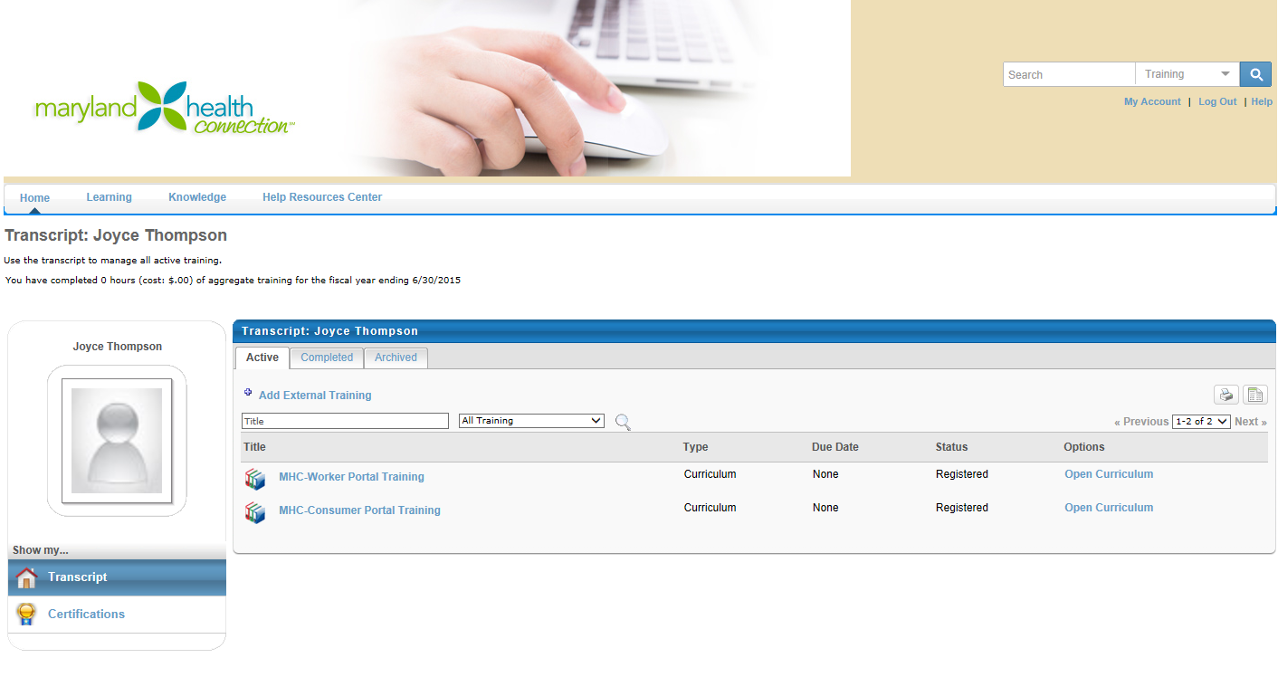

- Once you click “Open Curriculum”, each curriculum will contain a list of courses that must be completed, in the order listed, to complete that curriculum. Click “Activate” to access the course.

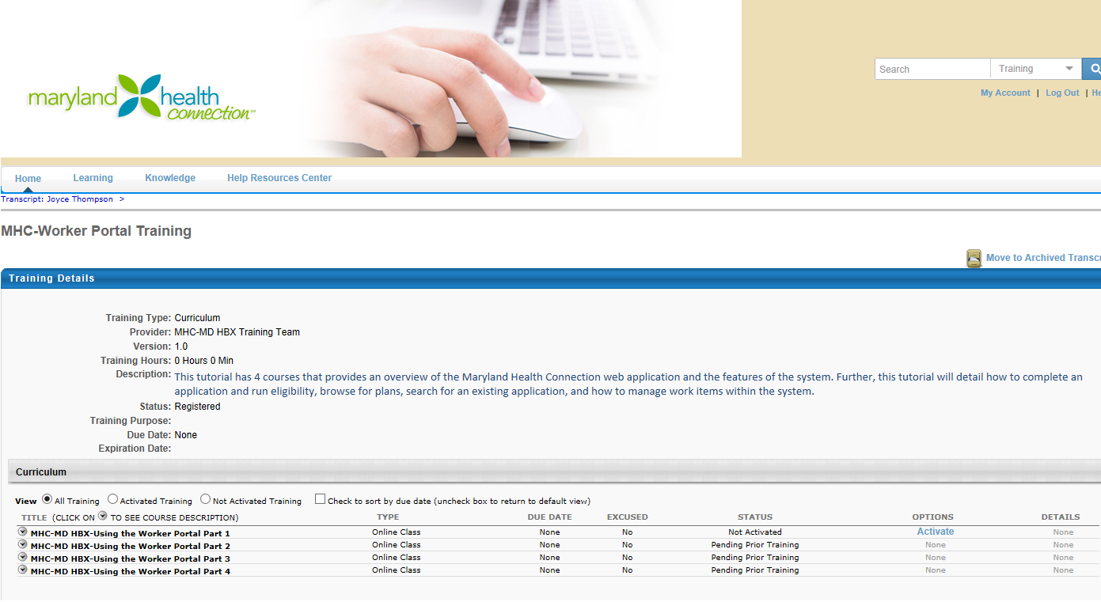

- Once you click “Activate”, the page will change to allow you to “Launch” the course.
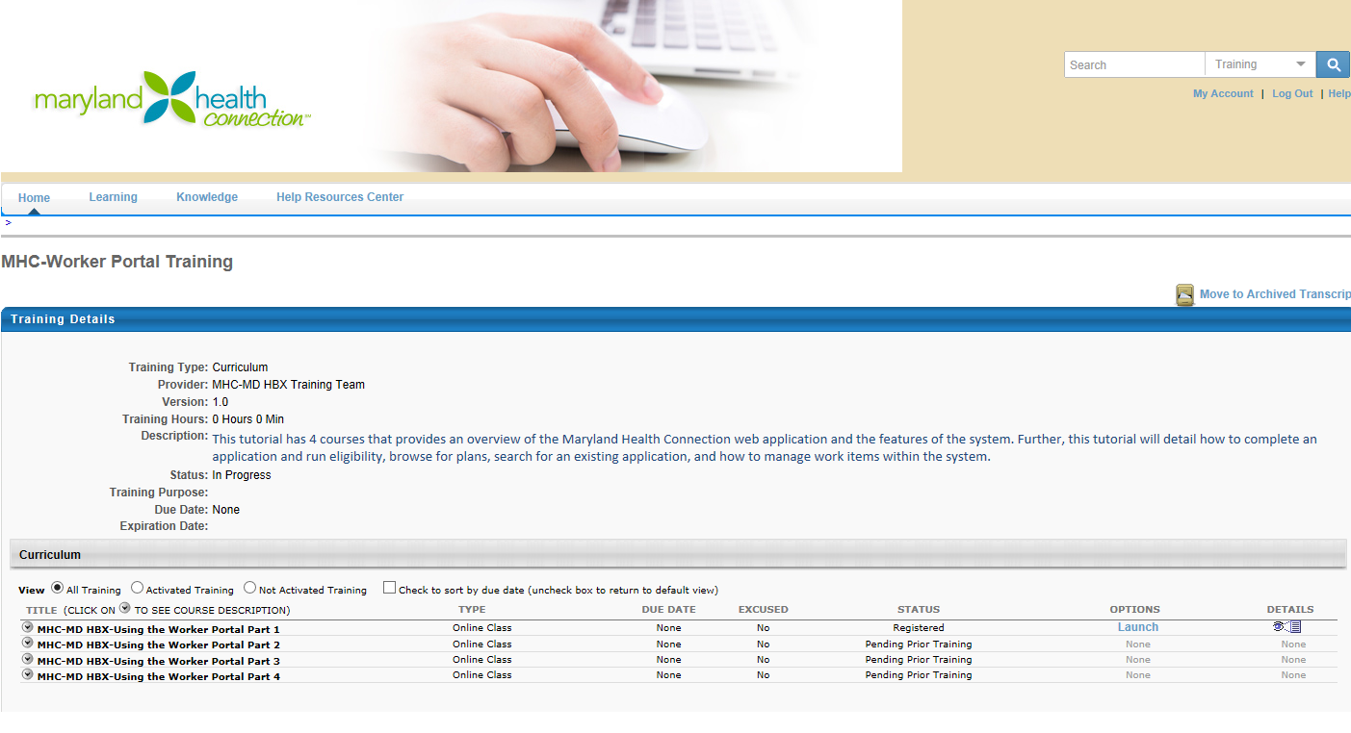
- If you are required to complete an online course, click “Launch” to access the training.

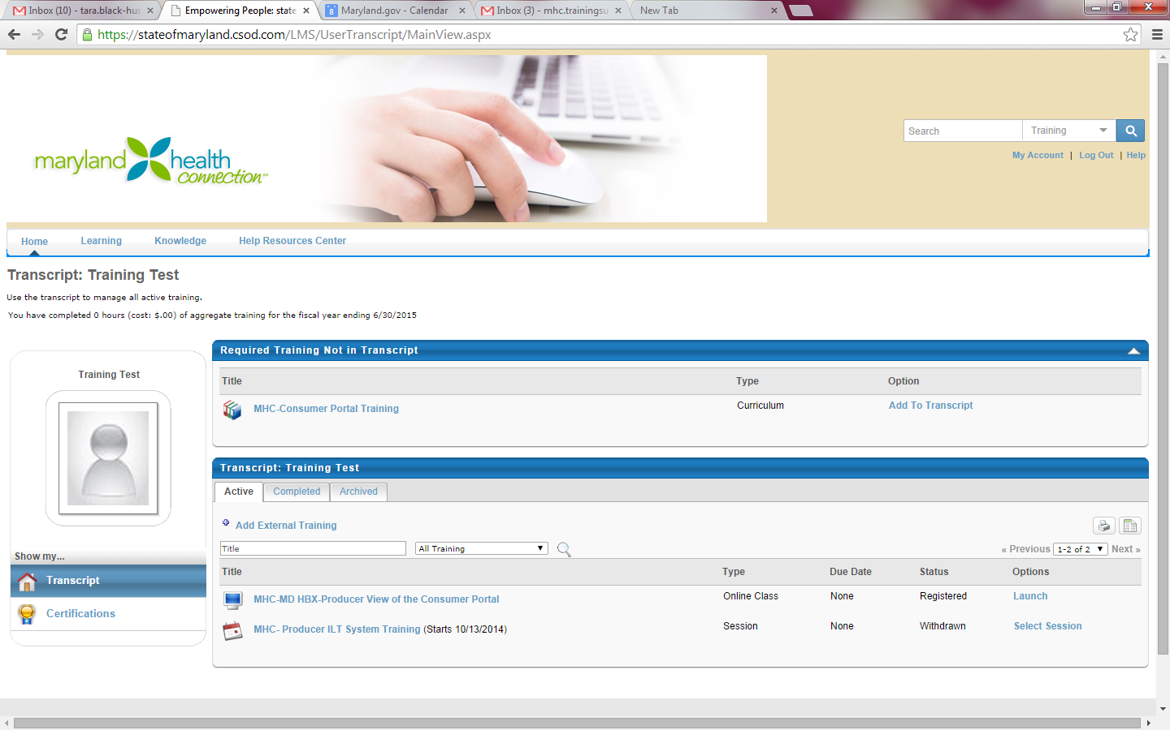
- Once the course is launched, select “Agree” to agree that “This is for State of Maryland Use Only” to begin course.
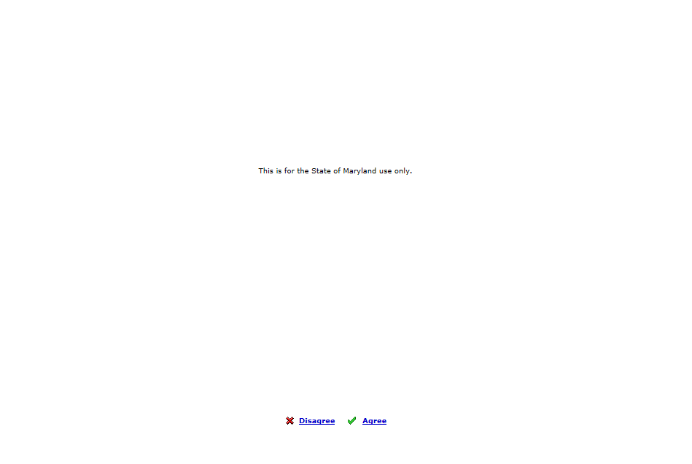

- At the beginning of each course, there will be additional instructions on navigating through the course.
- Once each course is complete, “Completed” will show under the status column on the Training Details page for that course. To access the next course in a curriculum click “Activate” and then click “Launch” for the next listed course.

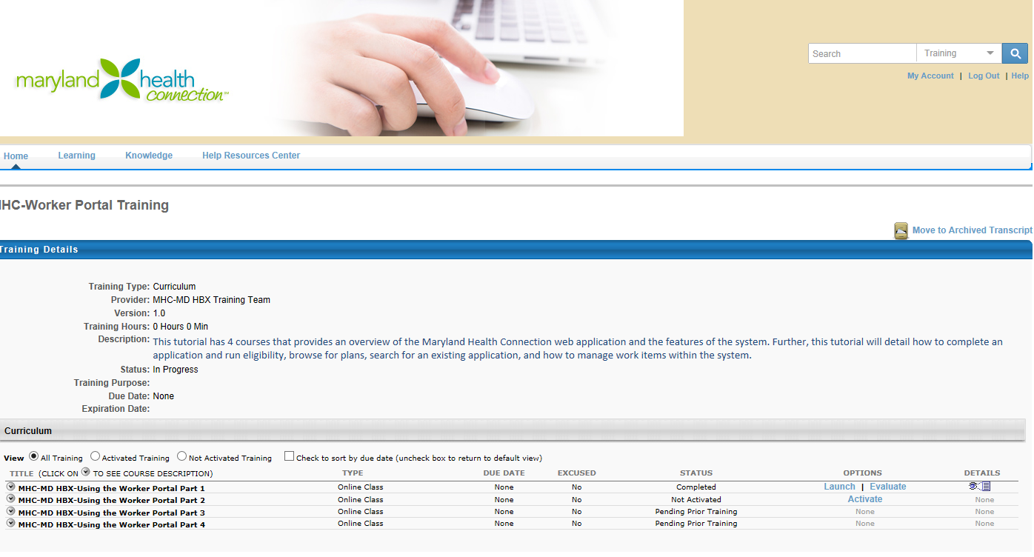
- Once a curriculum or a course is complete, you must complete the evaluation before it will be listed on the “Completed Tab” of your transcript. Completed courses will no longer be listed on the Home page.

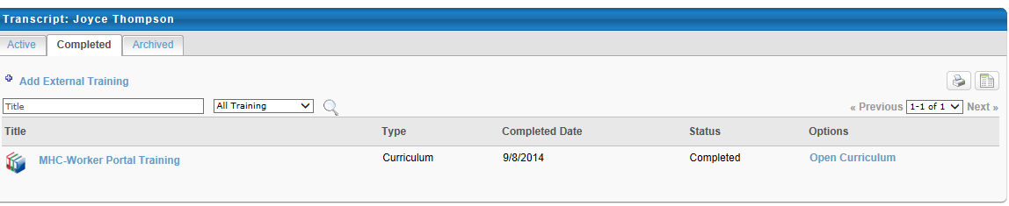
- All incomplete courses can be accessed from the “Active” tab of your transcript or through the Online Training Progress widget on the Home Page, and will no longer be listed under the Required Training widget.

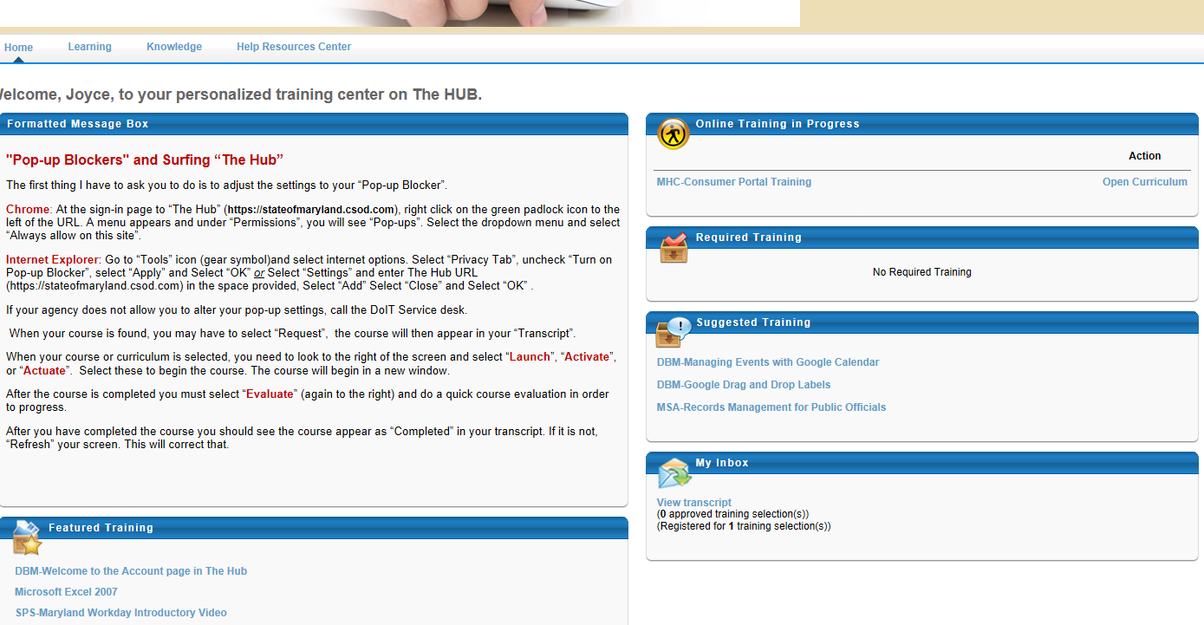
- The registration for instructor led training cannot be accessed until you complete the required online training assigned to you. Registration for ILT will not become available until 5 pm on 9/16/2014.
- If you have any questions regarding the registration process, please feel free to contact mhc.trainingsupport@maryland.gov.

