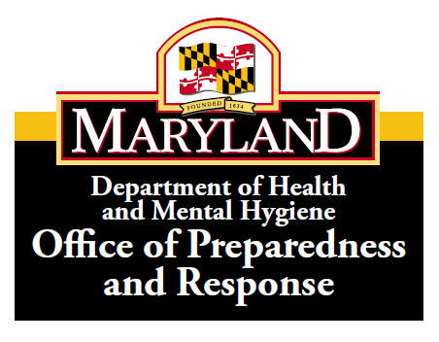

TRAINING ANNOUNCEMENT (01/15/14)

Course Title: Emergency Management of Radiation Accident Victims (REAC/TS)

Course Description: A two-day training on the medical management of radiation emergencies. Topics covered will include basic radiation protection, basic radiobiology, diagnosis and treatment of local and whole body irradiation, treatment for internal contamination, and adapting emergency response to manage radioactively contaminated patients. The course will be taught by faculty from the Radiation Emergency Assistance Center / Training Site (REAC/TS) of the Oak Ridge Institute for Science and Education (ORISE). ORISE program is sponsored by U.S. Department of Energy and managed by Oak Ridge Associated Universities (ORAU).

The Oak Ridge Institute for Science and Education designates this live activity for a maximum of 12.25 AMA PRA Category 1 Credits. Physicians should claim only the credit commensurate with the extent of their participation in the activity.

Target Audience: All staff involved in the medical management of radiation emergencies including Physicians, Physician Assistants, Nurses, Clinical Nurse Practitioners, First Receivers, Health Physicists, and Emergency Planners.

Dates of Course: Tuesday, April 22 and Wednesday, April 23, 2014

Time: 8:30 am – 4:30 pm

Location: Eastern Shore Hospital Center
5262 Woods Road
Cambridge, Maryland 21613
Room: English Hall

To register, click on the link below or cut and paste in browser:
http://preparedness.dhmh.maryland.gov/SitePages/Events.aspx

Questions: Clifford Smith at clifford.smith@maryland.gov or 410-767-5266
Artensie Flowers at artensie.flowers@maryland.gov or 410-767-5765

