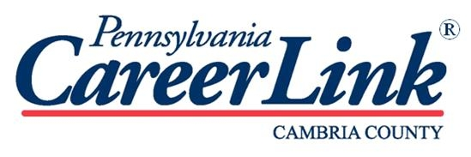

ATTENTION ALL MANUFACTURERS….
FALL JOB FAIR!!

You are invited to participate in a Manufacturers Job Fair
co-sponsored by PA CareerLink and JARI.

Thursday, November 6, 2014
4pm - 7pm
Cambria County War Memorial Lobby
326 Napoleon Street Johnstown, PA 15901

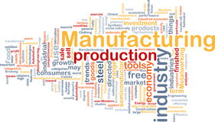

The Manufacturing Job Fair is for employers interested in hiring full-time and part-time
employees and distributing career information. Businesses that provide
employment and training program services are also encouraged to participate.
Table space is free but must be reserved.
Additional information available by contacting
Renee Shaw, Business Services Coordinator, PA Careerlink
at rshaw@goodwilljohnstown.org or 814-533-2493.

The Fair is free for both employers and participants.
PLEASE feel free to advertise your presence at the Fair.
Any help advertising the Fair will be greatly appreciated.

Contact CareerLink® for more information: 814-533-2493
Auxiliary aids and services are available upon request to people with disabilities.
Equal Opportunity Programs.
To receive this flier in an alternate format call 814-533-2493 or TTY 814-535-6698

